Table 1. Advanced Random Under Sampling for Ripper Algorithm and Modified Ripper Algorithm
Metrics  Algorithm |  | 10 | 20 | 30 | 40 | 50 | 60 | 70 | 80 | 90 | 100
RA | AUC | 0.0114 | 0.0488 | 0.1061 | 0.1852 | 0.2690 | 0.3911 | 0.5402 | 0.6715 | 0.8408 | 1.0497
 | ERR | 0.0523 | 0.0532 | 0.0569 | 0.0600 | 0.0633 | 0.0642 | 0.0857 | 0.0870 | 0.1000 | .2308
 | ACC | 76.9231 | 90.0000 | 91.3043 | 91.4286 | 93.5780 | 93.6709 | 94.0000 | 94.3089 | 94.6809 | 94.7712
MRA | AUC | 0.0151 | 0.0465 | 0.1070 | 0.1812 | 0.2716 | 0.3913 | 0.5408 | 0.6697 | 0.8410 | 1.0501
 | ERR | 0 .0459 | 0.0523 | 0.0532 | 0.0569 | 0.0580 | 0.0600 | 0.0615 | 0.0633 | 0.0857 | 0.1000
 | ACC | 90.0000 | 91.4286 | 93.6709 | 93.8462 | 94.0000 | 94.2029 | 94.3089 | 94.6809 | 94.7712 | 95.4128

 | AUC | ERROR | ACCURACY
ARUS | 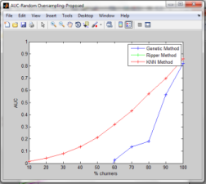 | 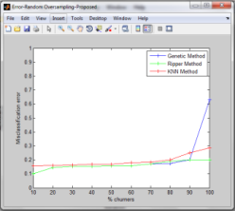 | 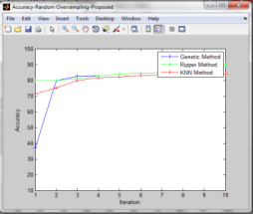
Figure 1. Comparison of ripper and modified ripper algorithm with advanced random under sampling

