 | International Journal of Engineering & Technology, 5 (x) (2017) xxx-xxx  International Journal of Engineering & Technology  Website: www.sciencepubco.com/index.php/IJET  doi:  Research paper, Short communication, Review, Technical paper | 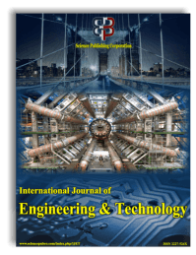

An Investigation on Design Innovation, Fabrication and
Experiment of Soy Bean Peeling Machine

Van Thanh Tien Nguyen¹*, Van Anh Dang¹, Cong Hoang Nguyen², Dai Hoa Vo², Dang Khoa Nguyen², Ngoc Lam Nguyen², Quang Lam Nguyen², Thien Long Tieu², Tan Nam Bui²
¹Lecturer, Faculty of Mechanical Technology, Industrial University of Ho Chi Minh city
² Undergraduate student, Faculty of Mechanical Technology, Industrial University of Ho Chi Minh city
*Corresponding author E-mail: nguyenvanthanhtien@iuh.edu.vn

Abstract

The equipment for peeling soybean testa uses using the friction principles of two conveyors to expose to dried soybeans. By making a large frictional contact on the surface of the soybeans, the link of the soybean testa and that makes its testa and seed detach separately. This paper presents a designing and manufacturing equipment for peeling processed soybeans including the number of rotation of the two conveyors, the exposed a gap between conveyors, The result shows products after peeling exceeding 80 per cents and its productivity is 15 kilograms per hour.

Keywords: Detach the soybean testa, the peeling equipment, exposing seed coats….

- Introduction
The equipment for peeling dried soybeans is a complex device. Its performance depends on the friction of two conveyors which expose to the surface of soybeans. The exposed gaps determined on by the distance between the conveyor and the soybean. The number of rotation of the two conveyors is necessary to meet enough capacity for moving the soybeans. The width of the conveyors affects the exposed area of the number of soybeans on the conveyor. The soybean moisture plays an important role in the link between its testa and the cotyledon. Conveyors have been applied and developed in research all over the world. The production process helps to collect data, monitor, supervise and handle parameters for controlling, optimizing the equipment operation, with technological processer that requires high reliability.
The equipment for peeling seed coat is a product used to detach the processed soybean coat. Nowadays, the similar equipment is not easy to find in the market.
There are fresh soybean coat peeling machine of Nguyen Tan Bien who appeared on the TV channel Rural Agriculture - VTC16 of Viet Nam channel [9]. The dried soybean peeling equipment studied by a group of students of Ho Chi Minh city University of Technology and Education, Viet Nam. There are a few dried soybean machines such as: Soybean testa machine HH-TK-300, HH-TK-400, HH-TK-500A made by Zukun of Germany [10]. Soybean testa machine TNĐ-Yamaguchi made in Japan [11].and other authors from many countries [12]-[14].

Green pea peeling and splitting machine 6FW-B9 made in China, which is a new machine specially designed according to soybeans and green. This is easy to operate. Peeled beans skin and perfect peeling effect which are suitable for small soybeans have to stable performance and low noise. Soybeans can be flavored to make tofu and soybean milk. It is a main peeling machine for 35TDP peeling plant with production capacity is 1500 kilograms per hour and peeling performance rate 98 percent [12].

Peeling soybean testa machine is not widely produced and the selection of equipment is not diversified, so the design and manufacturing of equipment is very potential and promised.
- Soybean coat peeling processes and equipment design
  - Calculational parameters of testing
Table 1. Specifications of basic parameters for the system
Specification | Value
Productivity (kg/h) | 5
Velocity of conveyor A (m/s) | 0.4
Velocity of conveyor B (m/s) | 0.7
Motor A (rpm) | 675
Motor B (rpm) | 675
Size of conveyor A (mm) | 2640x400
Size of conveyor B (mm) | 3200x400

2.2 Peeling principles
Peeling soybeans is the process which breaks the link between the cotyledon and the seed coat. The process applies the principle that two conveyors are installed in parallel and operated in opposite directions, with a certain gap. The main working parts are two exposed surfaces of the conveyors which have appropriate speed and gap to detach the processed soybean.
The equipment for peeling dried soybean was studied on a five kilogram per hour experimental model at Industrial University of Ho Chi Minh city, Viet Nam. Soybeans are dried then delivered through peeling device with the technology using two conveyors that rotate counter clockwise creating friction to detach its cotyledon from the seed coat. Velocity and gap between two conveyors are appropriately adjusted for the purpose of creating the best peeling process.
To detach its seed coat from the soybeans, the necessary force needs to be applied on the soybeans. Friction is important for peeling, therefore, the capacity of the two conveyors has to be computed, rotational speed has to be found out and the gap have to be ensured the products exceeding more than 80 percent.
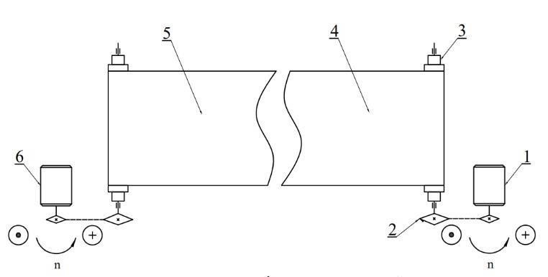
2.3 Equipment design
2.3.1 Engine diagram

1- Motor A 2- Sprocket and chain system
3- Drum shaft 4- Up Conveyor A
5- Down Conveyor B 6- Motor B

Fig. 1. Principle diagram of the system

When the engine A (1) works, its shaft will rotate and create transmission of moment through the sprocket and chain system (2) to rotate the drum shaft (3) and operate the conveyor A (4). Like the engine A (1), the engine B (6) operates the conveyor B (5). The two motors have the same rotation. The soybean will be pressed between the two conveyors (4) and (5), because the two surfaces of the two conveyors work in opposite directions. The conveyor B (5) works faster than conveyor A (4) to orient the soybean. The motor B (6) will be equipped with an inverter that can change the best suitable speed of the conveyors. Fig. 1 shows that the conveyor belt on the shaft is important parts in this design.

2.3.2 Selecting the conveyor

Table 2. Comparison of three types of conveyors

Ord | Option | Brand name | Purpose use | Applicability | Thickness | Renew | Innovation
1 | Opt 1 | Conveyor  HQ01-6 | Item  Conveyor | Surface | 0.5-30 mm | Available
1 | Measurement  1-5 points |  |  |  |  |  | 16pts
2 | Opt 2 | Conveyor LP-3GD | Food  Conveyor | Surface | 3 mm | Available
2 | Measurement  1-5 points |  |  |  |  |  | 15pts
3 | Opt 3 | Conveyor  LP-2RD | Food  Conveyor | Cross surface | 2.1 mm | Available
3 | Measurement  1-5 points |  |  |  |  |  | 18 pts

Table 2 presents that to ensure food safe, Opt 1 is the worst because Opts 2 and 3 are the types of conveyor providing for the food processing industry. With peeling capacity, there are many kinds of thickness that are the most suitable compared to all the rest the most. The Opt 3 is the best one. This equipment is only a device modelling for testing a small model testing device, therefore, the greater its thickness is, the harder it could work. The drum shafts have to be designed with a big diameter to fit the curve fangle of the conveyors. Besides, this requires a motor with high capacity which would increase more cost. The third one is the most appropriate for this study.
2.3.3 Designing and machining axis.
Design of components:
The type of the parts is various multiple diameter shafts. Its function is driving conveyor [4].

Specifications are required when designing part.
Reliability, durability and assembly ability of the shaft are precisely defined with the requirements. Two precise bearings were machined with the exact level 7, the smoothness of the surface is grade 8 [4], [6]. Errors of the drums compared with the shaft centre line of the draft are less than 0.05mm.
Setting up the experiments process and designing process
The work piece is fabricated through machining the two sides of shaft head surfaces and drilling the central holes of the shaft that selected for fine fixing during the manufacturing processes.[4], [7], and [8].
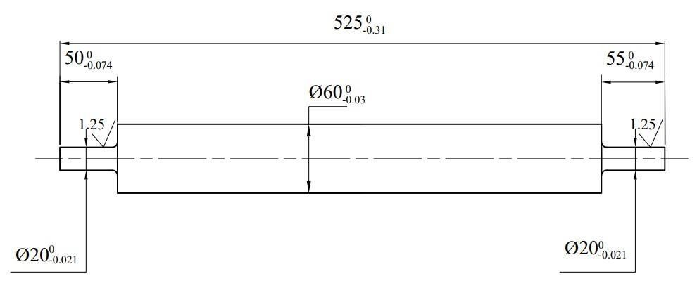
Fig. 2. Drum shaft drawing

Internal force diagram of the driven shaft
Tangent force:
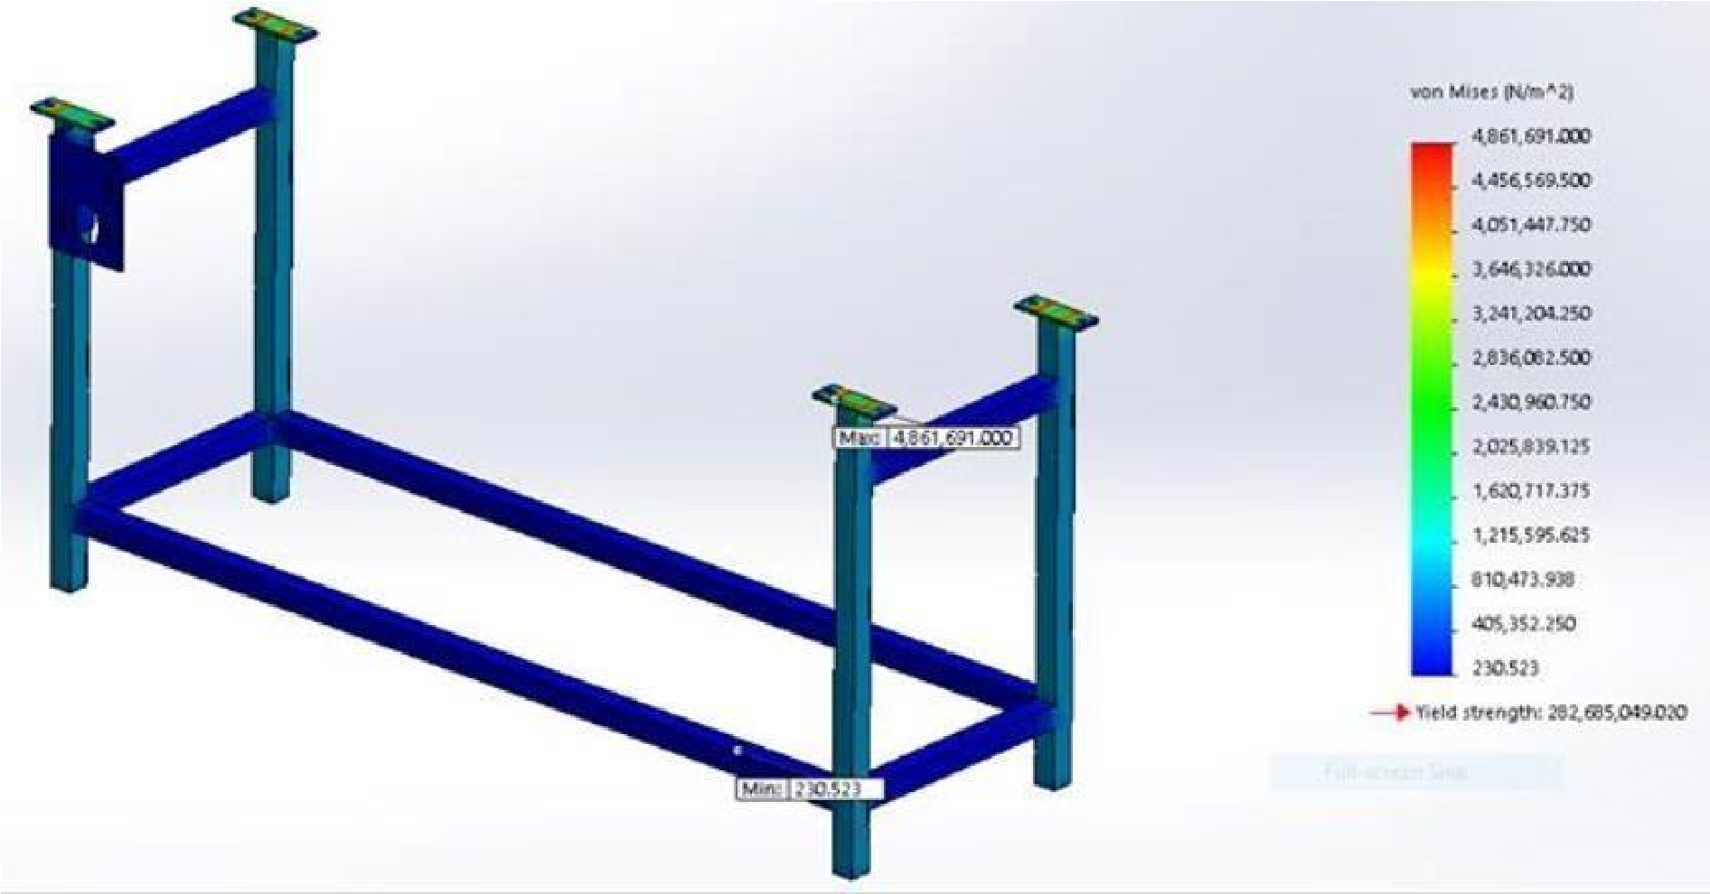
F_{b} = 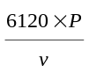 [9]
Tension on two sides of the conveyor:
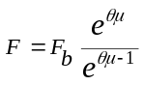[9]
Choosing C45 steel to for the shaft workpiece:
HB = 240, 𝛿_{𝑏} = 700 MPa, 𝛿_{𝑐} = 480 MPa [𝜏] = 30 Mpa [7].
Reacting force at bearings at Oxz plan:
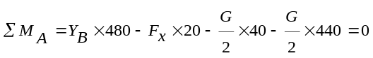 [8]
Therefore,
𝑌_{𝐵} = 89, 76 N
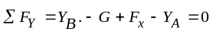 [8].
Therefore,
𝑌_{𝐴} = 642.76 N

Reacting force at bearings at Oyz plan:
∑ 𝑀_{𝐴} = - 𝑋_{𝐵}×460 + 𝑅×120 + 𝑅×2440 = 0 [8].
Therefore,
𝑋_{𝐵} = 295.83 N
∑ 𝐹_{𝑌} = 𝑋_{𝐴} + 𝑋_{𝐵} - 𝑅₁ - 𝑅₂ = 0 [11].
Therefore,
𝑋_{𝐴} = 691.17 N
Hazardous position at position C in the table 10.6[7] shows the torque and the torque reaction.

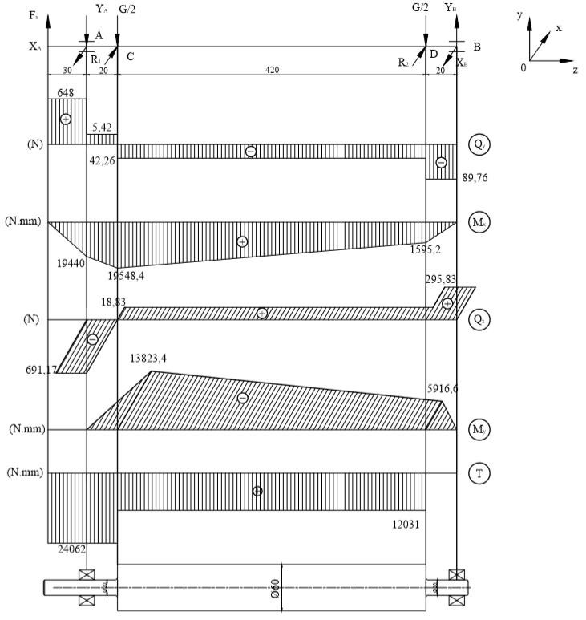
Fig. 3. Internal force moment and torque diagram (4)
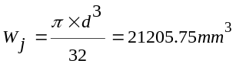
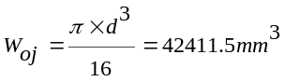
Shaft structuring is designed to ensure the fatigue if safety factors at dangerous sections meets the initial conditions.
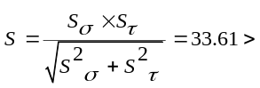[S]=1.5
Therefore, it meets conditions [5].
2.3.4 Simulation of the frame stress
The body frame is made of CT3 steel, to be able to work with load of 800N; the height of the frame is 600mm.
Fig. 4. Stress distribution on the designed body frame

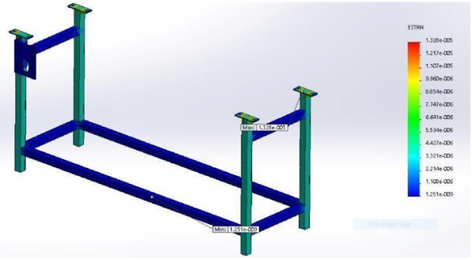
Fig. 5. Transposition on the body frame
  - The gap between the two conveyors.
The device used to measure the gap is TPG-700A Niigata with its code standing for TPG-700A, and its brand name is Niigata (SK) made in Japan.

Table 3. Parameter measurement gap TPG-700-Niigata
- Experimental settings and Results
Parameter | Value
Measurement range (mm) | 1~15
Accuracy (mm) | ±0.05
Dividing line (mm) | 0.1
Cone angle (o) | 7°9'10"
Length (mm) | 148.5
Thickness (mm) | 1.2
Weight (g) | 10

3.1 Experimental settings
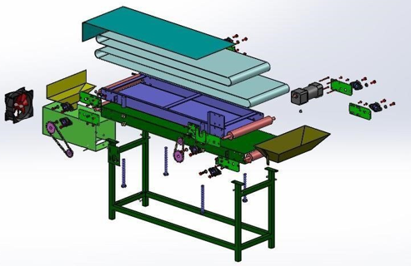

Fig. 6. The assembly drawing of the soy bean peeling machine

The equipment for peeling soybean testa has been successfully manufactured with a capacity of 15 kilograms per hour creating the experimental facilities. Thanks to this, there will be the replacement of workers to get higher productivity and ensure the food safety.

Fig. 7. Experimental equipment for peeling soybean testa

Experimental description and results:

The gaps conducted to the experiments with the gaps 5, 6, 7 and 8 mm. The conveyor speed levels (4) conducted to experiments with: 45, 60, 70, 92, 100, 110, 120, 133, 145 rpm. One hundred grams of soybeans is firstly supplied to the equipment and is weighed. The results demonstrate the same speed, gaps and performances in the table 4 and Fig. 9.
Experiments - 1:
In this experiment, soy beans were chose and clarified carefully before putting on the machine with the soy bean mass used around 100 kilograms. The test took 5 hours and lasted during the three continuous days in a manufacturing company. The experiments were conducted by the studied members.

Table 4. Experiments -1 settings

Experiments - 2 settings
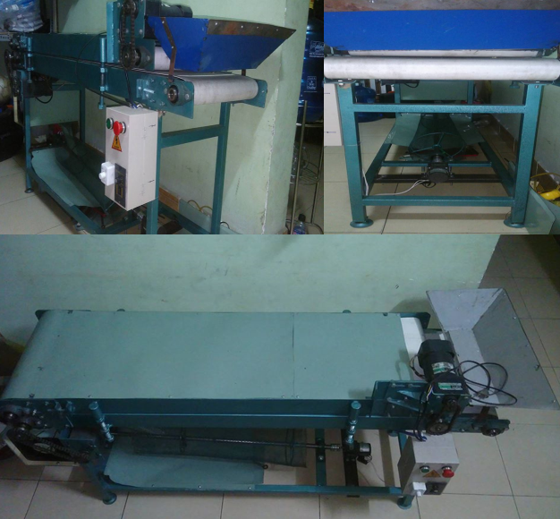
Experiment  1 |  | Speed (RPM)
 |  | 45 | 60 | 70 | 92 | 100 | 110 | 120 | 133 | 145
Gap (mm) | 5 | 5 times | 5 times | 5 times | 5 times | 5 times | 5 times | 5 times | 5 times | 5 times
Gap (mm) | 6 | 5 times | 5 times | 5 times | 5 times | 5 times | 5 times | 5 times | 5 times | 5 times
Gap (mm) | 7 | 5 times | 5 times | 5 times | 5 times | 5 times | 5 times | 5 times | 5 times | 5 times
Gap (mm) | 8 | 5 times | 5 times | 5 times | 5 times | 5 times | 5 times | 5 times | 5 times | 5 times
Table 5. The way to experiment the experiment 2
Experiment 2 |  | Speed 120 (rpm)
Gap (mm) | 5 | 8 Times
Gap (mm) | 6 | 8 Times
Gap (mm) | 7 | 8 Times
Gap (mm) | 8 | 8 Times

In the experiments-2, based on the results of the first experiments-1, the best speed could be employed to apply for the experiments -2 with various gaps listed 5,6,7,8 mm illustrated in the above table. The purpose of the experiments is to determine the best gap that is suitable for peeling with the highest performance.

Experiments - 3 settings

Experiments-3, based on the results of the first experiments-2, the best gap could be employed to apply for the experiments -2 with various speeds listed 92,100,120,133 and 145rpm illustrated in the above table. The purpose of the experiments is to determine the best speed that is suitable for the machine that could work with high efficiency.

Table 6. Settings up for the experiments-3
Experiment 3 | Speed (rpm)
Experiment 3 | 92 | 100 | 110 | 120 | 133 | 145
Gap 6 mm | 9times | 9times | 9 times | 9times | 9times | 9 times
  - Experimental results

3.2.1 Results of the experiments - 1
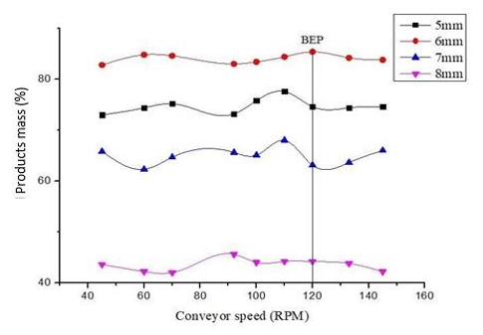
Fig. 9. The relationship between the rate of products with the gaps of the two conveyors and the speed of the top conveyor

The results of testing of the experiments 1can be seen that in the Fig. 9. Fig. 9 show that with the gap of 6mm, there is the highest weigh of productivity compared with all the rest. With the speed level is 120 rpm, there is the highest productivity. To have the best result should be set at 6mm respectively with 120 rpm; the experimental 2 and 3 are then conducted

3.2.2 Results of the experiments - 2 : 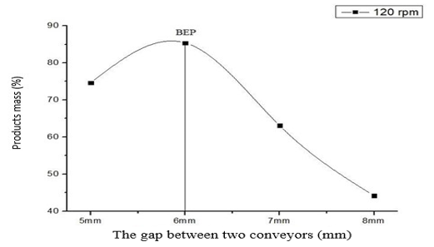
Fig. 10. The relationship between product rate and the gaps of the two conveyors
Experimental results in Fig. 10 show that when the gap increases to 6mm, the volume of fine products will raise. If we continue to increase the gap exceeding 6mm, the volume of fine products gradually reduced. Therefore, the best gap in the experiment is 6mm.

3.2.3 Results of the experiments -3
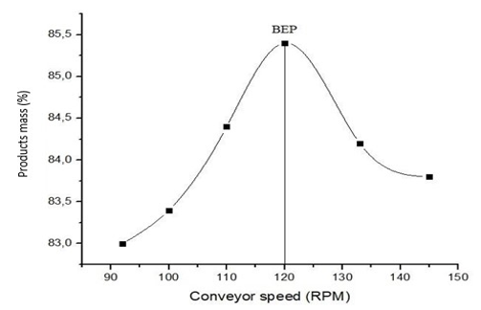
Fig. 11. Relationship between finished rate and speed of top conveyor (4)
Fig. 11 shows that when the speed is increased up to 120 rpm, the product mass will respectively increase. Continuously increasing the speed faster than 120 rpm, the volume of products will decrease. Therefore, the best speed should be in the experiment 120 rpm.
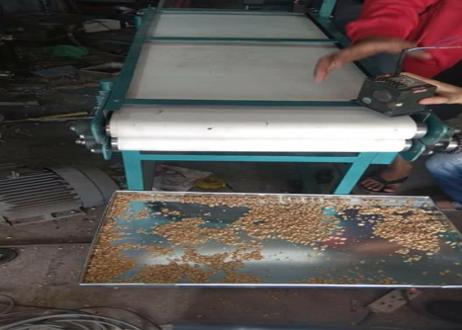
Fig. 12. Experiments practiced on the machine after fabricating

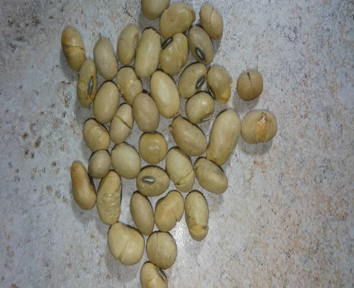
Fig. 13. Soybean raw used for doing experiments

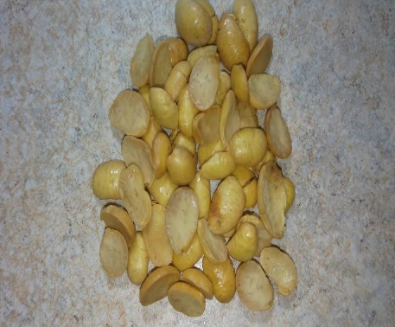
Fig. 14. Soybean product peeled by our machine

Figs 13, 14 show the soy bean raw and product before after peeled by using our machine that could be seen in Fig. 12. In the total number of unarticulated seeds, there are unrecovered and tough seeds. To increase performances of the productivity, selecting the soybeans classified in advance to ensure the uniform of their sub-equipment’s will be studied in the future and in this study limit quality or providing some sub-equipment for detaching is necessary.

4. Conclusion and discussion
The soybean testa peeling machine was designed & fabricated successfully. Mechanizing process soybean testa peeling processes, performance of productivity is over 80 per cents. The results show the two conveyors, the better soybean testa is peeled. However, the gap which is smaller than 6mm could make the soybean ease to be broken into many parts which do not meet the requirements of design objectives. Therefore, ensuring the food safety and suggested that the gap between the two conveyors is around 6mm and the lower conveyor speed should be around 120 rpm during the operation.
This study carried out the suitable machine that could in the implementation process practically applied with the parameters that are mentioned above. The data observe from the experiments could help in scaling up through the machine model.

5. Further studies
In order to make the machine which is suitable for the productivity, it has been improved to increase its productivity reaching the expected productivity of 35 kilograms per hour. After successful improvements, the study is directly putting into the test to assess the response achieving the initial objectives. Maintaining and fixing defects on the machine when increasing productivity should be paid attention. In order to make the machine friendlier, there will be a controller added on the machine to control automatically the production lines of soybeans.
6. References
[1]. Tran Van Dich, Manufacturing technology, Ha Noi Science and Engineering Publishing, Vietnam, 2008.
[2]. Nguyen Huu Loc, Fundamentals of Machine Design, Ho Chi Minh City National University Publishing, Vietnam, 2008.
[3]. Ninh That Ton, Fit Tolerance, Education publishing.
[4]. Tran Van Dich, Manufacturing Technology Design Project, Ha Noi Science and Engineering Publishing, Vietnam, 2005.
[5]. Nguyen Dac Loc, Manufacturing Technology notebook (chapter 1, 2 and 3), Ha Noi Science and Engineering Publishing, Vietnam, 2007.
[6]. Bridgestone, Conveyor Belt Design Manual, Vietnam, 2010.
[7]. Trinh Chat, Le Van Uyen, Calculating mechanism motion systems, chapter 1, Educational publisher, Vietnam, 2006.
[8]. Do Quoc Kien, Strength of Materials, Ho Chi Minh City National University Publisher, Vietnam, 2003.
[9]. Akaaimo D.I. and A.O. Raji(2006). Some Physical and Engineering Properties of Prosopis africana seed. Biosystems Engineering 95 (2), 197–205
[10]. Perkins, E. (1995). Composition of soybeans and soybean products. Practical Handbook of Soybean Processing and Utilization, Erickson, E.R., Ed., AOCS Press, Champaign, IL.
[11] C.N Agulanna and E.C. Oriaku, Design and Fabrication of a Micro-Scale Wet Process Soya-Bean De-Coating Machine, Journal of Emerging Trends in Engineering and Applied Sciences, (JETEAS) 4(1): 149-155, 2013
[12]. Amin, M.N., M.A. Hossain, and K.C. Roy. 2004. Effects of moisture content on some physical properties of lentil grains. Journal of Food Engineering, 65, 83–87
[13] Aviara, N.A., Shittu, S.K., and Haque M.A. (2007) Physical properties of guna fruits relevant in bulk handling and mechanical processing Int. Agrophysics, 21, 7-16
[14] Olajide, J.D. and J.C. Igbeka. (2003). Some physical properties of groundnut kernels. Journal of Food Engineering, 58, 201–204.

