EVALUATION OF 3D FACIAL PARALYSIS USING FUZZY RULES

Banita
PhD Research Scholar
School of Computer Science
Lingaya’s University
Faridabad, Haryana
Banita861023@yahoo.com

Dr. Poonam Tanwar
Associate Professor
School of Computer Science
Manav Rachna International University
Faridabad , Haryana poonam.tanwar@rediffmail.com

Abstract: Face recognition are of great interest to researchers in terms of Image processing and Computer Graphics. In recent years, various factors become popular which clearly affect the face model. Which are ageing, universal facial expressions, and muscle movement. Similarly in terms of medical terminology the facial paralysis can be peripheral or central depending on the level of motor neuron lesion which can be below the nucleus of the nerve or supra nuclear. The various medical therapy used for facial paralysis are electroaccupunture, electrotherapy, laser acupuncture, manual acupuncture which is a traditional form of acupuncture. Imaging plays a great role in evaluation of degree of paralysis and also for faces recognition. There is a wide research in terms of facial expressions and facial recognition but limited research work is available in facial paralysis. House- Brackmann Grading system is one of the simplest and easiest method to evaluate the degree of facial paralysis. During evaluation common facial expressions are recorded and are further evaluated by considering the focal points of the left or the right side of the face. This paper presents the classification of face recognition and its respective fuzzy rules to remove uncertainty in the result after evaluation of facial paralysis.
Keywords: Stages of face recognition, 3D face recognition, CNN, Evaluation of facial paralysis, MAMDANI Model.
- INTRODUCTION:
Face recognition is a biometric technique used to solve number of unsolved problem in terms of criminal detection or to recognize the face. To identify or verify person identity face recognition is widely used. It can be accessed from video or images of face model.
Face recognition include only three stages:
- Face location detection
- Feature extraction
- Facial image classification

In face location detection facial landmarks have been used to detect the uniqueness of face model. Feature extraction includes preprocessing technique and lastly face image classification detects whether image is in 2D or in 3D imaging.
Fig.1. Stages of Face recognition
- 3-Dimensional Face Recognition:
It is strictly deals with the shape (Dimensions) of a face model. One of the most common advantage of using 3D face recognition it that during analysis there is no effect on the outcomes with the variation in lightning or pose.3D technique in face recognition includes various data points (Fiducial landmarks) on face image to get more precise results. While combining various techniques in 3D face recognition, 3D is independent to facial expression like smiling.
Face recognition is quite useful in detecting crime. Here image of face can be captured at real time or at rest without touching a person which help for recognizing a person. It is similar to biometric process but3D imaging deals with more accuracy as compared with biometric process. Like biometric identification Face recognition is widely used and such applications are used in mobile phones as well to make more precise results.
As P. Jonathon Phillips et.al. in 2006 clearly define the Face Recognition Grad Challenge (FRGC)on the basis of identification and verification that for identification process only single image of face is required to identify a person, whereas for verification process in face recognition two or more face images are required in dataset. It is further concluded that FRGC in 3 Dimensional imaging identification and verification depends on range and the texture Channel. The distance from where an image has been captured and the texture of image detects the identification of a person.
P. Jonathon Phillips et.al. Further introduced three possible goals:
- High resolution still imagery
- Multiple still images
- 3D facial imagery

3D face recognition algorithm used to detect face model from the 3D images which has been saved in the database. It further improves the performance and accuracy in terms of result when compared with 2 Dimensional imaging. In 2D imaging results may vary as it depends on the lightning and pose variation. Moreover 2D face recognition includes 2D face images whereas 3D imaging includes 3D face model images for analysing the different perspectives in terms of face recognition.

For validation and motivation of research in better face recognition under illumination variation in terms of computation and recognition rate Principal Component Analysis has been performed to get relevant results.

Fig.2 Average Recognition rate

PCA is the well-known popular and successful holistic method [1]. Local Gabor Binary pattern Histogram Sequence (LGBPHS) is a non-statistical based face recognition approach[1].During implementation DPL6 and DPL25 dual stage algorithm has been used which depend on the number of images supplied [1]. Fig.2 clearly determines the average recognition rate in terms of PCA, LGBPHS and also dual stage algorithm DPL6 and DPL25. DPL gives better recognition rate than PCA and LGBPHS [1].

Fig.3 Average Computation time (ms)
Here the average computation time per image has been reduced while comparing it with recognition rate [1].Fig.3 clearly defines the average computation time in ms w.r.t. PCA, LGBPHS , DPL6 and DPL25.
- CONVOLUTION NEURAL NETWORKS
Convolution Neural Networks (CNN) includes a multilayer perception which is designed for minimum pre-processing time. CNN is also known as Shift variant. It includes number of hidden layers along with input and output layer.

Fig.4 CNN Layers in 3 Dimensions
CNN basically includes three categories:
- Pooling
- Fully Connected
- Weights
Pooling can be local or global pooling. It connects the output layer of one neuron to a single neuron in its next layer. Fully connected includes a zigzag architecture because all the neurons are connected to all the neurons present in all the layers. Weights can be shared in convolution layer as neurons are partially or completely connected with each other. Hence best category i terms of time constraints is fully connected CNN because in fully connected CNN number of processing has been done parallel. In terms of face recognition CNN is widely used but it again depends on the number of images in database.
Eigen Face is the principal component of initial stage of face recognition. Eigen face is defined as the method to split face image in to number of small set in database. Face recognition depends upon the clarity of face image. For this high resolution digital cameras have been used to recognize face.

Fig.5 Face recognition techniques and its accuracy

In total five techniques has been compared in terms of accuracy. It has been clearly observed that Viola-Jones Algorithm along with PCA and ANN shows better accuracy in face recognition [6]. Fig.5 represents the accuracy rate in terms of face recognition, hence to identify a person in an image with other techniques Viola-Jones algorithm along with PCA and ANN has been used.
- Evaluation of Facial Paralysis:
One of the best approaches to evaluate the level of facial paralysis is House-Brackmann Grading system; it clearly detects the level of facial paralysis with the help of six Universal expressions. In case of Bell’s palsy face has been split into two halves for comparison between both sides of face model. In case of facial palsy face model has been divided into four quadrants to evaluate the branch of facial nerve i.e. VIIth Cranial nerve. For the evaluation purpose in 3D fuzzy logic plays a great role to achieve high accuracy when compared with 2D imaging. Questionnaire has been used to evaluate and to judge whether patient need further medical surgery or not.
In terms of 3D imaging for analysis of facial paralysis large data has been evaluated within an appropriate time. To make result more accurate fuzzy set of rules has been used in the uncertainty result where it results as may or may not be cured. In this category result has been found at high risk for which to remove this uncertainty fuzzy set of rules has been applied.
Depending on the distance using Euclidian distance evaluation in 3D the difference as outcome has been categorized into 3 sections;
- Facial Paralysis patient can be cured
- Facial paralysis cannot be cured
- Facial paralysis patient may or may not be cured.
Out of above three categories the outcome where “Facial paralysis patient may or may not be cured” deals with uncertainty in result. Hence to overcome such uncertainty fuzzy logic has been used for further evaluation.
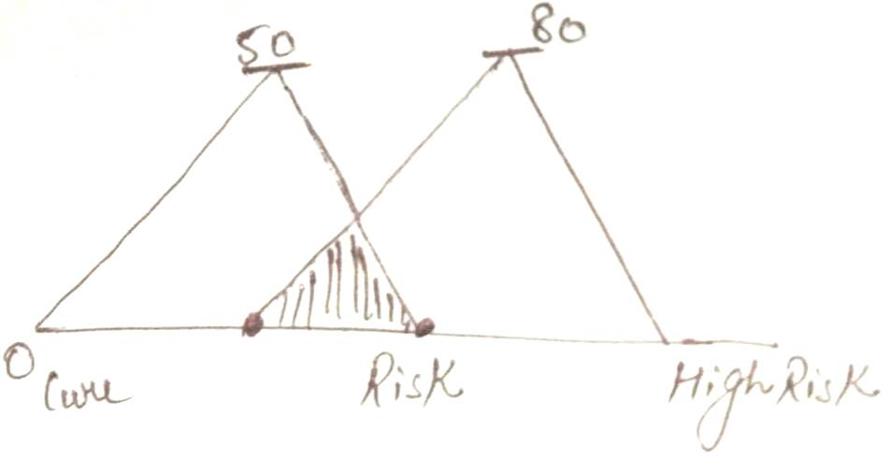
Fig.7 Risk Factor in Distance Evaluation
Euclidian distance in terms of 2D and in 3D includes face model and distance evaluation using X-Y and X-Y-Z axis respectively. During evaluation classifier has been used for further outcomes at great accuracy. Proposed method worked on 3D imaging to evaluate the severity of facial paralysis. It has been notified that if difference in distance is 50-80mm using Euclidian distance evaluation then uncertainty has been detected which reduces the accuracy. But to improve the accuracy of proposed method fuzzy logic has been implemented.
If the difference is 0-50mm then patient can be cured , if difference is 80-100mm then the patient cannot be cured completely but somehow recovery has been notified. Whereas between 50-80mm difference in distance leads to the result as “Patient may or may not be cured”. Fig.7 clearly defines the risk factor after evaluation of distance in Euclidian distance evaluation in 3D.
The shaded portion is the value at which facial paralysis evaluation results in risk factor. That shaded portion includes further evaluation using fuzzy set of rules to minimize the risk factor and to get more precise result. Questionnaire has been further investigated to follow-up the progress rate of facial paralysis patients. Additional in same in terms of medical science Electromyography (EMG) has been used to evaluate the severity of facial paralysis but not the recovery rate of facial paralysis patient.

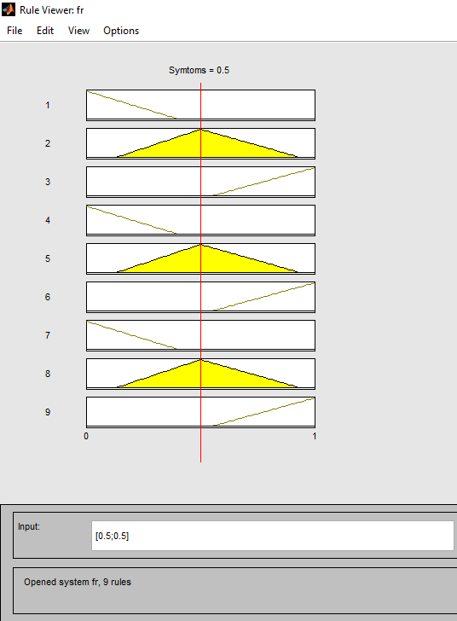
Fig.6 Fuzzy rules for facial paralysis
In MAMDANI Model total set of fuzzy rules has been implemented for more accurate result which clearly detects the chances to get recover from facial paralysis.
The proposed model is based on the distance evaluation and the questionnaire which has been evaluated at PGIMS Rohtak after taking the consent of facial paralysis patients.
Total of 47 patients examined under questionnaire and in total of 82 patients evaluated using distance evaluation in 3D imaging.
MAMDANI Model is the first system used to control the uncertainty in any perspective during evaluation. It results in 2 aspects whether value is 0 or 1. When there is no progress rate found then it results in 0 values and if some progress rate has been noted then model results to value1. For facial paralysis patient after questionnaire, progress rate has been followed in different aspects as per the level of facial paralysis.
MAMDANI Fuzzy inference model help to Analyse the evaluation more precisely and quickly. With the help of fuzzy set of rules in different conditions it results in more accurate value.
MAMDANI Model includes 4 basic steps:
- Fuzzification: In includes the dataset and rules information for input variables.

- Rule Evaluation: All the fuzzy rules which has been applied during analysis must be stored and evaluated in this category of MAMDANI Model.

- Aggregation: This category of MAMDANI Model includes the condition implemented in fuzzy set of rules.

- Defuzzification: Defuzzification is the final step to evaluate all the fuzzy rules. Defuzzification is also defines as the aggregate output fuzzy sets in a single number.
Table.1 Follow-up for analyzing facial paralysis
Current state | After 7 days | After 30 days | Progress Rate
L | L | L | 0
L | M | M | 0
L | H | M | 1
L | H | H | 1
L | M | H | 1

Here L,M and H is represented as below:
L= Low progress
M= Moderate progress
H= High progress rate
These 3 perspectives is basically the comparison of distance evaluation in MATLAB and the progress rate to reach high accuracy. The proposed method clearly detects the exact progress rate of facial paralysis. One of the major advantage of proposed method is there is no use of facial paralysis for evaluating the level of facial paralysis and the exact progress rate which also help in detection of recovery rate of facial paralysis patient.
As the progress rate has been divided into 3 sections hence in total of 9 set of fuzzy rules has been developed from a single questionnaire. Same has been implemented on all the patients after their consent for evaluation at PGIMS Rohtak.
Fig.7 Progress Rate in 3D
Progress rate is divided into 3 categories i.e. 0-25%, 25-50%, 50-75% and greater than 75%. Fig.7 indicates that Progress rate is directly proportional to the recovery of patient from facial paralysis. If the progress rate is low then there will be fewer chances for recovery. In case of facial paralysis, medical science is lagging in such field to analyze the recovery rate of paralysis. Progress rate has been evaluated manually as well as physically to select the progress rate.
Out of 3 different range of progress depending upon the progress rate proposed method results in the Chances to get cured from facial paralysis in terms of percentage.

Table.1 Comparison between various techniques used for face recognition and their outcomes.
S.No. | Work | Methodology Used | Outcomes
1 | Issam Dagher et.al. Vol.7, Issue:1, 2014 [2] | - K-means clustering algorithm. | Using SIFT most representative images is presented in terms of face recognition.
2 | Aruni RoyChowdhury , Published in March 2016 [3] | - Open set identification which is also referred as 1:N identification | B-CNN makes a sensible starting point for a huge variety of experiments.
3 | Avenir K.Troitsky, Vol.11 No.6,2016.[4] | - “Weight” to eye and Bridge to nose point. | Computation time is decreased by assigning some “weight” value for each position.  High probability of face detection.
4 | Byoung Chul Ko, January 2018. [5] | - Facial action coding system.  - Facial action unit. | It can be used as a dictionary to new researchers in FER.
5 | Narayan T. Deshpande, Vol.10,No.5 , 2017.[6] | - Voila-Jones algorithm.  - Haar- features in Viola-Jones.  - Face Tagging. | Better accuracy in face recognition with the proposed method.
6 | Manjunatha Hiremath, Vol.12,No.1, January 2018 [7] | - PCA,LDA.  - Elastic bunch graph matching. | Overview of different face recognition approaches.
7 | Xiangyi Kong,et.al., 2018.[8] | - Convolution neural networks.  - Machine learning.  - K-N ear Neighbors. | Artificial Intelligence can automatically detect acromegaly with high sensitivity and specificity at early detection.
8 | Hwai-Jung Hsu,et.al. [9] | - True positive rate.  - False positive rate.  - Haar face recognition. | Face recognition technologies are able to perform adequately on drones.
9 | Raunak Dave,et.al., March 2018.[10] | - Local region principal component analysis (LRPCA).  - SVM , Cohort Linear Discriminant analysis (Cohort LDA) | It’s the survey of face recognition.
10 | Sudha Narang , Vol.8, No.2, Frb.2018.[11] | - Viola-Jones Algorithm.  - Fisher face  - Local Binary histogram algorithm. | Tradeoff exists between correct recognition rate and threshold value.
11 | STM Siregar , et.al., 2018.[12] | - PCA  - Face recognition eigen face method. | Pre-processing phase must be done to get similar image source.
12 | Claire L .Witham, July 2017,Elsevier.[13] | - Local binary pattern  - Local discriminant classification algorithm | Possibility to identify individual macaques by their faces in videos.
13 | Suparna Biswas, et.al., 2017.[14] | - Contourlet transformation  - Curvelet transformation. | Experimental analysis demonstrate good performance of proposed method on data set ORL, JAFFE and FERET which are available publically.
14 | Pratibha Sukhija, ett.al., (CMS2016),Science direct.[15] | - PCA  - LDA | Face recognition rate is better in proposed model.

CONCLUSION:
In this paper, Scale Invariant Feature Transform gave the best recognition result [2]. 3D imaging has been used to upgrade the accuracy because 2D based analysis has difficulty handling large variation in pose and subtle facial behavior [5]. As far as the accuracy in different techniques of face recognition is concern the performance and accuracy of Viola-Jones algorithm, Artificial Neural Network and PCA together is better as compared with other face recognition techniques. Various types of challenges in face recognition can be solved using different algorithm and datasets of face expressions and face detection. Commonly used PCA technique for face recognition but when compared to LDA , LDA consumes less time as compared to PCA. Face recognition has been used in attendance system to make results more precise and accurate. Using face recognition no duplicity has been observed which further help to reduce the error up to its maximum extent. 2D face recognition requires facial expressions whereas in 3D face recognition facial expression is not mandatory. One can evaluate the identity of person without using its respective facial expression in 3D. Lightning variation and pose variation whereas in 3D imaging outcomes may vary with respect to lightning variation and pose variation.
Pose variation and lightning has no effect on the outcomes of 3D imaging. Hence 3D imaging has been used for evaluation of facial paralysis. To remove uncertainty up to great extent fuzzy logic sets has been used for minimizing the risk factor. MAMDANI model has been used on risk factor. Euclidian distance in terms of 3D has been used. Questionnaire has been used for followup of the facial paralysis patient. Total of 47 patients examined under questionnaire and in total of 82 patients evaluated using distance evaluation in 3D imaging at different Civil Hospital in Haryana.

REFRENCES: .

- An efficient hybrid face recognition algorithm using PCA and GABOR wavelets” Hyunjong Cho et.al. , “International Journal of advanced Robotics systems” 2014

- Face recognition using the most representative SIFT Images” Issam Dagher et.al. “International Journal of Signal processing, image processing and pattern recognition” Vol.7, Issue:1, 2014

- One to many face recognition with Bi-linear CNNs” Aruni RoyChowdhury “IEEE Conference on application of computer Vision” Published in March 2016

- Two-level multiple face detection algorithm based on Local feature Search and structure recognition methods” Avenir K.Troitsky, “International journal of applied engineering research, Vol.11 No.6, 2016.

- A brief review of facial emotion recognition based on visual information” Byoung Chul Ko, “ Sensors” January 2018.

- Face detection and recognition using Viola-Jones algorithm and fusion of PCA and ANN” Narayan T. Deshpande,“ Advances in Computational sciences and technology” Vol.10,No.5 , 2017

- Current trends on face recognition methods in face biometrics” Manjunatha Hiremath, “International journal of computer engineering and applications, Vol.12,No.1, January 2018

- Automatic detection of Acromegaly from facial photographs using machine learning methods” Xiangyi Kong,et.al., “EBioMedicine”, 2018.

- Face recognition on Drones: Issues and limitations” Hwai-Jung Hsu,et.al., “Institute of Information Science,Academic Sinica”.

- Face recognition techniques : A survey” Raunak Dave,et.al., March 2018.

- Comparison of face recognition algorithms using Opencv for attendance system” Sudha Narang, “International journal of scientific and research publication”, Vol.8, No.2, Frb.2018.

- Human face recognition using Eigen face in cloud computing environment” STM Siregar , et.al., “ 10th International conference Numerical analysis in engineering”, 2018.

- Automated face recognition of rhesus macaques” Claire L .Witham, “ Journal of neuroscience method”, July 2017,Elsevier.

- An efficient face recognition method using contourlet and curvelet transform” Suparna Biswas, et.al., “Journal of king saud University-Computer and information science”, 2017.

- Face recognition system using genetic algorithm” Pratibha Sukhija, ett.al., “Inetrnation conference on computational modelling and security (CMS2016),Science direct.

