 | International Journal of Applied Mathematical Research, 3 (xx) (2014) xxx-xxx
 | ©Science Publishing Corporation
 | www.sciencepubco.com/index.php/IJAMR

On Convergence and Error Analysis of the
Parametric Iteration Method
S. A. Saeed Alavi*, Aghileh Heydari
Department of Mathematics, Faculty of Basic Sciences, Payam-e-Noor University of Tehran, Tehran, Iran.
*Corresponding author E-mail: alavisaeid.pmu@gmail.com

Abstract

Parametric iteration method falls under the category of the analytic approximate methods for solving various kinds of nonlinear differential equations. Its convergence only for some special problems has been proved. However in this paper, an analysis of error is presented, then due to it, the convergence of method for general problems is proved. To assess the performance of the claimed error bound and also the convergence of the method, numerical experiments are presented performed in MATLAB 2012b.

Keywords: He’s variational iteration method, parametric iteration method, convergence, error bound.
- Introduction
Parametric iteration method (PIM) is an analytic approximate method for solving linear and nonlinear problems proposed in [1]. At beginning it was proposed for solving nonlinear fractional differential equations by modifying He’s variational iteration method (VIM) [2]. The PIM enjoys some augmented factors which made it more completed than the VIM. In fact by adjusting these factors one can establish more accurate approximations in comparison with the VIM.
During recent decade, many researchers have been worked on the VIM for solving various kinds of problems which mentioning them is out of the scope of this paper. Besides, some authors have been centered on the convergence of the VIM for some specific problems, like for multi-order fractional DE’s [3], multi-delay DE’s [4], ODE’s [5], systems of ODE’s [6] and etc. Herein, the work of Odibat [7] is more interesting and different because of its generality. In fact, he concluded the convergence of the VIM by introducing a semi-contraction operator and completed the proof like the proof of the Banach’s fixed point theorem.
On the other hand, the PIM was utilized for solving various kind of differential equations like Abel equation [8], nonlinear chaotic Genesio system [9], boundary value problems [10], linear optimal control problems [11] and etc. Convergence theorem for some particular cases was discussed in some of these literature (e.g. [8,9]), but what is still missing is a proof of the convergence of the PIM for a general differential equation. Also, from the both theoretical and practical viewpoint, another necessary talk is a complete discussion about the error bound of the approximations. Therefore, the goal of this article is to establish an error term and then presenting a general proof of the convergence of the PIM.
- Parametric Iteration Method (PIM)
To explain the basic ideas of the PIM consider the following differential equation:
Where is a nonlinear operator, denotes the time, and is an unknown variable. First consider (1) as below:
where and denote linear and nonlinear differential operator of the unknown respectively, and is the source term. We then construct a family of iterative formulas as:
where and denote the so-called auxiliary parameter and auxiliary function respectively. Accordingly, the successive approximations will be readily obtained by choosing the zeroth component . (For more details about PIM see [1]).
- Error Analysis
Consider the following nonlinear problem
where and are defined as:
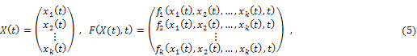

where and are continuous real functions on . In we use the infinity norm i.e. for vector we have and for everywe use the maximum norm as. Also the norm of vector functions like is:
In order to use the PIM, we rewrite (7) as
where is an auxiliary linear operator and is the nonlinear operator. Then the constructed iteration formula by PIM will be defined by:
Taking and choosing the initial approximation in the above sequence, clearly we can say that . So the following lemma will be obtained.
Lemma 3.1: For every and for every
Now the iteration formula (8) can be written as
Let’s denote n^{th} approximation by and then the convergence of is due to the norm
Before presenting the main theorem, we restate the Lipschitz condition for the vector function . Suppose that for every the component of function , there exist a positive real constant such that for every and for every and the following condition satisfies:
In this situation, letting we can say that satisfies a Lipschitz condition with respect to the first argument with the Lipschitz constant L, i.e.

Theorem 3.2: Assume that is continuous on where and satisfies a Lipschitz condition on with respect to the first argument with the Lipschitz constant L. Also suppose that is bounded onto a positive real number. Then for two arbitrary successive approximations we have
Proof: If we denote the approximate solution obtained by the first iteration with and , according to (10) and noticing that where and we can write
Now, let in (10), using the notation, we have

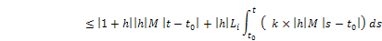
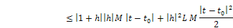
We rearrange the final statement as bellow
And similarly
In summary, this argument will lead to the following general form
On the other hand, due to the defined norm by (6) we know that
The right hand side of (18) is independent from vector index . So taking maximum on both side of (18) for all completes the proof. ■
Now we want to prove that if we choose such that then the right hand side of (14) vanishes when n tends to infinity. First we prove an auxiliary lemma.
Lemma 3.3: Assume that then for every where we have
Proof: For a fixed we have 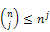 . So
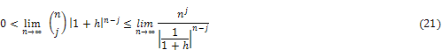
Also for every real number and we know that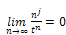. Therefore noticing to the assumption and taking 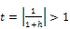 will complete the proof. ■

Theorem 3.4: Due to the last assumption for every there exist an such that for every we have
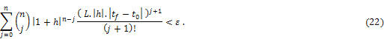
Proof: Let 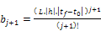 and 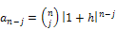. Therefore the sum in (22) can be written as
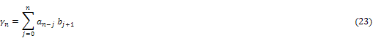
or
Noticing to the expansion of the exponential function and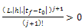 for all, the series is absolutely convergent and we name its sum. Clearly, the limit of is zero. Also, by lemma 2 we know that. So, for every given there exist an such that for every we have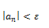. In this case we can write
In the last inequality absolutely convergence of is used. On the other hand, as tends to infinity. So if we keep fixed and let then we have
Since the was arbitrary, the proof is complete. ■
Theorem 1 and 2 indicate that for sufficiently large, two successive terms of the sequence for every arbitrary satisfy the following relation
Using this, one can easily show that is a Cauchy sequence in. Therefor it is convergent in the complete space. So we have:

Corollary 3.5: Due to the last assumptions, the sequence (10) constructed by the PIM is convergent.
Corollary 3.6: The valid region of the convergence-control parameter is .
- Numerical experiments
To demonstrate the efficiency of the error bound defined by (14) we consider the following two dimensional test problem.
where the time domain is and the exact solutions from [12] are:
In view of (4) and (5) we have:
is linear and obviously, it satisfies a Lipschitz condition by Lipschitz constant . Choosing, theis bounded by and using the notation for the error bound described in (14) we have:
Furthermore the norm of direct difference of two successive approximations and appeared in the left hand side of (14) is denoted by
Then for everyand for all the numerical results must confirm the relation to ensure that the theoretical result of the Theorem 1 is reliable.
Also in order to discuss the convergence of the PIM claimed in the Corollary 1, we denote the absolute error by and define it by
In Fig.1, we plot , and obtained by the PIM with and . Other different values of and is discussed in Fig.2 and Table 1.
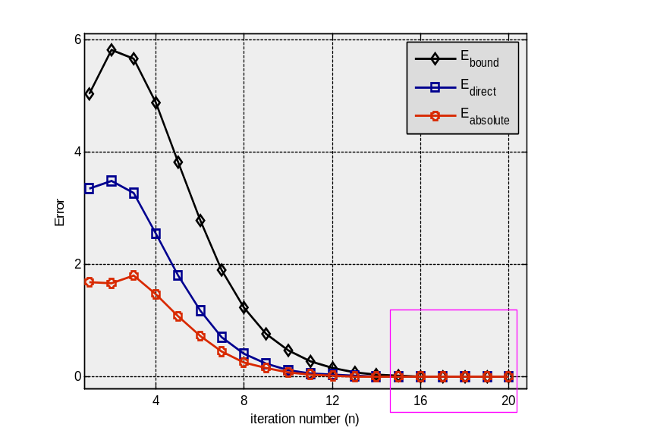
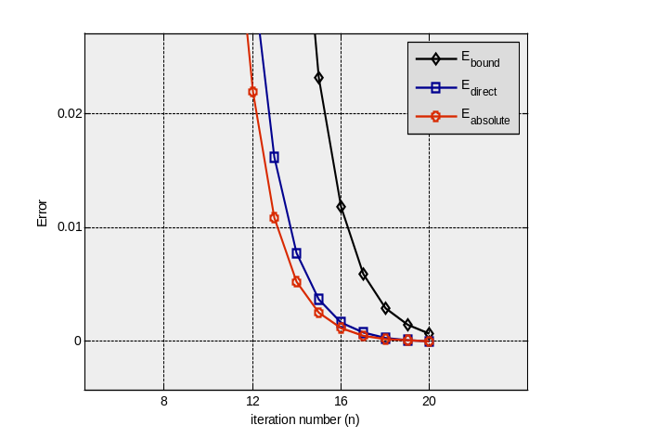
Fig.1: Plot of error due to the iteration number

Analysis of the Fig.1:
Error bound: As could be seen from the plot of , the estimated error bound is really an upper bound for which confirms the inequality (14). This is true for every iteration as zoomed out part shows. Plot of also shows that by increasing the error bound vanishes which is a confirmation of theorem 2.
Cauchy sequence: The plot of shows that when grows. This means that for every and for sufficiently large, which confirms (27). The latter can be used to conclude the sequence is a Cauchy sequence.
Convergence: The plot of shows that for sufficiently large the absolute error tend to zero i.e. and this means the convergence of the PIM.
In Fig.2, we plot and for the solutions of the PIM by various and . As could be seen the error bound confirms what is claimed in theorem 1 and 2.
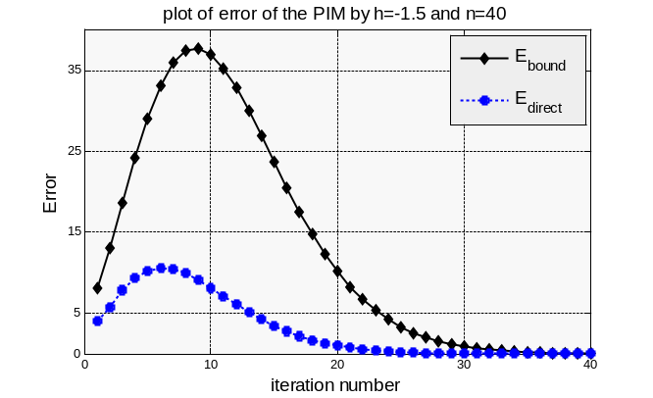
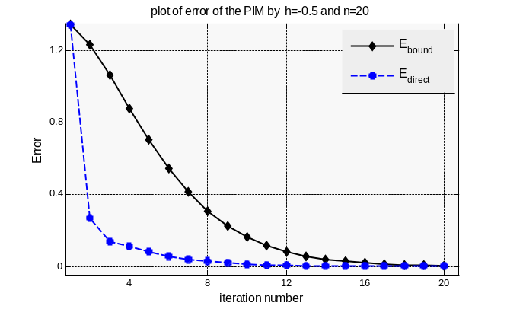
Fig.2: Test of error bound. Left:
; Right:

Although Fig.1 and Fig.2 provide us a good information of error bound, but what is doesn’t show is a specific data for the convergence rate. So to clear the convergence rate we report the final values of and for and in Table 1 .

Table 1: Test of error bound for various and
0.0011

Table 1 shows that for the convergence is excellent but for we need many iterations to conclude the convergence. For, although seems to be appropriate for vanishing but bigness of in the same formula (32) makes very big. On the other hand, for, similarly but is not very big in opposite of the case, consequently the convergence is faster. From this viewpoint, seems to be the best choice since, however there exist many counterexamples in nonlinear problems showing that some values other than can give better approximations. Such an argument leads to a known problem that is to say finding optimal value of accelerating parameter which in general is an open problem in this field. By the results of this paper a proposal is minimizing the error term as a function of the parameter as a variable which is left to the further works.
- Conclusion
In this paper, a convergence analysis of the PIM is presented. This is performed by establishing a novel error bound and showing this error bound tends to zero. Also an interesting result has been concluded for the auxiliary parameter h. Although finding optimal h in general is an open problem, but we hope that the results of this paper be a promising tools for researchers. Our proposal is to find optimal h by minimizing the presented error term as a function of , which is left to the further works.
References
[1] A. Ghorbani, “Toward a New Analytical Method for Solving Nonlinear Fractional Differential Equations”, Comput. Meth. Appl. Mech. Engrg. Vol.197, (2008), pp: 4173-4179.
[2] J. H. He, “Variational iteration method – a kind of non–linear analytical technique: some examples”, Int. J. Non–Linear Mech. Vol.34, (1999), pp:699-708.
[3] S. Yang, A. Xiao, H. Sua, “Convergence of the variational iteration method for solving multi-order fractional differential equations”, Computers and Mathematics with Applications, Vol.60, (2010), pp:2871–2879.
[4] S. Yang, A. Xiao, “convergence of variational iteration method for solving multi-delay differential equations”, computers & mathematics with applications, Vol.61, No.8, (2011), pp:2148-2151.
[5] E. Yusufoğlu, “Two convergence theorems of variational iteration method for ordinary differential equations”, Appl. Math. Lett. (2011), http://dx.doi.org/10.1016/j.aml.2011.02.005
[6] D. Khojasteh,”convergence of variational iteration method for solving linear systems of ODE’s with constant coefficients”, computers & mathematics with applications, Vol.56, No.8,(2008),pp: 2027-2033.
[7] Z. M. Odibat, “A study on the convergence of variational iteration method,” Mathematical and Computer Modelling Vol.51, (2010), pp: 1181_1192.
[8] J. ‎Saberi-Nadjafi‎, ‎A‎. ‎Ghorbani‎, “Piecewise-truncated parametric iteration method‎: ‎a promising‎ analytical method for solving Abel differential equations"‎, ‎Z‎. ‎Naturforsch‎. Vol.‎65a, (2010), pp: 529-539‎.
[9] A. Ghorbani and J. Saberi-Nadjafi, “A Piecewise-Spectral Parametric Iteration Method for Solving the Nonlinear Chaotic Genesio System”, Mathematical and Computer Modeling, Vol.54, (2011), pp: 131-139.
[10] A. Ghorbani, M. Gachpazan, J. Saberi-Nadjafi, “A modified parametric iteration method for solving nonlinear second order BVPs”, Comput. Appl. Math. Vol.30, No.3, (2011), pp: 499-515.
[11] A. S. Alavi, A. Heydari, “Parametric Iteration Method for Solving Linear Optimal Control Problems”, Applied Mathematics, Vol.3, (2012), pp: 1059-1064. http://dx.doi.org/10.4236/am.2012.39155.
[12] C. K. Chui and G. Chen, “Linear Systems and Optimal Control”, Springer-Verlag, Berlin, Heidelberg, (1989), pp: 76-80

