PRE-OPERATIVE VIEW
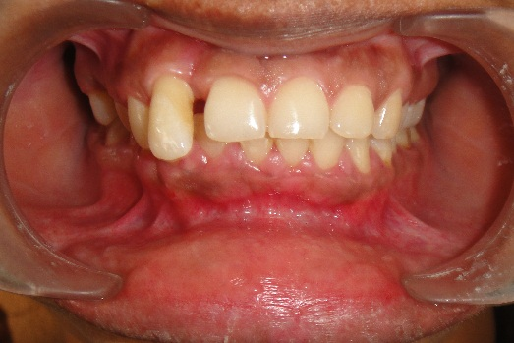

FIGURE 1 – Before phase I

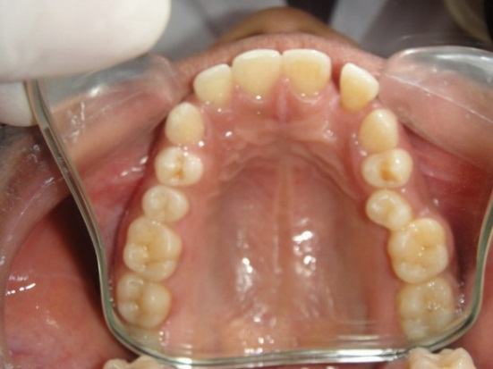
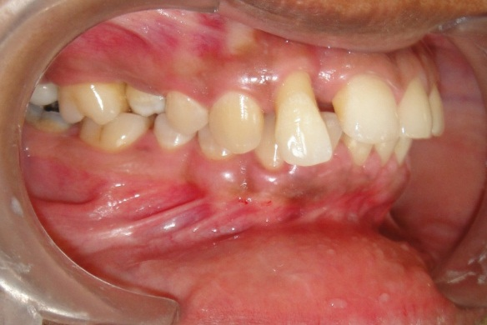

FIGURE 3 – Cross bite wrt 15
FIGURE 2 – Extruded 12 and loss of contact b/n 11 and 12

PERIODONTAL FLAP SURGERY
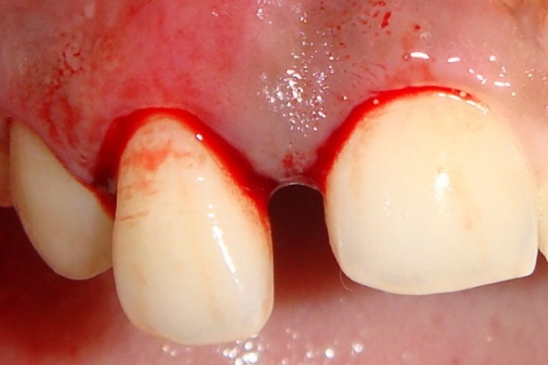
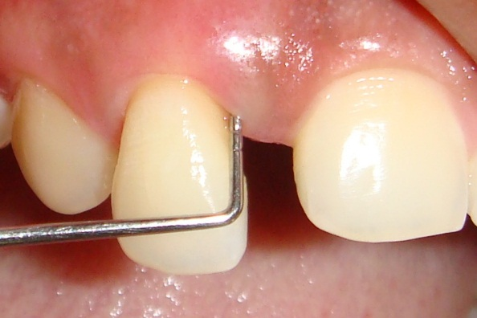

FIGURE 5 – Crevicular incisions given
FIGURE 4 – Probing pocket depth wrt 12 is 8 mm

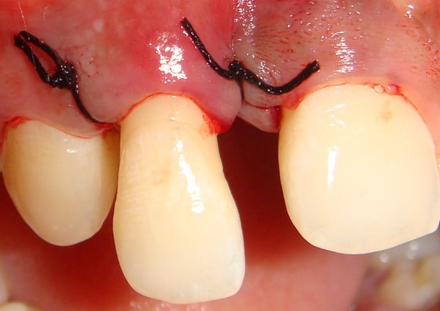
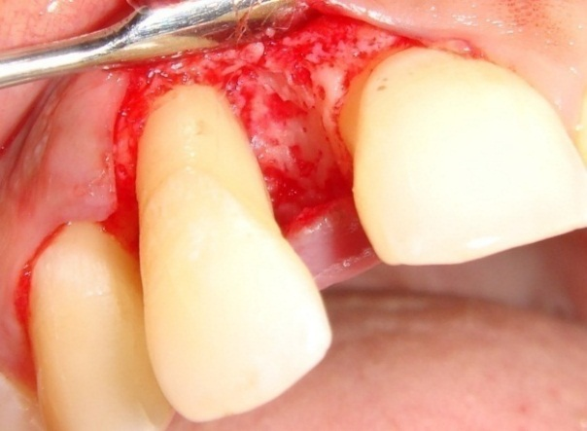

FIGURE 7 – Sutures placed
FIGURE 6 – Full thickness mucoperiosteal flap reflected

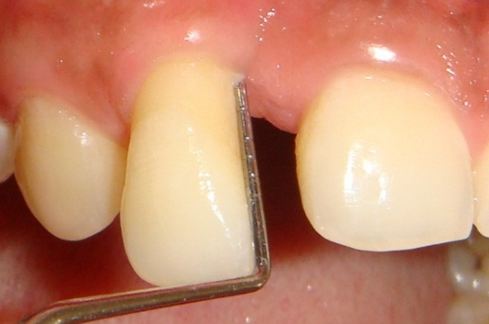

FIGURE 8 – Probing pocket depth reduced to 4 mm 6 months after flap surgery,
ORTHODONTIC THERAPY

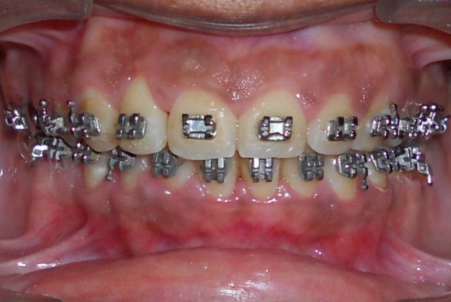
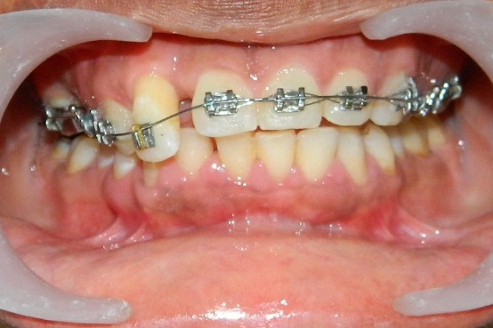

FIGURE 9 – Levelling and alignment of upper teeth
FIGURE 10 – space closure

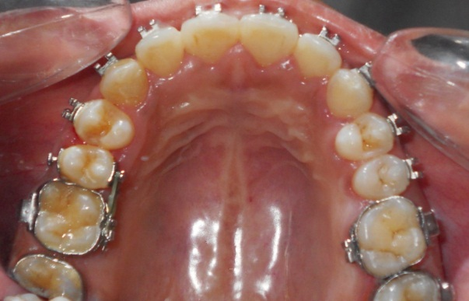

FIGURE 11 – Correction of cross bite wrt 15

COMPLETION OF TREATMENT

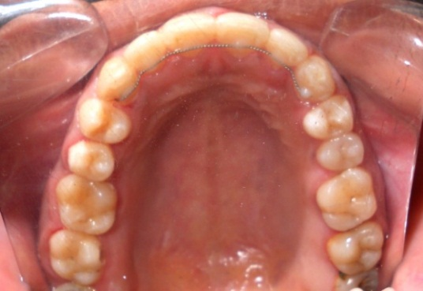
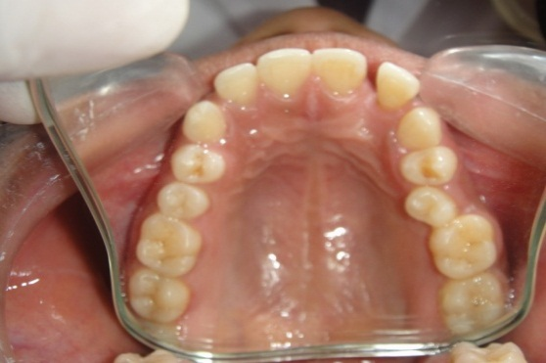
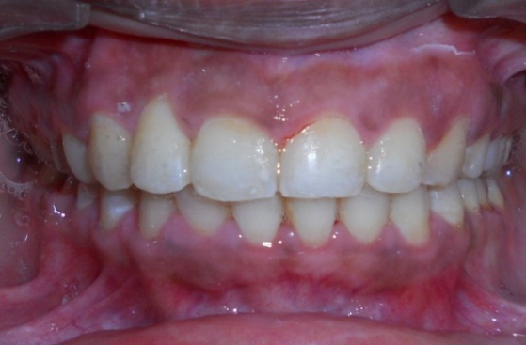
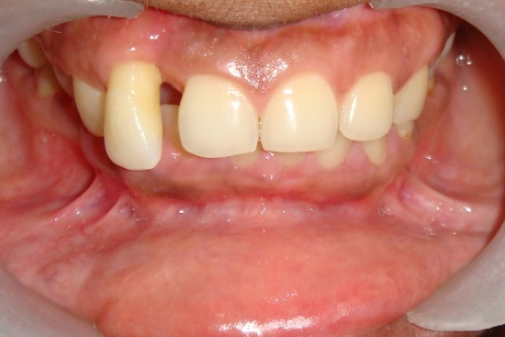
FIGURE 13 – Cross bite wrt 15 corrected and fixed lingual retainer placed
FIGURE 12 – Extruded 12 is intruded, aligned and space is closed b/n 12 and 11

