Title page

1. Title of manuscript:
PEDIATRIC ALLERGY: A COMMON OCCURRENCE WITH MULTIFARIOUS IMPLICATIONS

Author’s Name:
Name Email – ID
1. Dr. Maya U Shinde mayashinde0404@gmail.com
2. Dr. Shweta M Chaudhary drdentist@rediffmail.com
3. Dr. Smita S Patil sheetalsmita4@gmail.com
4. Dr. Chetana M Jagtap jagtapchetana4@gmail.com
5. Dr. Sanket S Kunte drsanketkunte@gmail.com
6. Dr. Alok R Patel pedodentcare@rediffmail.com

Department(s) and institution(s)
- Postgraduate student, Department of Paediatric and Preventive Dentistry, Bharati Vidyapeeth (Deemed To Be University) Dental College and Hospital, Pune, Maharasthtra, India.
- Associate Professor, Department of Paediatric and Preventive Dentistry Bharati Vidyapeeth (Deemed To Be University) Dental College and Hospital, Pune, Maharasthtra, India.
- Assistant Professor, Department of Paediatric and Preventive Dentistry, Bharati Vidyapeeth (Deemed To Be University) Dental College and Hospital, Pune, Maharasthtra, India.
- Assistant Professor, Department of Paediatric and Preventive Dentistry, Bharati Vidyapeeth (Deemed To Be University) Dental College and Hospital, Pune, Maharasthtra, India.
- Professor, Department of Paediatric and Preventive Dentistry, Bharati Vidyapeeth (Deemed To Be University) Dental College and Hospital, Pune, Maharasthtra, India.
- Head Of The Department, Department of Paediatric and Preventive Dentistry, Bharati Vidyapeeth (Deemed To Be University) Dental College and Hospital, Pune, Maharasthtra, India.

4. The name, address and e-mail address of the author responsible for correspondence about the manuscript:
Name: Dr. Maya Shinde
E-mail – mayashinde0404@gmail.com
Address: Flat no.1, sn 33/3b Sahakari Gruh Rachana Sanstha, near Shani Maruti temple, Trimurti chowk, Katraj, Pune 411046 Maharashtra, India
Phone numbers: 7972903433
5. Running title:
PEDIATRIC ALLERGY IN DENTISTRY
6. Scientific field of dental science: Pediatric and Preventive Dentistry
7. Article type: Review article
10. Declarations of interest: none
11. This research did not receive any specific grant from funding agencies in the public, commercial, or not-for-profit sectors.

Abstract
Paediatric professionals treat the nature’s most benevolent creation i.e. child.

It is important to focus not only on the oral health but also on the overall health of pediatric patient because oral health is an integral part of total development.

There are various dental materials ranging from diagnosis to rehabilitation for the management of oral diseases are not devoid of posing a potential risk of inducing allergic reactions to the Paediatric patients in dental setting.

Most importantly, a dental practitioner must be trained in medical emergencies and be capable of resuscitating a patient. Not only the dentist but also the assistants present in the clinic should be trained how to manage any allergic emergency conditions in child in dental settings.

As some of these diseases have higher rates of morbidity and mortality, management of such conditions requires a multidisciplinary medical team approach consisting of physicians, dermatologists, Paediatric dentists, and ophthalmologists.

So, this review involves an in-detail information regarding what is allergy, history of allergy, allergic and immunological responses of oral mucosa, dental materials prone for allergies, its diagnosis and treatment modalities in child hoping that it will be helpful to every practicing Pediatric professionals.
9. Keywords: Allergy, Children, Dental materials, Dental practitioner, Pediatric

MAIN TEXT
1.Introduction:
Allergy is described as altered bodily reactivity to an antigen in response to first exposure - Merriam Webster.
The prevalence of allergic diseases worldwide is rising in both developed and developing countries. These diseases comprises asthma; rhinitis; anaphylaxis; drug, food, and insect allergy; eczema; and urticaria (hives) and angioedema. This increase is devastating for children, who are bearing a major brunt of the rising trend which has occurred over the last couple of decades.
Over the last few years, due to the rise in number of patients with allergies from different materials, the practicing pediatric dentists should have knowledge about documented allergies to known materials and thus circumvent such allergic manifestations in the dental clinic.
2. History:
The concept of "Allergy" was originally introduced by the Viennese pediatrician Clemens von Pirquet in 1906. “Allergy” derived from the Ancient Greek word allos meaning (other, different, and strange) + ergon (activity, to do).
In 1911, Von Pirquet wrote his final written piece on allergy which was a monograph emphasizing his theory.
Paradoxically, in 1913 when Richet received the Nobel Prize for his work on anaphylaxis, the term ‘allergy’ started appearing in various scientific articles and attracted the attention of clinicians and scientists.
From the 1930s, a new medical subspecialty called allergology became established. Physicians and patients in the USA had already established hay fever clinics and associations in the late nineteenth century.⁵
A sure evidence of the triumph of the ‘allergy’ word was the creation in USA in 1929 of an important journal: the Journal of Allergy.⁵ Speciﬁcally in 1963, Philip Gell and Robin Coombs made a new and groundbreaking classiﬁcation of hypersensitivity diseases in their book Clinical aspects of immunology, which is still in use today with minor changes.
Allergy in 21st century
The extension of the idea of ‘allergy’ to the streets, which started in 1930s as we showed above, has reached vast proportions.⁵
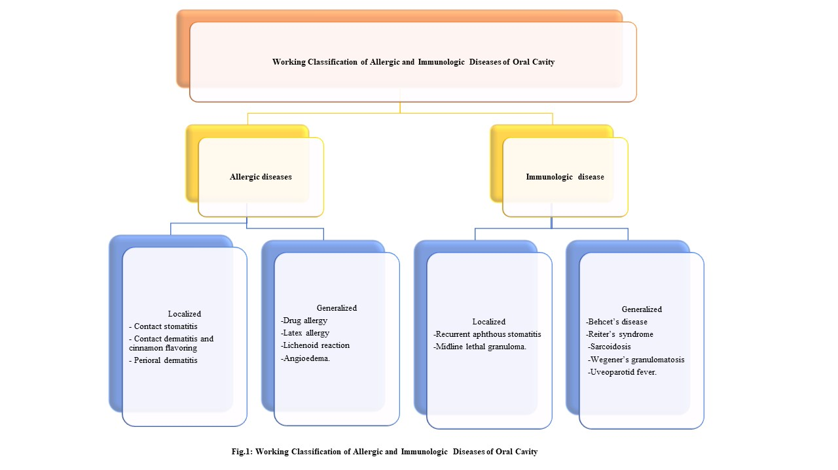
3. Working classification of allergic and immunologic diseases of oral cavity (Fig.1) ,,,

4. Latex allergy:
Natural latex is a derived product of the rubber tree, Hevia brasiliensis.
Allergic reactions may be a response to the NRL (Natural Rubber Latex) from which the glove is made or to other chemicals used in the manufacturing process.
Latex is considered to be an occupational allergen as it can cause occupational asthma in the people with the regular use of latex such as dental and medical professionals.
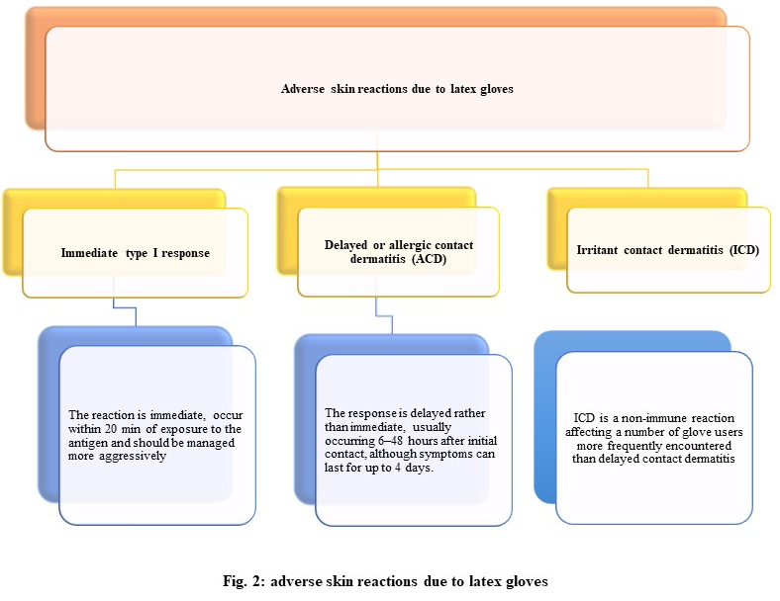
4.1 Adverse skin reactions due to latex gloves (Fig. 2)

4.2 Alternative products for patients with latex allergy:
Product Alternative
Latex gloves Vinyl/Nitrile/Silicone gloves
Rubber dams Non-latex(Polyvinyl-Chloride) dams
Latex bite blocks Metallic/Silicone mouth props
Rubber file stops Wax file stops
Injectable ampules (rubber plungers in syringe) Injectable vials
Orthodontic elastics used for oral fixation sterile wire to secure arch bars
Polishing cups Non-latex toothbrushes
Rubber mixing cups Silicone mixing cups
Penrose latex surgical drains Silicone/Polyvinyl-Chloride Surgical drains
Containers with rubber droppers Containers without rubber droppers
Patient with latex allergy should be immunologically tested for gutta-percha sensitivity also as gutta-percha is in the same botanical family as the rubber tree (Havea brasiliensis) as gutta percha is derived from the juice of the Taban tree (lsonandra percha).
4.3 Precautions: ¹⁵
- Detail history
- For emergency dental treatment, Use Nonlatex products.
- The ambient air in the dental clinic should have minimal level of powder contamination.
- Schedule the appointment at the beginning of the office workday when the level of powder contamination in the air is at a minimum.
- A thorough wipe down of office equipment before the patient's appointment.
- Patients with an extreme sensitivity to latex should consult with their physician regarding premedication with prednisone or Benadryl.
- Prepare to manage an allergic reaction, including use of epinephrine such as an EpiPen.

5. Allergy to eugenol:
Eugenol is an active, primary aromatic liquid responsible for various pharmacological activities. It is routinely used with zinc oxide as a primary tooth obturating material in Pediatric dentistry and in other form such as impression pastes, periodontal dressings, cements, filling materials, endodontic sealers, dry socket dressings, as well as used as flavouring agent in cosmetics and food items.,
5.1 Mechanism:
The setting reaction between zinc oxide and eugenol produces zinc eugenolate, which is highly unstable in the existence of water. The surface of this material undergoes hydrolysis, releasing free eugenol, which has been reported to induce type IV hypersensitivity reactions as well as generalized anaphylactic symptoms.
5.2 Clinical features:
According to Barkin, therapeutic action of eugenol on the pulp is cytotoxic and three reaction types may be observed which are:
  - Direct tissue damage
  - Contact dermatitis
  - True allergic reaction

5.3 Preventive measures
1. Avoid tissue contact and follow manufacturer’s instructions when eugenol containing ZOE cement is used.
2. Use other safer eugenol free temporary restorative cements
3. Refer the patient suspected of having an allergy to dental materials for allergy tests prior to dental treatment.

6. Allergy to metals:
In Pediatric dentistry nickel and chromium are the most important constituent in preformed metal crowns, space maintainers, brackets, fillings, as endodontic instruments and orthodontic appliances which has irreplaceable place. So, we must aware about its allergic consequences in child.
Most of the time, allergic reactions to metals are mainly type-IV reactions.
Nickel sensitivity has been reported in children treated with old generation SSCs with high (up to 72%) nickel content. Based on these ﬁndings, the new generation of SSC contains only 9%– 12% nickel.
In association with pediatric dentistry, Ni ions are released by stainless crowns, space maintainers, and orthodontic appliances in the course of time in patient saliva. This has been seen to rise after tooth brush abrasion and increase in the oral pH.

6.1 Clinical features of Nickel allergy:
6.1.1 Intraoral:
- Stomatitis from mild to severe erythema
- Papula-perioral rash, lichen planus
- Loss of taste or metallic taste
- Burning sensation
- Soreness at the sides of the tongue
- Angular cheilitis
- Severe gingivitis in the absence of plaque
6.1.2 Extraoral:
- Generalized urticarial
- Widespread eczema
- Flare-up of allergic dermatitis
- Exacerbation of preexisting eczema
6.2 Chromate
Chromium differs from nickel, in that it is not antigenic in metal form, but usually only in the hexavaletit salt form as chromate. Minute quantities of chromium salts can, however, sensitize. Chromium compounds.
6.3 Treatment:
Alternatives to Nickel-Titanium Wires (TSME) proposed by C. Maspero et al in 2018.
If a diagnosis of nickel hypersensitivity is established, the nickel titanium arch-wire should be removed and replaced.
Alternatives include:
1. Twist flex stainless steel
2. Fiber reinforced composite arch-wires
3. Wires such as TMA, pure titanium, and goldplated wires may also be used safely.
4. Altered nickel-titanium arch-wires also exist and include plastic/resin coated nickel-titanium archwires.
5. Ion-implanted nickel-titanium arch wires have their surface bombarded with nitrogen ions, which forms an amorphous surface layer, conferring corrosion resistance and displacing nickel atoms, and decreasing the risk of an allergic response.
6.3.1 Symptomatic treatments
Steroids: Topical steroids are very useful and represent the ﬁrst-line treatment.
Calcineurin inhibitors
Psoralen plus UV-A.
Disulﬁram
Binding agents and barrier creams:
- Ethylene diamine tetra-acetic acid (EDTA 15%)
- 5-chloro-7-iodoquinolin-8-ol (clioquinol).
However, it has been shown that some patients might beneﬁt from a nickel free or a low nickel diet and must be prescribed according to Veien’s guidelines.
6.4 Nickel hyposensitization:²⁵
Although “nickel vaccination” using oral hyposensitizing treatment is commercially accessible in some countries its potency is still to be deﬁnitively proven. Alitretinoin (9-cis retinoic acid): a promising new option in treatment of chronic, severe, and refractory hand dermatitis acting as anti-inﬂammatory and immunomodulator.
7. Drug allergy:
Drug allergy is one type of unpredictable ADR (adverse drug reaction) that encompasses a spectrum of immunologically-mediated hypersensitivity reactions with varying mechanisms and clinical presentations.
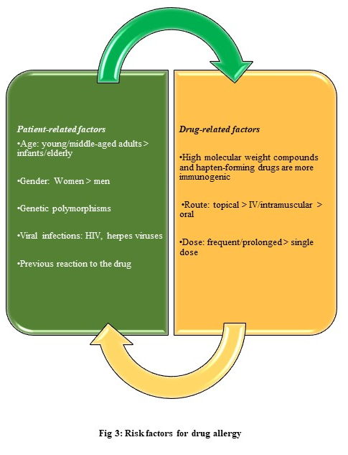
A considerable proportion of children develop rashes, urticaria, angio-oedema and respiratory symptoms while sick, frequently while taking antibiotics. Thus many children are diagnosed with ‘suspected antibiotic allergy’. This is understandable, since 51 (36.7%) of the anaphylactic deaths in the UK over a 6-year period were due to medication. Sixteen of these deaths resulted from antibiotics, including a 5-year-old child.
  - Risk factors for drug allergy: (Fig. 3)

Local anesthetics, analgesics, and antibiotics are the most common drug classes used in dental practice, and allergic or pseudo allergic reactions have been reported for each.
7.2 Signs of drug allergy:
7.2.1 Early reactions:
- Extensive pruritus
- Rhinoconjunctivitis, obstructive respiratory symptoms, nausea, vomiting
- Pruritus around the mouth, in the palms and soles
- Sudden erythema on the skin with conjunctivitis and rhinitis
7.2.2 Delayed reactions:
- Fever, malaise
- Long-term findings after discontinuation of the drug
- Lymphadenopathy
- Pain and burning in the skin
- Bullous lesions, epidermal separation (Nikolsky sign)
- Mucosal involvement
- Edema in the face and diffuse erythematous swelling
- Confluent lesions in extensive skin areas
- Eosinophilia (>1.5x109/L)
- Hepatic involvement
7.3 Diagnosis:
Drug provocation tests (dpts)
Skin testing in children‍
In vitro and/or ex vivo testing‍
Drug-specific tests‍
The basophil activation test
Lymphocyte transformation testing (LTT)
Enzyme-linked immune spot (ELISPOT) assays
Drug challenge. ‍
Drug desensitization.‍

7.4 Common drug allergies
7.4.1 Local Anesthetics:
Although the actual incidence of confirmed allergy to local anesthetics is extremely low (,1%), any claim must be given serious attention considering the staggering number of local anesthetic procedures we perform. Cutaneous reactions or airway compromise/obstruction should be regarded as potentially allergic in nature. For these cases, consultation of an allergist is essential.

      - Etiology of allergy to local anesthesia (Fig. 4)

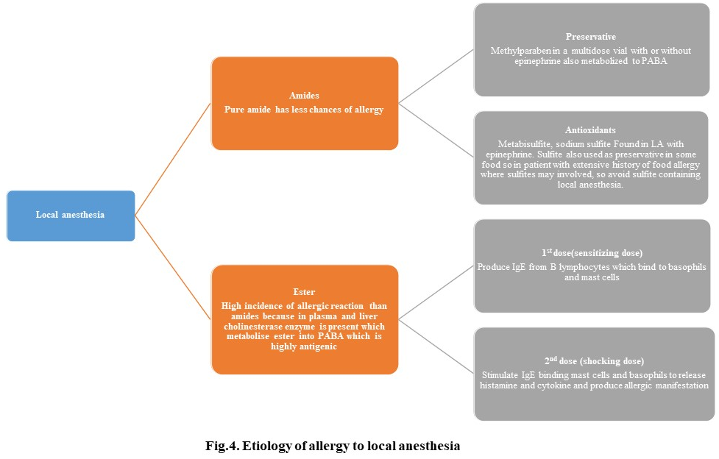

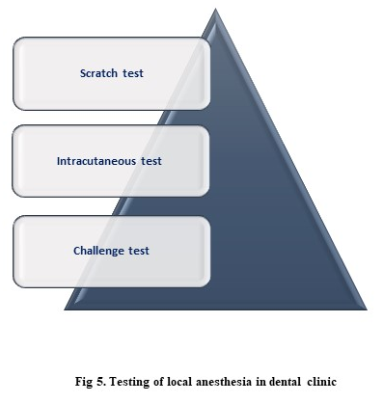
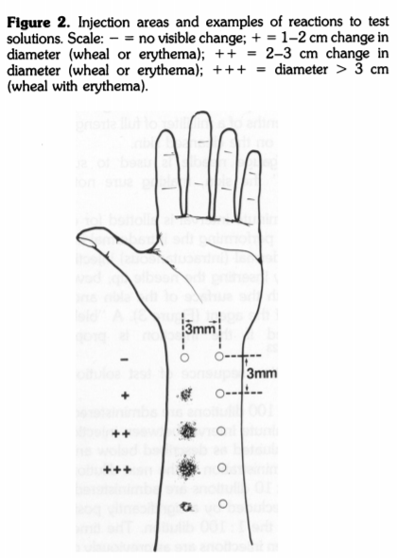
7.4.1.2 Testing of local anesthesia in dental clinic (fig. 5)

I. Scratch test:
Least sensitive and less reliable.
II. Intracutaneous test:
Primary mode of assessing a patient for local anesthetic allergy.
Most reliable.
Deposit 0.1 ml of test solution into extensor surface of the patient’s forearm that will produce wheal of a few mm in diameter if the patient is allergic. Redness, swelling, itching should be measured upto 15-20 minute.
III. Challenge test:
If the patient does not produce allergic reaction to intracutaneous test then take challenge and perform challenge test. 0.9 ml of local anesthesia that produces no intracutaneous reaction is injected intraorally via supraperiosteal infiltration atruamatically (but without topical anesthesia) above maxillary right or left premolar or anterior teeth.
Observe the injection site, general symptoms like rash/erythema, facial edema, bronchospasm, hypotension, gastrointestinal or neurovascular syndrome and vital signs for 30 minute.
This is called an intraoral challenge test and it frequently provokes the allergic reaction like fainting, sweating and palpitations. If there is no allergic manifestation found during challenge test then we should proceed for intraoral anesthetic block injections.

7.4.1.2 Managing history of local anaesthetic allergy: ³¹
Clarify nature of reaction
- Rule out other reactions :
Syncope: unconsciousness, brief seizures
Epinephrine: palpitations
Consider sedations, minimal or no epinephrine
- Pruritus or rash:
Non-IgE-mediated;cross-reaction unlikely
Use alternate agent without vasopressor to avoid preservatives
May consider allergist referral

- Urticaria or anaphylactoid:
Refer to allergist for lidocaine testing
Also provide mepivacaine or prilocaine plain
Request testing for bisulfites

  - 2 Nonsteroidal Anti-Inflammatory Drugs
Nausea and dyspepsia are the most common events labeled by patients as being allergic reactions to NSAIDs, but a significant number of patients may describe reactions that appear allergic in nature. True IgE-mediated reactions to aspirin and NSAIDs have been confirmed, but they are rare, and is more often a pseudo allergic mechanism.,
For patients giving the details of only a history of rash or pruritus, it is safe to select an alternative NSAID. For those reporting urticaria or respiratory symptoms, it is judicious to avoid all NSAIDs and prescribe acetaminophen, regardless of their underlying respiratory status. It should be mentioned that true IgE-mediated reactions to acetaminophen have also been reported, but there is no relation to reactions involving NSAIDs.
7.4.3 Opioids
Only 1 case of IgE-mediated reaction has been published in the literature, and this claimed cross-reaction among various opioids, including codeine. However, nearly all opioids are capable of producing pseudo allergic reactions by triggering degranulation of mast cells and the direct release of histamine.³²

7.4.4 Antibiotics
It is preferable to substitute an alternate penicillin or cephalosporin for a patient claiming penicillin allergy, provided the nature of the reaction was exclusively pruritic (itch) or a maculopapular rash. A history of urticaria (hives) or anaphylactoid symptoms are more persuasive evidence that the patient’s reaction to penicillin was truly IgE mediated, and in this case, there is little recourse but to abstain from prescribing any beta-lactam derivative.³¹
7.4.4.1 Managing history of penicillin allergy. ³¹
Clarify nature of reaction
- Hives or Anaphylactoid
IgE-mediated; cross reaction possible
Avoid all Beta Lactum

- Pruritus or rash
Non-IgE-mediated; cross-reaction unlikely
Use alternate penicillin or cephalosporin

- Dyspepsia,Nausea, Diarrhea
No issue
Avoid offending formulation

7.4.5 General anesthetics:
Although rare, anaphylaxis may occur in patients treating under general anesthesia. The investigation of severe reactions during general anesthesia is specially challenging given that the patient is often exposed to many co-administered drugs and agents. Reactions during the use of general anesthesia are often due to neuromuscular blocking agents and antibiotics. but have also been related with IV anesthetics (e.g., propofol, thiopentone, etomidate), NSAIDs, chlorhexidine, and latex allergy.
7.5 Prevention of future reactions:
The patient should be provided with detail written information about which drugs to avoid (including over-the-counter medications). Inscribed allergy bracelets/necklaces, such as those provided by MedicAlert®, should also be considered.²⁹

8. Rare allergic materials
8.1 Resin material composites:
The dental personnel or staff commonly complain of contact dermatitis and asthma caused by methacrylates. HEMA, EGDMA and TEGDMA are the constituents responsible for occupational contact allergies.
Even though resin-based restorative materials are considered safe, their constituents can leach out and responsible for allergic contact stomatitis.

8.2. Fissure sealant:
Hallstrom U (1993) reported an isolated case in which adverse reactions like asthma and urticaria were reported after fissure sealant placement and the symptoms disappeared after its removal suggesting allergy.
8.3. Mercury associated with amalgam restoration:
Delayed hypersensitivity reactions to amalgam restorations are seen as erythematous, pruritic lesions on the oral mucosa and skin of the face and neck. The usual presentation of these reactions are oral lichenoid lesions (OLL).
8.4. Titanium:
In Pediatric Dentistry, endodontic hand instruments, rotary instruments, orthodontic brackets, orthodontic wires contain titanium.
The first case of delayed hypersensitivity reaction to titanium in the form of local granulomatous reaction was described in patients having cardiac pacemakers. ,Titanium allergy has a low prevalence rate of 0.6% and presents with urticaria, eczema, redness of the mucosa.,
8.5. Alternate substitutes to titanium
Polyether ether ketone (PEEK) which offer mechanical properties and bone forming capacity similar to titanium are also under investigation.
Allergy to the materials in endodontics such as root canal sealers and obturating materials, Formaldehyde. {Munaco et al., (1978) and Pascon & Spangberg (1990)}, Ledermix paste , Pulpotec reaction and Impression materials were reported.
9.Diagnosis:
‘’LISTEN TO YOUR PATIENTS ……THE PATIENTS WILL GIVE YOU THE DIAGNOSIS’’ -Jeffry Okeson
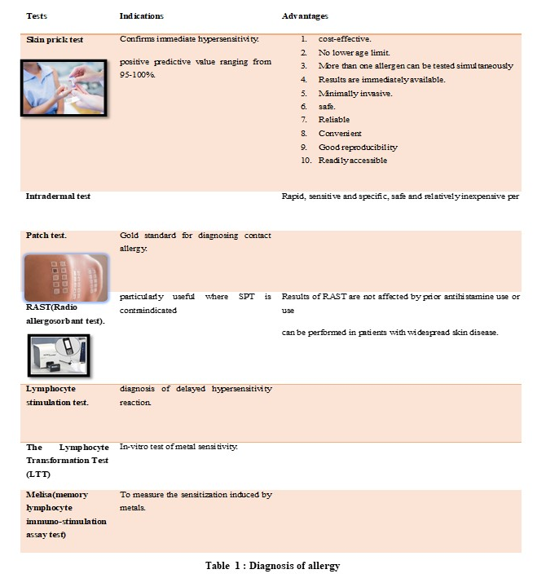
When a patient is suspected of allergy in dental clinic, a thorough history taking, clinical examination and confirmatory test should be performed.Prick test and scratch test are used to diagnose immediate hypersensitivity while patch test confirms delayed hypersensitivity.
9.1 Diagnosis of allergy (Table 1)

10. Management: (Fig. 6) (Fig.7)⁴⁷ (Table 2)⁴⁷

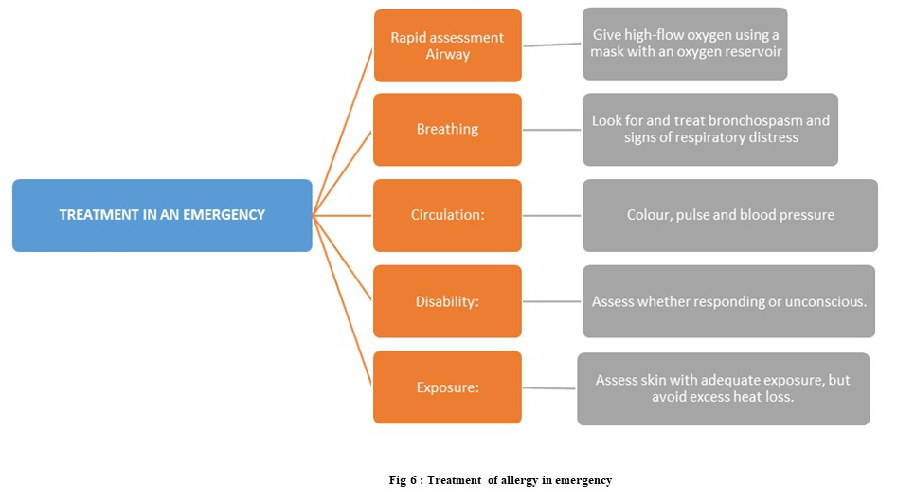

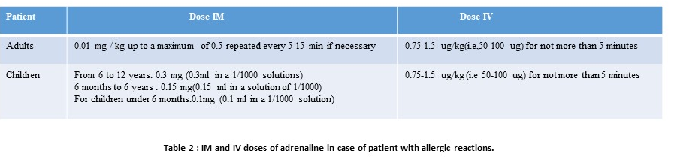

10.1 DISABILITY MANAGEMENT
If the child is conscious: Dentists should place them in a position where they are comfortable and able to breathe easily until the ambulance arrives. If they are feeling dizzy or giddy, they should be laid flat with their legs elevated, if acheivable.⁴⁶
If the child is unconscious: Dentists should place them in the recovery position (on their side, supported by one leg and one arm, with the head tilted back and the chin lifted). If the person’s stops breathing or heart stops beating, cardiopulmonary resuscitation (CPR) should be performed effectively.
10.2 MONITORING
Maintain the PaO2 as close to normal as possible (approximately 13 kPa or100 mm Hg).

10.3 Further investigation
Mast-cell tryptase as soon as possible after emergency treatment for anaphylaxis.

10.4 In the long-term follow-up ^{46,}
Refer to an allergist to try to identify the allergen to avoid in the future.
Organize autoinjetors (e.g., EpiPen).
Give a written self-management plan, in detail information about anaphylaxis and biphasic reactions, and details of the possible signs and symptoms of a severe allergic reaction.
Motivate the patient to wear a MedicAlert bracelet/necklace advised by doctor.

11 . Allergen immunotherapy:
An immune-modulatory method for the treatment of immunoglobulin E (IgE)-mediated allergic diseases to control the symptoms and decrease the sensitivity toward allergen(s) by sequentially introducing an increasing dose of antigen(s) to make a shift of the immunological response from TH2 to TH1.
11.1 Routes of administration of Allergic Immunotherapy
- Sublingual
- Oral
- Intranasal
- Epicutaneous
- Intra lymphatic

11.2 Duration of Allergen Immunotherapy
Generally administered for 3–5 years; the duration and decision to discontinue it must be individualized.
11.3 Allergen immunotherapy in children
Compliance with the injection regimen or doses may be affected by age and may be problematic, particularly during the adolescent years. It is recommended to start allergen immunotherapy at an early age in children with allergy to improve the natural way of allergic disease.

At present, Allergic immunotherapy is restricted to a very few allergens which are not closely related to dental conditions and require further research.

- Conclusion:
We should keep our ;eyes open and become more vigilant for possible allergic incidence with child in dental setting as paediatric dentist holds the privilege of being the first person to diagnose any earliest signs of allergic disorders or any systemic condition, which are manifested more frequently in child’s mouth as compared to adults.

If we diagnose allergic conditions at early age, we can advise the child to wear medical bracelets as well as council the parents and inform other health care professional regarding allergies in child to avoid future consequences.

13.Impact statement: This article provides an insight of the possibility of allergic reactions to dental materials in pediatric population, diagnosis of the allergic conditions, their prevention and treatment option of the possible allergic reactions in pediatric population in dental office.

Acknowledgments: I want to thanks all my staff members.

https://www.merriam-webster.com/dictionary/allergy
Pawankar R et al WAO White Book on Allergy: Update 2013, Executive summary
Von Pirquet C (1906). “Allergie”. Munch [24] Med Wochenschr. 53 (5): 388–90. PMID 20273584. Reprinted in Von Pirquet C (1946). “Allergie”. Annals of Allergy
Von Pirquet C. Allergy. Arch Intern Med 1911;7:259–288, 383-436.
Igea JM. The history of the idea of allergy. Allergy 2013; 68: 966–973.
Gell PGH, Coombs RRA, editors. Clinical aspects of immunology. 1st edn. Oxford:Blackwell, 1963.
Rajan TV. The Gell-Coombs classification of hypersensitivity reactions: a re-interpretation. Trends Immunol 2003;24:376–379
Gissi DB, Venturi M, Gabusi A, De Martino A, Montebugnoli L. Autoimmune diseases of oral cavity. Rev Health Care 2011;2:113-36.
. Shafer WG, Hine MF, Levy BM. A Textbook of Oral Pathology. 7th ed. Philadelphia, PA: WB Saunders; 2012. p. 34-7.
Neville B, Damm DD, Allen CM, Bouquot JE. Oral and Maxillofacial Pathology. 3rd ed. St. Louis: Elsevier; 2009.
Cawson RA, Odell EW. Cawson’ s Essentials of Oral Pathology and Oral Medicine. London: Elsevier Health Sciences; 2008.
Guyton AC, Hall JE. Textbook of medical physiology. 10th ed. Philadelphia: WB Saunders, 2000.
Ouellet.L. et al, understanding latex allergy in the dental setting A SELF STUDY GUIDE April 2017
A. Dermata et al Balk latex allergy in dental practice J Dent Med, Vol 18, 2014
Donald J. Kleier, DMD, and Kelly Shibilski Management of the Latex Hypersensitive Patient in the Endodontic Office, DDS VOL. 25, NO. 12, DECEMBER 1999
Tammannavar P, et al. BMJ Case Rep 2013. doi:10.1136/bcr-2013-009464
Grade AC, Martens BPM. Chronic urticaria due to dental eugenol. Dermatologica1989; 178:217-220
Karabucak B, Stoopler ET. Root canal treatment on a patient with zinc oxide allergy: a case report. Int Endod J 2007; 40:800–7.
De souza Costa CA et al. Pulp-capping studies with zinc oxide-eugenol, varying the age of materials, correlated with fluidity. Rev Odontol UNESP, Sao Paulo 1993;22(2):223-230.
Chandu GS et al. Dental Metal Allergy: An Update Review Article J Res Adv Dent 2014; 3:3:156-163.
R. C. Randall, “Preformed metal crowns for primary and permanent molar teeth: review of the literature,” Pediatric Dentistry, vol. 24, no. 5, pp. 489–500, 2002.
Wataha JC, Lockwood PE, Khajotia SS, Turner R. Effect of pH on element release from dental casting alloys. J Prosthet Dent 1998;80:691‑8.
Kilpatrick NM. Durability of restorations in primary molars. J Dent 1993; 21:67-73
Liden C. Nickel in jewelry and associated products. Contact Dermatitis. 1992;26:73–75.
The International Nickel Company. Romance of nickel. New York; 1960.
Khan DA, Solensky R. Drug allergy. J Allergy Clin Immunol. 2010;125:S126–37.
Tsakok T, du Toit G, Flohr C. Pediatric urticaria. Immunol Allergy Clin North Am 2014;34:117–39.
. Marrs T, Fox AT, Lack G, et al. Arch Dis Child2015;100:583–588.
Mirakian R et al BSACI guidelines for the management of drug allergy. Clin Exp Allergy. 2009;39(1):43–61.
Schnyder B. Approach to the patient with drug allergy. Immunol Allergy Clin North Am 2009; 29: 405-18.
Daniel E. Becker, DDS Drug Allergies and Implications for Dental Practice Anesth Prog 60:188–197 2013
Stanley.F.Malamed Handbbok of local anesthesia : Elsevier;2014. 331 p.
. Solensky R, Kahn DA. Drug allergy: an updated practice parameter. Ann Allergy Asthma Immunol. 2010; 105:259
Babu KS, Salvi SS. Aspirin and asthma. Chest. 2000; 118:1470–1476.
Rutkowski K, Nasser SM, Ewan PW. Paracetamol hypersensitivity: clinical features, mechanism and role of specific IgE. Int Arch Allergy Immunol. 2012; 159:60–64.
Ewan PW, Dugué P, Mirakian R, Dixon TA, Harper JN, Nasser SM, BSACI. BSACI guidelines for the investigation of suspected anaphylaxis during general anaesthesia. Clin Exp Allergy. 2010;40(1):15–31.
Marquardt W, Seiss M, Hickel R, Reichl FX. Volatile methacrylates in dental practices. J Adhes Dent. 2009;11(2):101-07.
Stoeva I, Kisselova A, Zekova M. Allergic contact stomatitis from bisphenol-A-glycidyl dimethacrylate during application of composite restorations. A case report. J IMAB-Ann Proc. 2008;book 2:45-46.
Hallstrom U. Adverse reaction to a fissure sealant. Report of a case. J Dent Child. 1993;60(2):143-46.
Kal BI, Evcin O, Dundar N, Tezel H, Unal I. An unusual case of immediate hypersensitivity reaction associated with an amalgam restoration. Br Dent J. 2008;205(10):547-50.
Peeters MS, Schroeter AL, Van Hale HM, Broadbent JC. Pacemaker contact sensitivity. Contact Dermatitis. 1984;11(4):214-18.
Yamauchi R, Morita A, Tsuji T. Pacemaker dermatitis from titanium. Contact Dermatitis. 2000;42(1):52-3.
Hensten-Pettersen A. Casting alloys: side-effects. Adv Dent Res. 1992;6:38–43.
Lhotka CG, Szekeres T, Fritzer-Szekeres M, et al. Are allergic reactions to skin clips associated with delayed wound healing? Am J Surg. 1998;176(4):320–23
Sagomonyants KB, Jarman-Smith ML, Devine JN, Aronow MS, Gronowicz GA. The invitro response of human osteoblasts to polyether ether ketone (PEEK) substrates compared to commercially pure titanium. Biomaterials. 2008;29(11):1563-72.
Coetzee O, Green RJ, Masekela R,A guide to performing skin-prick testing in practice: tips and tricks of the trade S Afr Fam Pract 2013;55(5):415-419
Nanavati RS, Kumar M, Modi TG, Kale H. Anaphylactic shock management in dental clinics: An overview. J Int Clin Dent Res Organ 2013;5:36-9.
Przybilla B, Ring J, Ruëff F. Anaphylaxis. Clinical manifestations and diagnosis. Hautarzt2007;58:1025-31.
Chiu CY, Lin TY, Hsia SH, Lai SH, Wong KS. Systemic anaphylaxis following local lidocaine administration during a dental procedure. Pediatr Emerg Care 2004;20:178-80.
Vervloet D, Magnan A, Birnbaum J,Pradal M. Allergic emergencies seen in surgical suites. Clin Rev Allergy Immunol 1999; 17:459-67.
Lieberman P, Camargo CA Jr, BohlkeK, Jick H, Miller RL, Sheikh A, et al. Epidemiology of anaphylaxis: Findings of the American College of Allergy, Asthma and Immunology Epidemiology of Anaphylaxis Working Group. Ann Allergy Asthma Immunol 2006;97:596-602.
Burks AW, Calderon MA, Casale T, Cox L, Demoly P, Jutel M, et al. Update on allergy immunotherapy: American Academy of Allergy, Asthma & Immunology/European Academy of Allergy and Clinical Immunology/PRACTALL consensus report. J Allergy Clin Immunol 2013;131:1288-96.e3.
Hochfelder and Ponda Allergen immunotherapy: routes, safety, efficacy, and mode of action ImmunoTargets and Therapy 2013:2
Durham SR, Walker SM, Varga EM, Jacobson MR, O'Brien F, Noble W, et al. Long-term clinical efficacy of grass-pollen immunotherapy. N Engl J Med 1999;341:468-75.
Purello-D'Ambrosio F et al. Prevention of new sensitizations in monosensitized subjects submitted to specific immunotherapy or not. A retrospective study. Clin Exp Allergy 2001;31:1295-302. Figure legends: Fig. 1: Working classification of allergic and immunologic diseases of oral cavity Fig. 2: Adverse skin reactions due to latex gloves Fig. 3: Risk factors for drug allergy Fig. 4. Etiology of allergy to local anesthesia Fig. 5. Testing of local anesthesia in dental clinic Fig. 6. Treatment of allergy in emergency Fig. 7. Pharmacotherapy for allergic conditions Table legends: Table 1. Diagnosis of allergy Table 2. IM and IV doses of adrenaline in case of patient with allergic reactions

