Results – Tables and Graphs
Table 1: Distribution of males and females in three study groups
Gender | Group I | % | Group II | % | Group III | % | Total | %
Male | 31 | 77.50 | 30 | 75 | 27 | 67.50 | 88 | 73.33
Female | 9 | 22.50 | 10 | 25 | 13 | 32.50 | 32 | 26.67
Total | 40 | 100 | 40 | 100 | 40 | 100 | 120 | 100
Chi-square=1.1028 P = 0.5751

Table 2: Distribution of patients in three study groups by age groups
Age groups | Group I | % | Group II | % | Group III | % | Total | %
20-29yrs | 5 | 12.50 | 7 | 17.50 | 26 | 65 | 38 | 31.67
30-39yrs | 12 | 30 | 7 | 17.50 | 4 | 10 | 23 | 19.17
40-49yrs | 15 | 37.50 | 16 | 40 | 8 | 20 | 39 | 32.50
50+yrs | 8 | 20 | 10 | 25 | 2 | 5 | 20 | 16.67
Total | 40 | 100 | 40 | 100 | 40 | 100 | 120 | 100
Chi-square=33.5946 p=0.0001*
Mean age | 43.43 |  | 45.23 |  | 32.13 |  | 40.26
SD age | 13.49 |  | 14.75 |  | 10.93 |  | 14.28
*p<0.05

6.6
2.8
6.5
2.7
0.00
1.00
2.00
3.00
4.00
5.00
6.00
7.00
8.00
Mean value
Group 1
Group 2
Mean
SD
Figure 3: Comparison of Group I and Group II with respect to
frequency of tobacco consumption

Table 3: Summary of duration of quitting the habit in Group II (in years)
Summary | Value
Minimum | 0.40
Maximum | 10.00
Range | 9.60
Mean | 2.48
SD | 1.84
SE | 0.21

Table 4: Normality of NNN and NNK levels in three study groups by Kolmogorov Smirnov test
Variables | Group I |  | Group II |  | Group III
Variables | Z-value | P-value | Z-value | P-value | Z-value | P-value
NNN | 0.9660 | 0.3080 | 1.3620 | 0.0490* | 2.3720 | 0.0001*
NNK | 1.1500 | 0.1420 | 1.4110 | 0.0370* | 2.4010 | 0.0001*

Table 5: Pair wise comparisons of three study groups with NNN levels by Mann-Whitney U test
Groups | Mean | Median | SD | Mean rank | U-value | Z-value | P-value
Group I | 651.84 | 589.39 | 359.78 | 58.80
Group II | 119.52 | 95.05 | 87.67 | 22.20 | 68.00 | -7.0437 | 0.0001*
Group I | 651.84 | 589.39 | 359.78 | 60.50
Group III | 3.44 | 0.00 | 6.55 | 20.50 | 0.00 | -7.6980 | 0.0001*
Group II | 119.52 | 95.05 | 87.67 | 60.50
Group III | 3.44 | 0.00 | 6.55 | 20.50 | 0.00 | -7.6980 | 0.0001*
*p<0.05

Table 6: Pair wise comparisons of three study groups with NNK levels by Mann-Whitney U test
Groups | Mean | Median | SD | Mean rank | U-value | Z-value | P-value
Group I | 168.32 | 131.78 | 131.83 | 52.54
Group II | 42.78 | 25.12 | 43.19 | 28.46 | 318.50 | -4.6332 | 0.0001*
Group I | 168.32 | 131.78 | 131.83 | 60.50
Group III | 1.98 | 0.00 | 3.68 | 20.50 | 0.00 | -7.6980 | 0.0001*
Group II | 42.78 | 25.12 | 43.19 | 60.38
Group III | 1.98 | 0.00 | 3.68 | 20.63 | 5.00 | -7.6499 | 0.0001*
*p<0.05
PHOTOGRAPHS

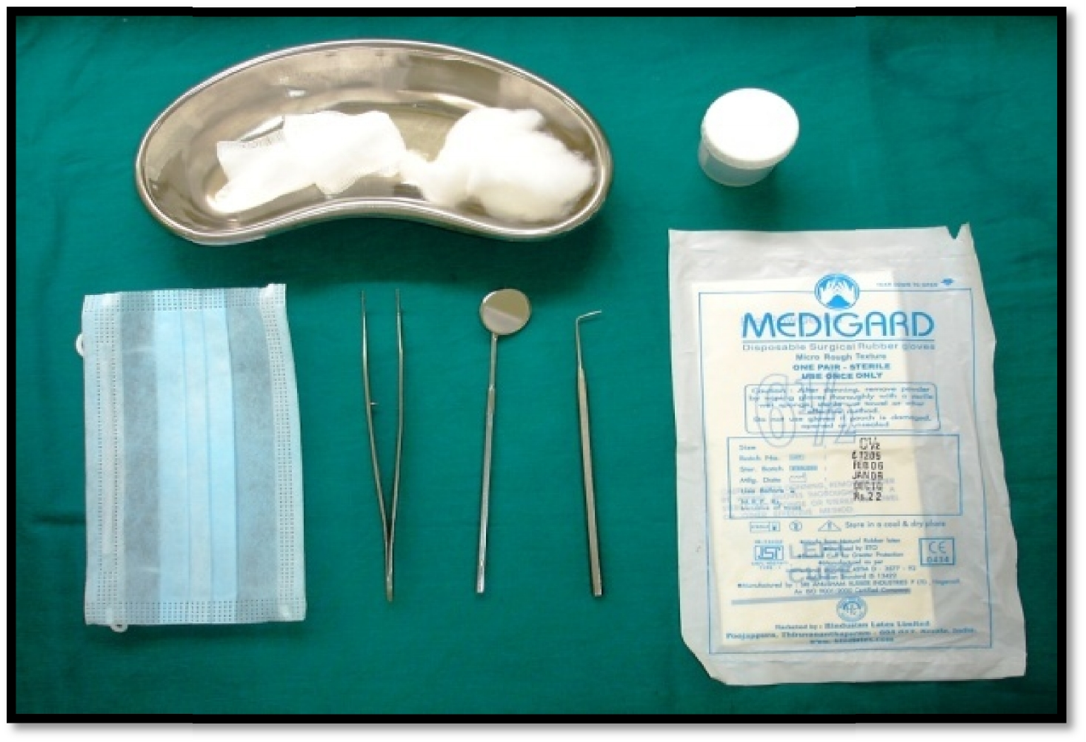
Pic. 1: Armamentarium used for clinical examination and collection of saliva sample

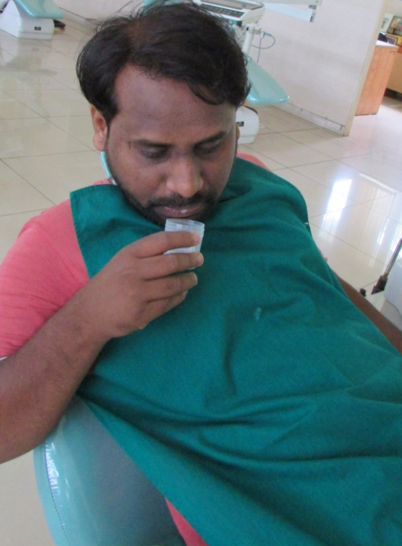

Pic. 2: Collection of Unstimulated saliva by saliva spit method

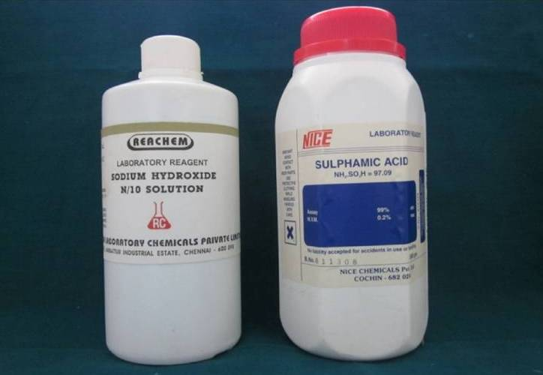
Pic. 3: Reagents for sample preservation
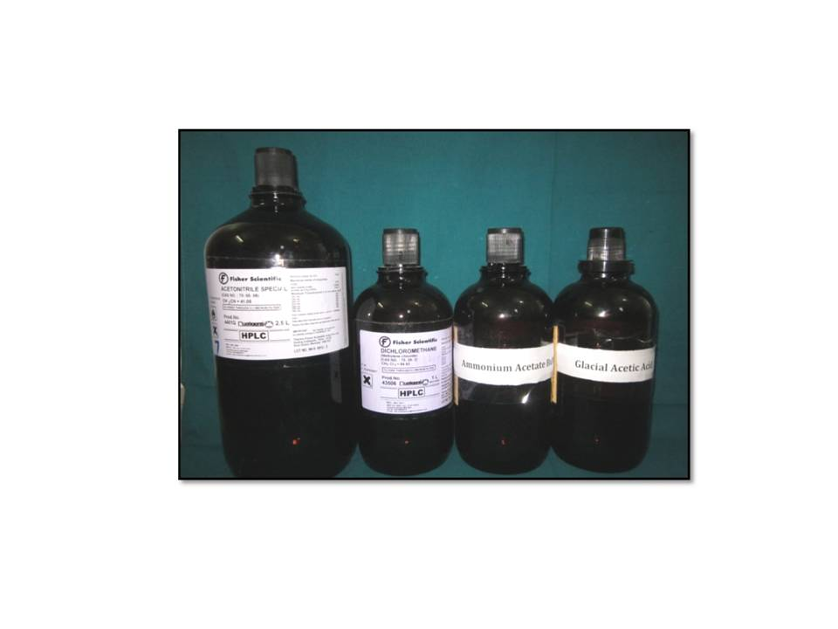
Pic. 4: Reagents used for estimation of nitrosamines by GCMS

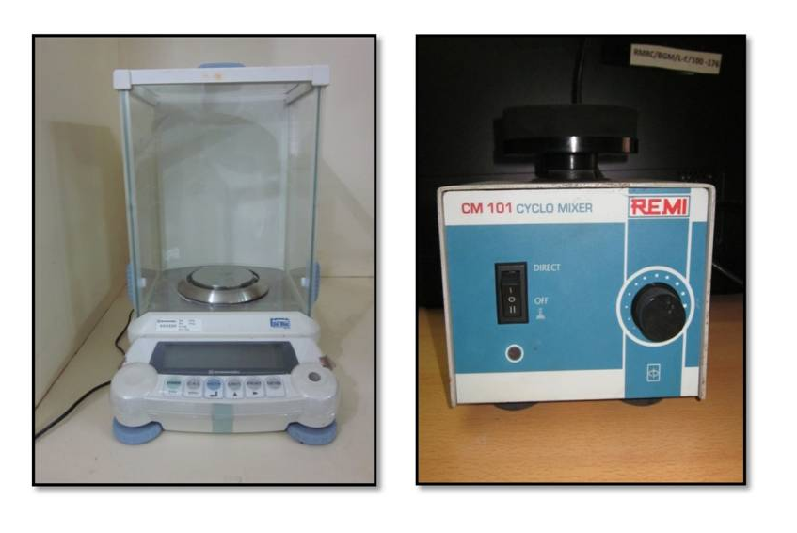
Pic.5: Precision scale for weighing samples
Pic.6: Cyclomixer for vortexing

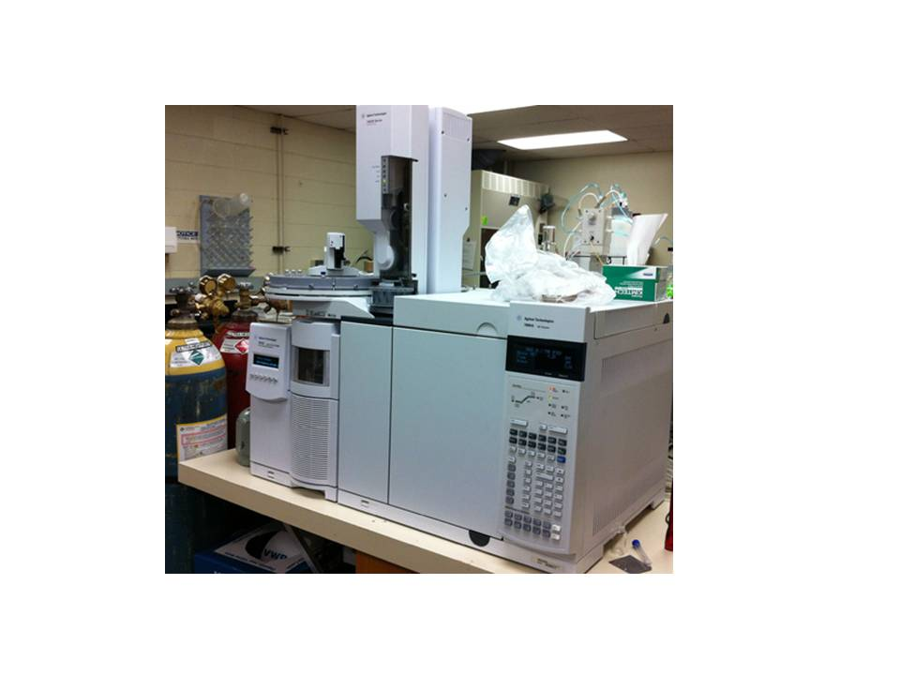
Pic.7: Gas Chromatography with Mass Spectrometry (GC-MS) - Agilent

