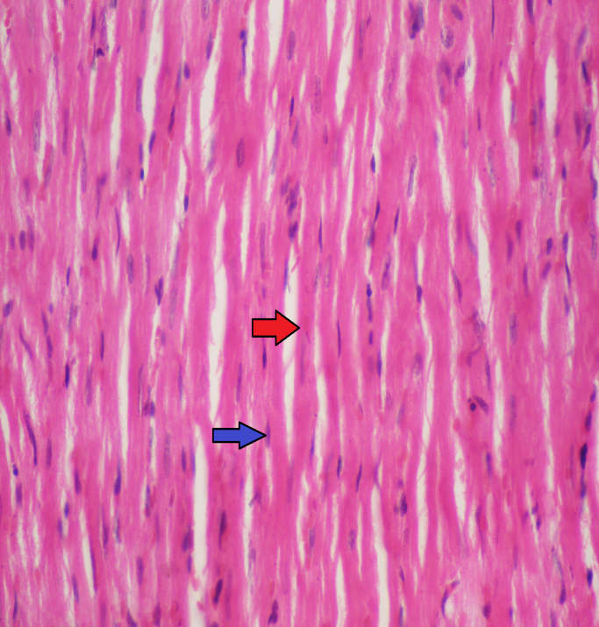

Fig. (1): Histopathlogical slide of longitudinal section of the heart stained with hematoxylin and eosin (40X) in the rats of control group showing cylindrical muscle fibers have acidophilic sarcoplasm (red arrow) and centrally located oval nucleus (blue arrow).

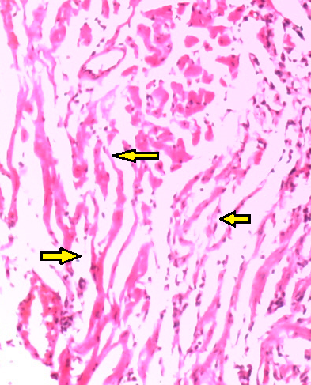

Fig. (2): Histopathological slide of the heart stained with hematoxylin and eosin in the rats of AlP intoxicated group (2 mg/Kg) shows goasts of myocardial cells indicating infarction (yellow arrow) (40X).

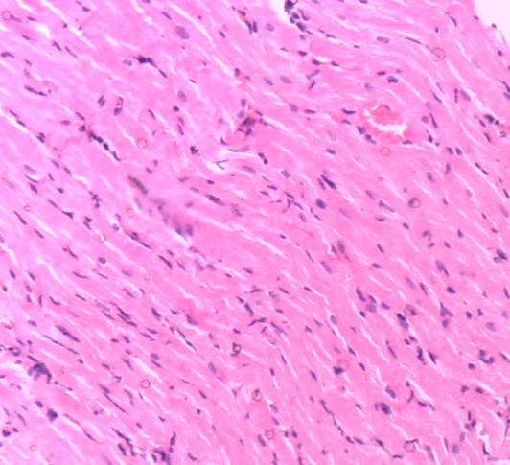
Fig. (3): Histopathological slide of the heart stained with hematoxylin and eosin (×10) in the rats of rutin treated group (100 mg/kg) showing near normal structure of viable myocardium.

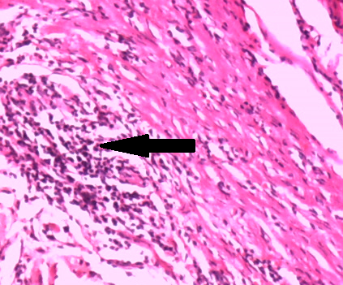

Fig. (4): Histopathological slide of the heart stained with hematoxylin and eosin (×10) in (AlP + rutin) group showing myocardial muscle fibers with moderate inflammatory cells infiltration mainly lymphocytes ( black arrow).

