**PRE-OPERATIVE VIEW**

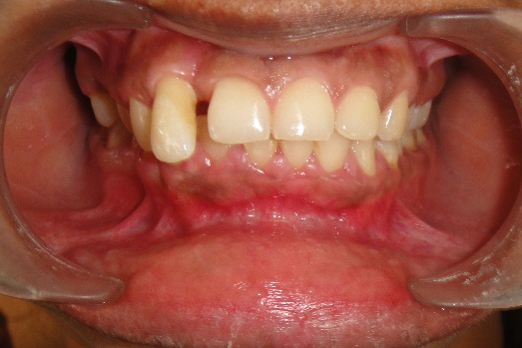

FIGURE 1 – Before phase I

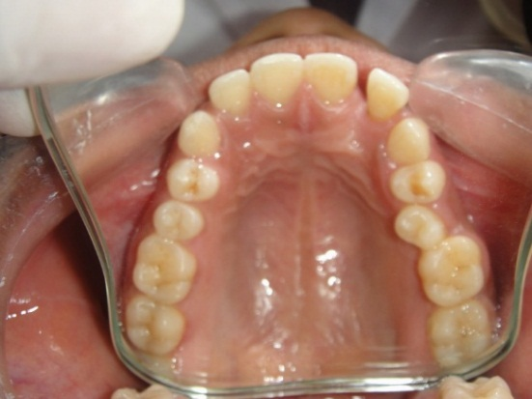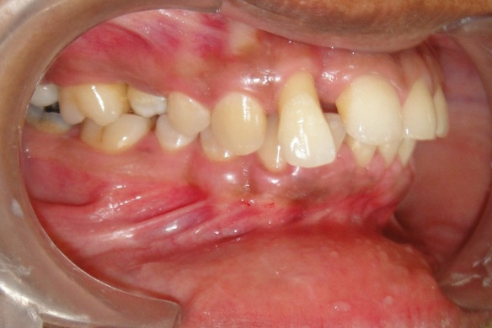

FIGURE 3 – Cross bite wrt 15

FIGURE 2 – Extruded 12 and loss of contact b/n 11 and 12

**PERIODONTAL FLAP SURGERY**

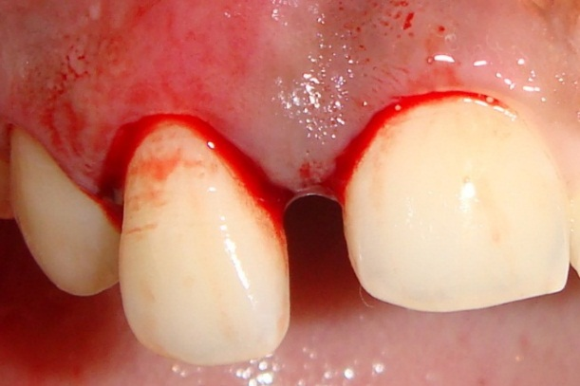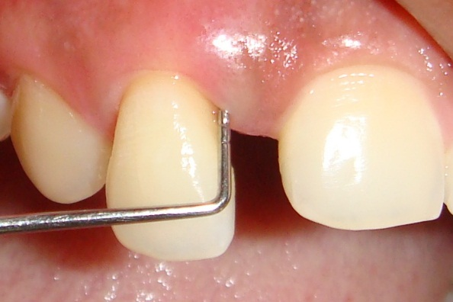

FIGURE 5 – Crevicular incisions given

FIGURE 4 – Probing pocket depth wrt 12 is 8 mm

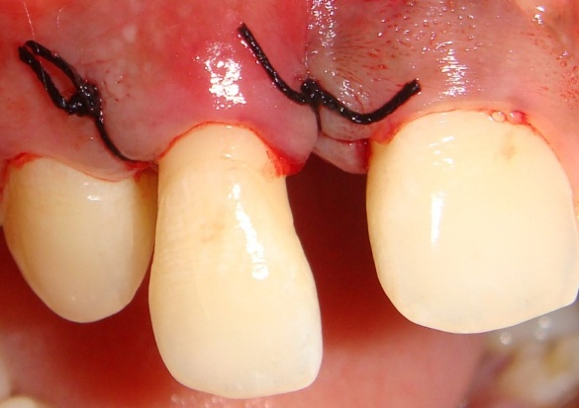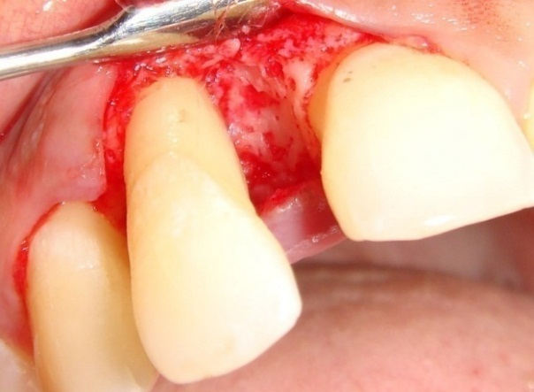

FIGURE 7 – Sutures placed

FIGURE 6 – Full thickness mucoperiosteal flap reflected

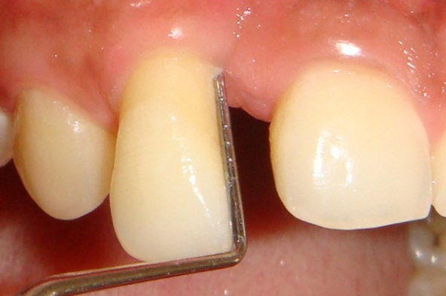

FIGURE 8 – Probing pocket depth reduced to 4 mm 6 months after flap surgery,

**ORTHODONTIC THERAPY**

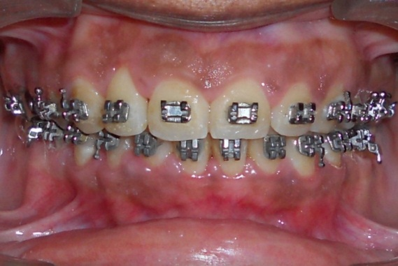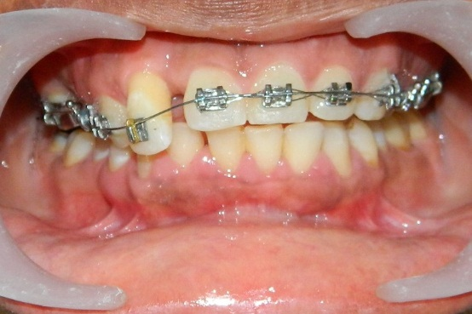

FIGURE 9 – Levelling and alignment of upper teeth

FIGURE 10 – space closure

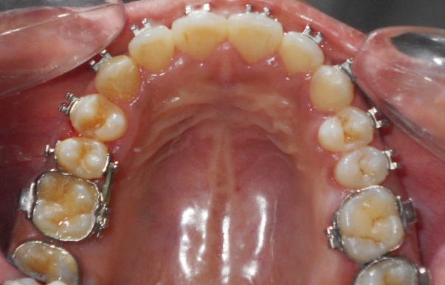

FIGURE 11 – Correction of cross bite wrt 15

**COMPLETION OF TREATMENT**

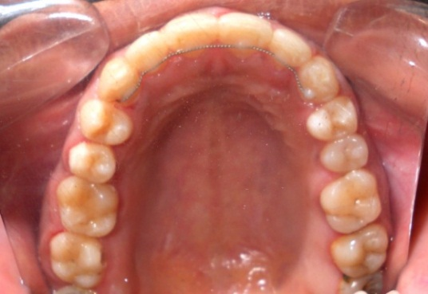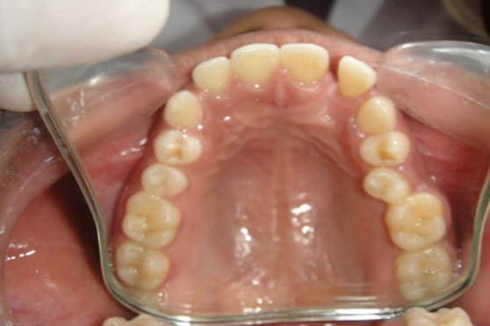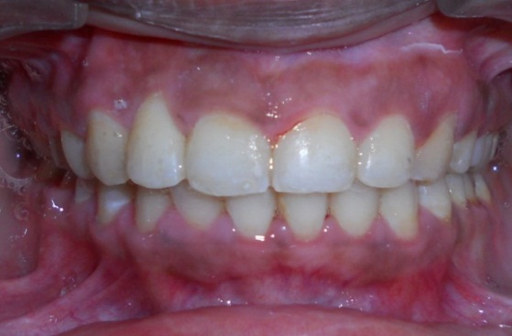 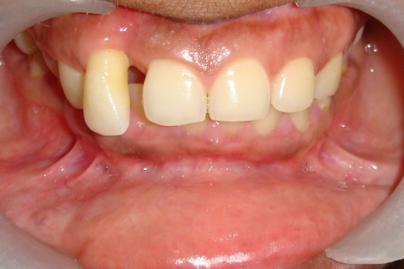

FIGURE 13 – Cross bite wrt 15 corrected and fixed lingual retainer placed

FIGURE 12 – Extruded 12 is intruded, aligned and space is closed b/n 12 and 11