Figures:-

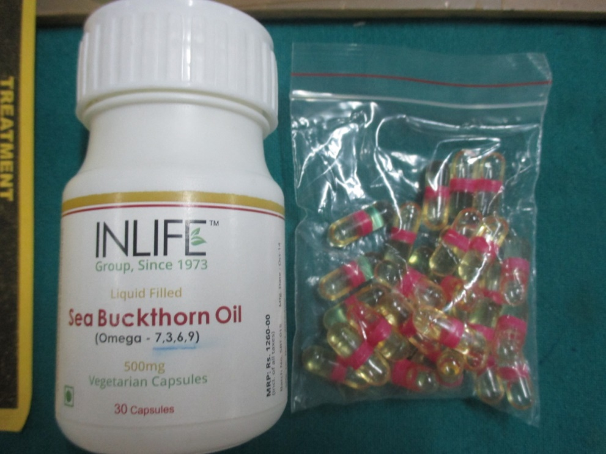
Fig 1: SBO capsules

Fig 2:- shows no statistical significant difference between group A and B after the treatment.

Fig 3:- shows no significant difference between group A and B after the treatment

Gingival Index
Fig 4:- shows no significant difference between group A and B after the treatment

Fig 5: showing statistical difference between group A and B after the treatment suggesting some regenerative potential of SBO oil.

Fig 6:- shows no significant difference between group A and B after the treatment.

