Figure and ligands.

Figure 1. Harvested sternoclavicular graft.
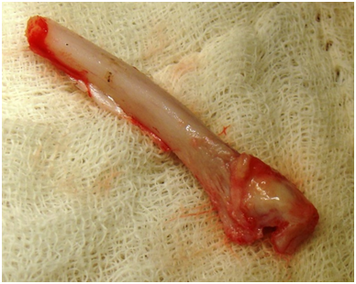

Figure 2. Graft shaped and fixed to posterior border of mandible.
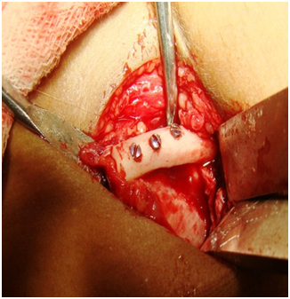

Figure 3. Post operative OPG.
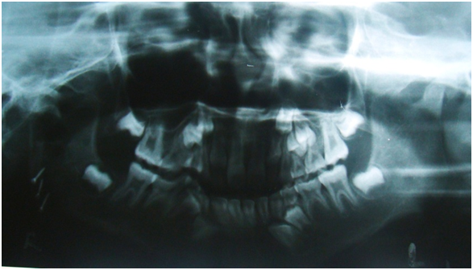

Figure 4. Harvested and shaped coronoid process.
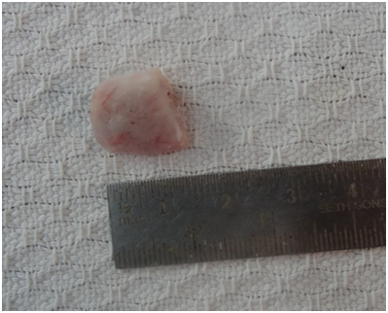

Figure 5. Graft fixed with trapezoidal plate.
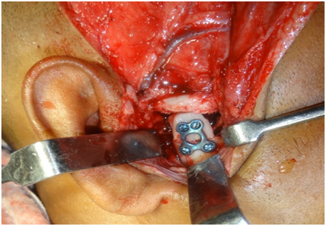

Figure 6. Hydroxyapattite collagen block shaped and fixed with L plate.
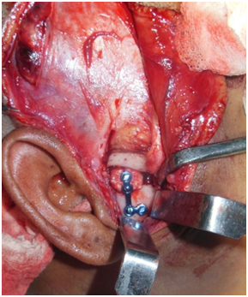

Figure 7. Custom-made total joint prostheses
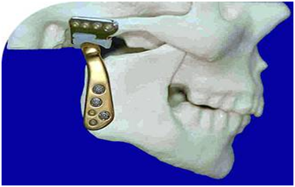

Figure 8.. Inverted L shape osteotomy
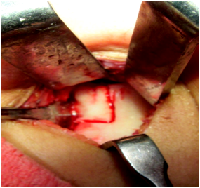

Figure 9. . Distractor fixed on both ramus and transport disc.
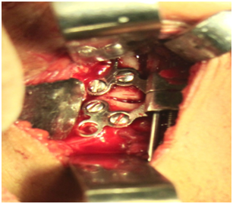

Figure 10. OPG after distraction.
