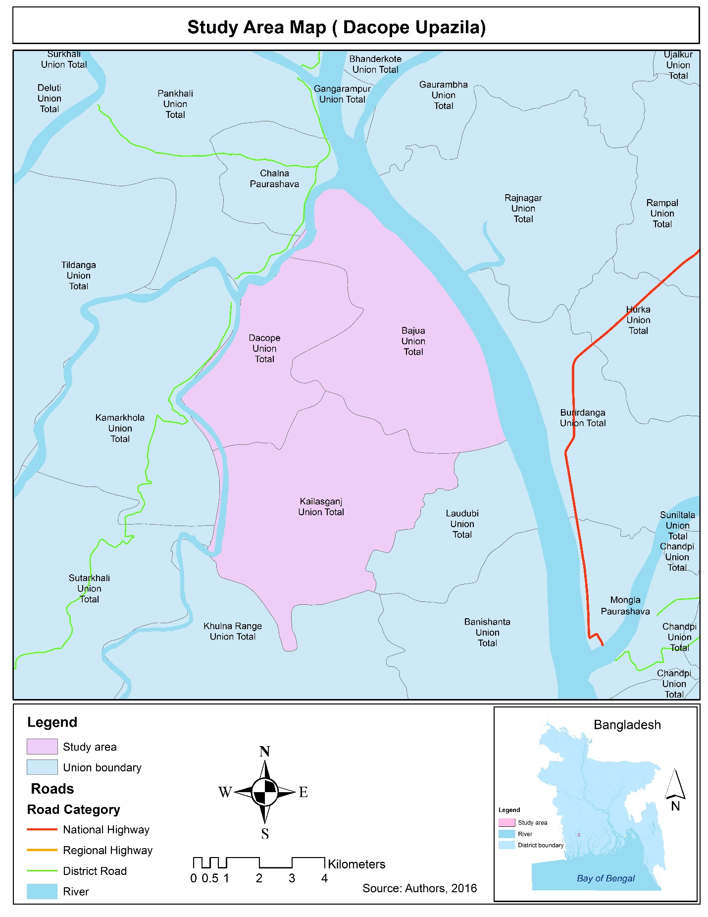
Figure 1. The map of Dacope Upazilla
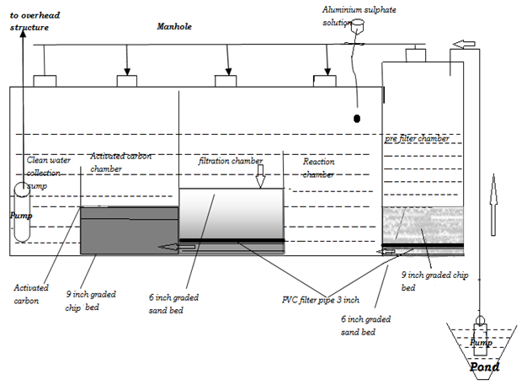
Figure 2. Design of PSF-A
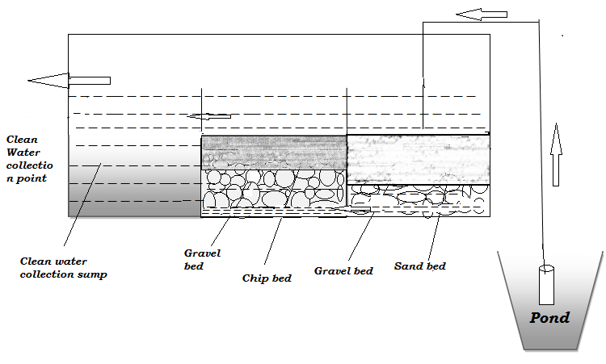
Figure 3. Design of PSF-B
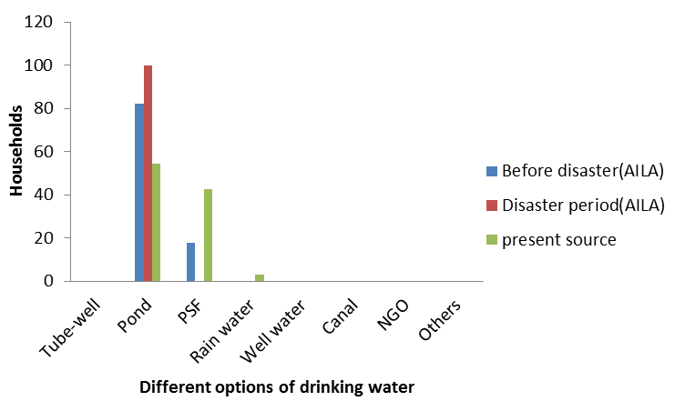
Figure 4. Sources of drinking water at different times
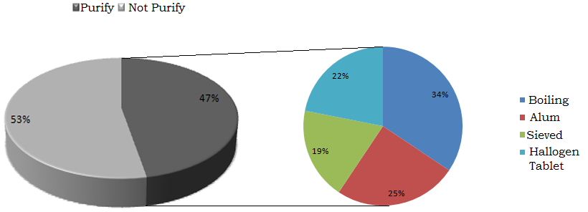
Figure 5. Percentage of households who use different purify technique of pond water
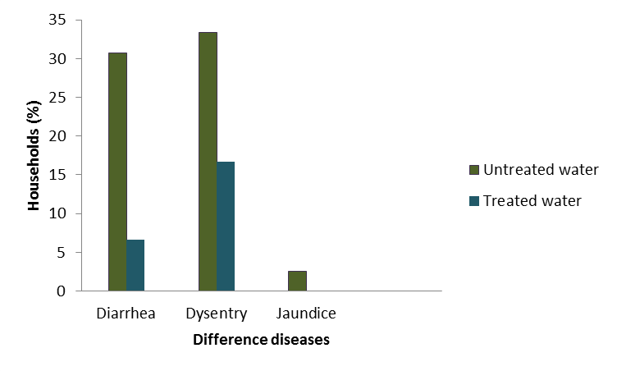
Figure 6.Percentage of different water borne diseases among treated and non-treated water users
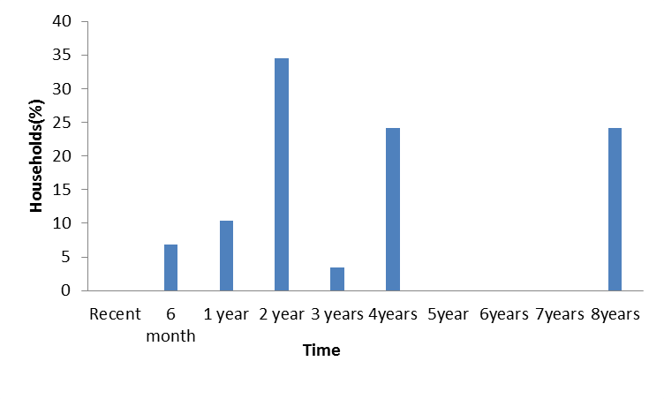
Figure 7. PSF use from different times by respondent households.
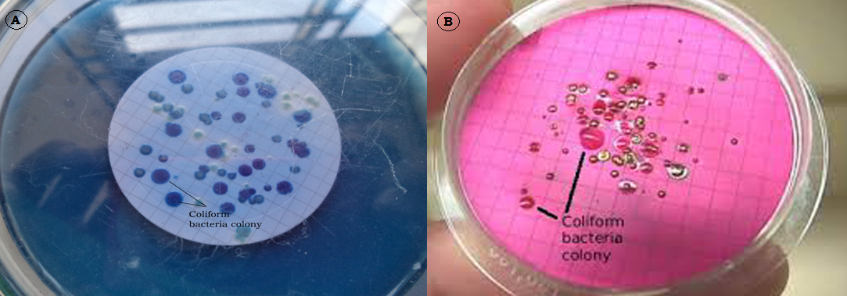
Figure 7. Blue colonies of (A) fecal coliforms and red colonies of (B) total coliforms

Table 1. Different parameters with their units and measuring instruments
Parameters | Units | Methods/Instruments
P^{H} |  | MARTINI instruments, P^{H} 56 PHWP
Sulphate (SO₄) | mg/l | Atomic absorption spectroscopy
Nitrate (NO₃) | mg/l | Cadmium reduction method (HACH)
Phosphate (PO₄) | mg/l | PhosVer Method (HACH)
Ammonia (NH₃) | mg/l | Nessler method (HACH)
Total Dissolve Solids (TDS) | mg/l | HACH sension-156 multi parameter
Electrical Conductivity (EC) | µs/cm | HACH sension-156 multi parameter
Turbidity | FAU | HACH portable spectrophotometer DR/2010
Faecal coliform | CFU/100ml | Filtration Technique
Total Coliform | CFU/100ml | Filtration Technique

Table 3. Different Physicochemical analysis of PSF water (Input and Output)
PSF | Dacope (PSF) |  | Koilashgong (PSF) |  | Bauja (PSF)
Parameter | Input (B-pond) | Output (B-Pond) | Input (K-pond) | Output (K-Pond) | Input (C-pond) | Output (C-Pond)
pH | 8.71 | 8.68 | 8.09 | 8.55 | 6.64 | 6.89
TDS (mg/l) | 362 | 308 | 800 | 744 | 88 | 73
EC (µs/cm) | 724 | 605 | 1600 | 1574 | 136 | 145
NH3 (mg/l) | 0.24 | 0.04 | 0.28 | 0.04 | 0.35 | 0.12
NO3 (mg/l) | 0.9 | 0.5 | 1.3 | 1.1 | 0.8 | 0.7
PO4 (mg/l) | 0.32 | 0.23 | 1.57 | 0.23 | 0.37 | 0.34
Turbidity (FAU) | 67 | 15 | 38 | 20 | 32 | 19
Fecal Coliform (CFU/100ml) | 176 | 38 | 122 | 19 | 64 | 9
Total Coliform (CFU/100ml) | 185 | 50 | 258 | 94 | 74 | 11

