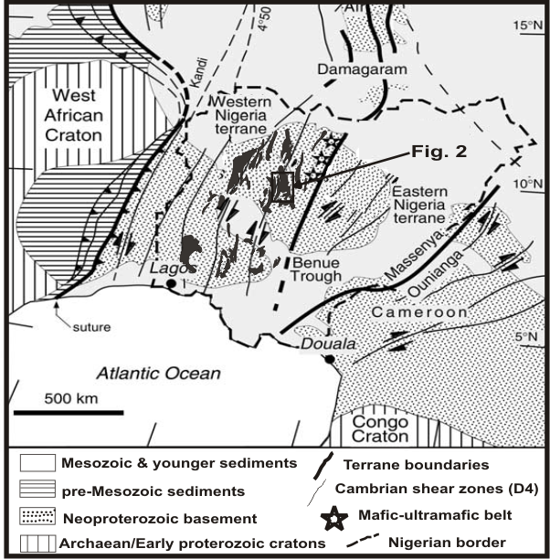

Fig. 1: Geological sketch map of the Nigeria province showing the
Neoproterozoic terrane amalgamation between the cratons of West
Africa and Congo (modified after Ferre et al., 1996)

Fig. 2: Geological map of northern part of Kushaka and Birnin Gwari schist belts (Sheet 122)
Modified after Truswell and Cope, (1963).

Fig. 3: (A) Field occurrence of Porphyritic and granitic leucosome and paleosome
in Gwaska (N10⁰ 43’ 40” E 6⁰ 43’ 34”); (B) granodioritic gneiss outcrop in Marinai
(N 10⁰ 33’ 27” E 6⁰ 51’ 31”) in the Kushaka Gneiss complex; (C) biotite granite in
Manini (N10⁰ 40’ 77” E 6⁰ 51’ 94”); (D) Kampani Doka granitic gneiss outcrop used
as quarry (N10⁰ 45’ 10” E 6⁰ 36’ 13”); (E) Marinai basalt in Kushaka Gneiss Complex
(N10⁰ 33’ 27” E 6⁰ 51’ 31”) and biotite and muscovite granite in Mando
(N10⁰ 43’ 27” E 6⁰ 33’ 74”).

Fig. 4: Hand Specimen and Photomicrograph of Marinai basalt; Ungwan
Madaki paleosome; Sabo-Layi tonalite, all of the basement complex and
Gwagwaulu granite gneiss of the Kushaka Gneiss Complex in the northern
part of the Kushaka and the Birnin Gwari schist belts.

Fig. 5: Outcrop, hand specimen and photomicrograph of Koriga syenite;
Maganda granite in Kushaka; and Mando granite and Bagwoma quartzolite
in the Birnin Gwari schist belts. Mcl=Microcline, Bt=Biotite,Ms=Muscovite,
Hb=Hornblende, Or=Orthoclase.

Fig. 6: Modal classification diagrams of the granitoids in the (A): Basement and Kushaka Gneiss Complex; (B): Kushaka and (C): Birnin Gwari Schist Belts (after Streckeisen, 1976).

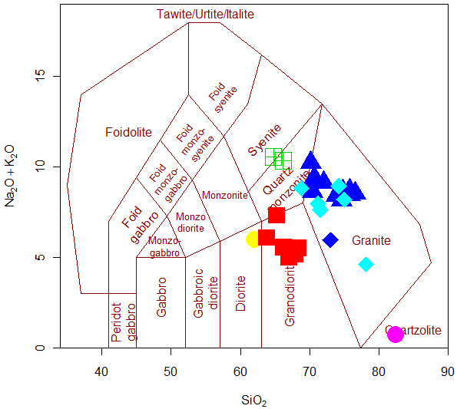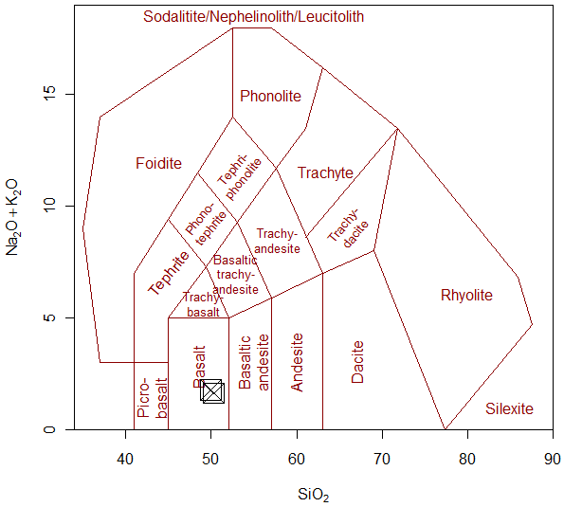
Fig. 7: (A): SiO₂ vs Na₂O + K₂O diagram (Middlemost, 1985) with nomenclature of the
granitoids as granites, grandorites, diorite, syenite and quartzolite; (B): as basalt, distin-
guishing them as subalkaline magmatic series (after Cox et al., 1979).

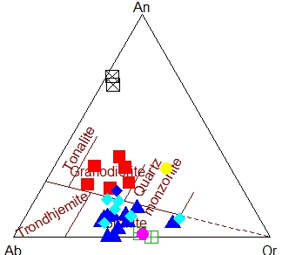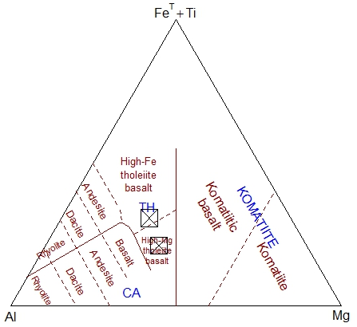
Fig. 8: (A) Normative An-Ab-Or diagram showing the distribution of the granitoids in granitic to granodioritic and quartz monzonite field (after O‟Connor, 1965) and and Al- Fe+Ti-Mg of Jensen (1976) showing basalts are high Fe and Mg tholeiite basalt. (Symbols as in Fig. 2).

Fig. 9: Harker variation diagrams; silica (SiO₂ wt %) plotted against a range of major (in wt %) elements in the granitoids of the Kushaka and the Birnin Gwari schist belts (Symbols as in Fig. 2).

Fig. 10: Harker variation diagrams; silica (SiO₂ wt %) plotted against a range of trace (in ppm) elements in the granitoids and associated basalt of the Kushaka and the Birnin Gwari schist belts (Symbols as in Fig. 2).

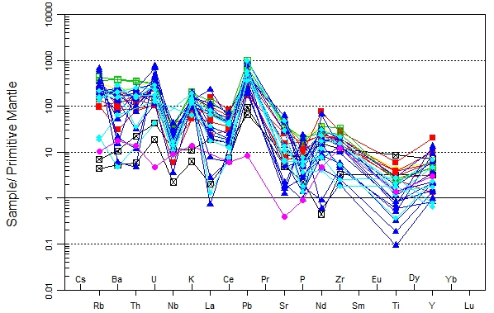
Fig. 11: Mantle-normalized multi-element diagram of granitoid in the northern part of the Kushaka and the Birnin Gwari schist belts (Sun and McDonough, 1989) (Symbols as in Fig. 2).

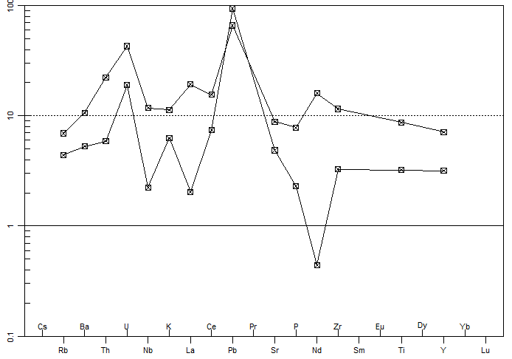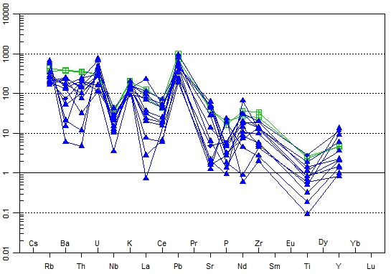
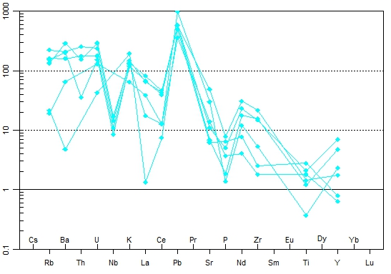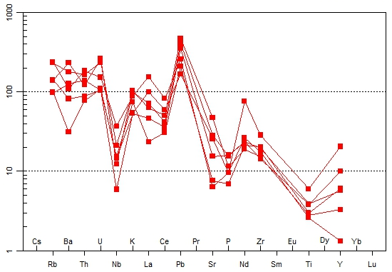

Fig. 12: Mantle-normalized multi-element diagram of each rock type showing (A): Basalt=Black (B): Granite =Blue (C): Granitoid Gneiss=Till and (D): Granodiorites=Red in the Kushaka and the Birnin Gwari schist belts (Sun and McDonough, 1989) (Symbols as in Fig. 2).

Fig. 13: Chondrite-normalized pattern for the Kushaka and the Birnin Gwari schist belts granitoids, chondrite normalization values are from (Boynton, 1984) (Symbols as in Fig. 2).

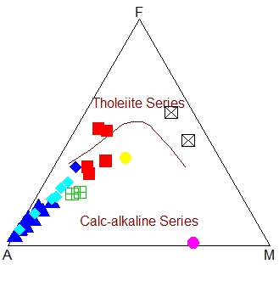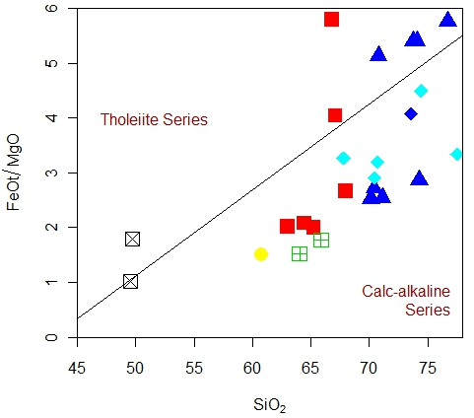
Fig. 14: (A) AFM diagram (after Irvine and Baragar, 1971) and (B) SiO₂ vs Fe₂O₃/MgO diagram (after Miyashiro, 1974) discriminating granitoids and basalt as tholeiite and calc-alkaline series (Symbols as in Fig. 2).

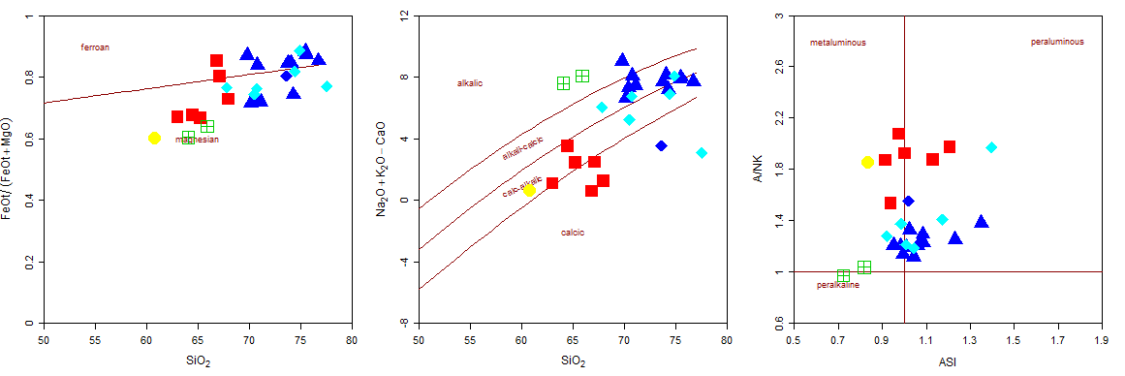

Fig. 15: (A) SiO₂ vs Fe₂O₃/( Fe2O3+MgO); (B) SiO₂ vs Na₂O+ K₂O-CaO and (C) ASI vs A/NK diagram (after Frost et al, 2001) discriminating granitoids as ferroan to magnesian, alkali to calcic and metaluminous to peraliminous (Symbols as in Fig. 2).

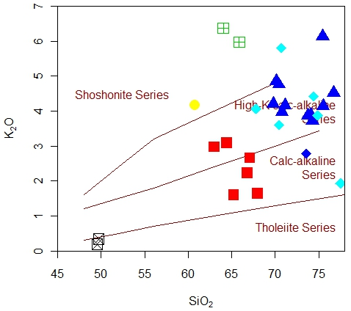
Fig. 16: (A) Alkali concentration discrimination diagram (K₂O vs Na₂O in wt %) defining the I- and S-type nature of the granitoids and (B) SiO₂ vs K₂O after Peccerillo and Taylor (1976) discriminating basalt as tholeiite and granitoids as calc-alkaline, High-K calc-alkaline and
Shoshonite series. (Symbols as in Fig. 2).

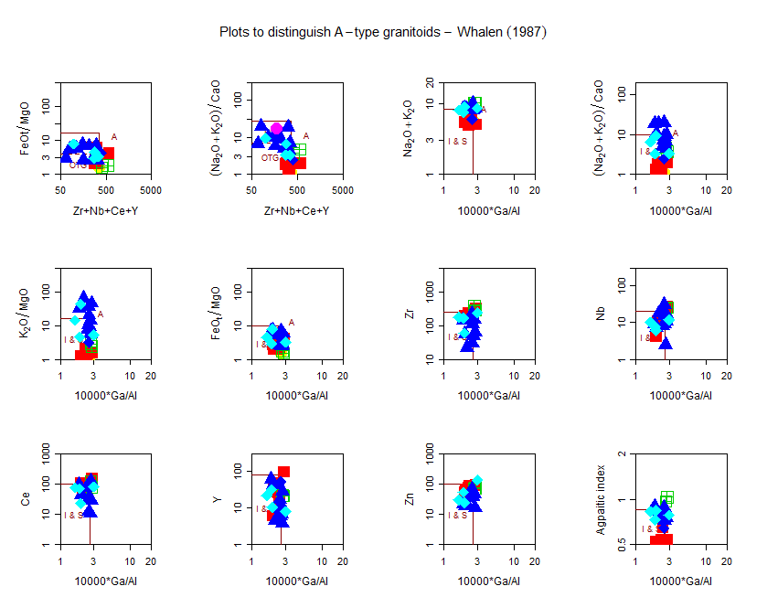

Fig. 17: Set of binary plots Zr+Nb+Ce+Y vs Fe₂O₃/MgO and (Na₂O+ K₂O)/CaO; 10000*Ga/Al vs Fe₂O₃/MgO and K₂O+MgO; 10000*Ga/Al vs Y and Ce proposed by (Whalen et al., 1987) to distinguish A-type granitoids from I- and S-type (Major elements in wt % and trace elements and REE in ppm) (Symbols as in Fig. 2).

Fig. 18: Sr-Rb-Ba ternary diagram after Tarney and Jones (1994) illustrating the high Ba-Sr nature and Ba-Rb-Sr ternary diagram showing the distribution of granitoids as diorite; granodiorite and quartz diorite; anomalous, normal and strongly differentiated granites (after El Bouseily and El Sokkary, 1975) (Symbols as in Fig. 2).

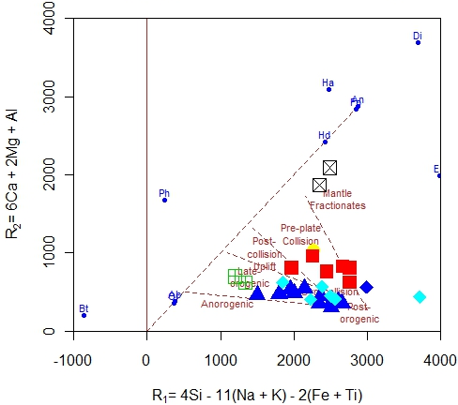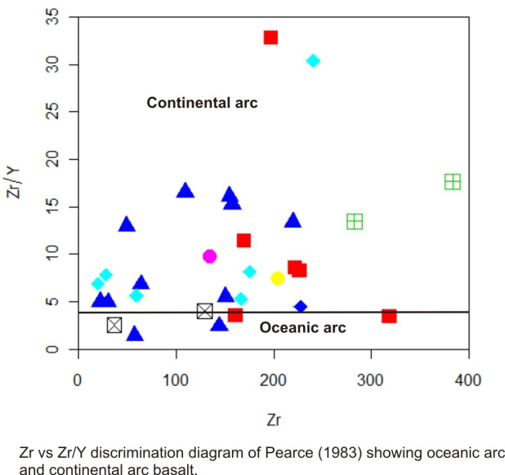
Fig. 19: R1 vs R2 diagram of (Batchelor and Bowden, 1985) [R₁=(4Si – 11(Na+K) – 2(Fe+Ti); R₂=(6Ca+2Mg) + Al)]. and Zr vs. Zr/Y discrimination diagram of Pearce (1983) showing oceanic and continental arc basalt to delineate the tectonic settings of granitoids and basalts (Symbol as in Fig. 2)
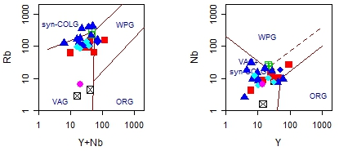
Fig. 20: (A) (Y+Nb) vs Rb and (B) Y vs Nb (in ppm) geotectonic discrimination diagram (after Pearce et al., 1984) of the basalts and granitoids. ORG=ocean ridge granites, syn-COLG=syn-collisional granites, VAG=volcanic arc granites, WPG=within plate granites (Symbol as in Fig. 2).

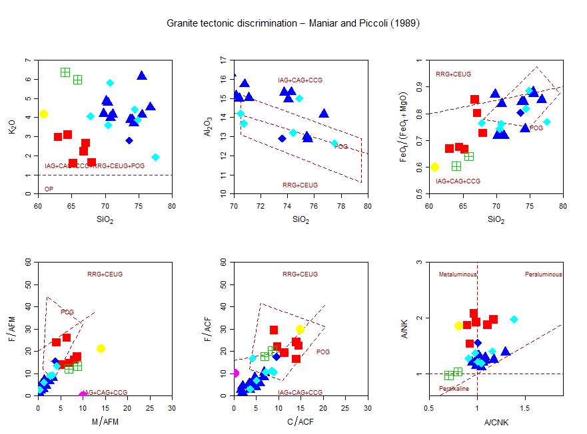
Fig. 21: Major element based geotectonic classification of the granitoids (A) SiO₂ vs K₂O; (B) M/AFM vs F/AFM; (C) SiO₂ vs Fe₂O₃/( Fe₂O₃+MgO); (D) C/ACF vs F/ACF (after Maniar and Piccoli, 1989). Field IAG=island arc granitoids, CAG=continental arc granitoids, CCG=continental collision granitoids, CEUG=continental epeirogenic uplift granitoids, OP=oceanic plagiogranites (Symbols as in Fig. 2).
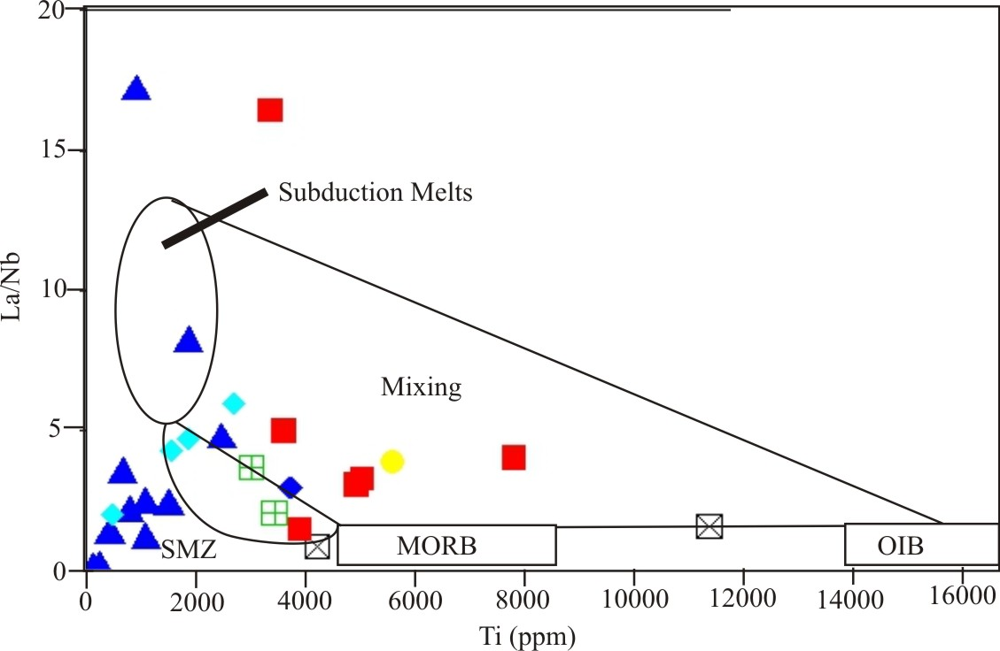
Fig. 22: (A) La/Nb vs. Ti (ppm) plot of Pearce et al., (1990) and (B) Ba/Nb vs. La/Nb plot of (after Jahn et al., 1999) of granitoids and basalt showing magma mixing and setting. SMZ=sub-duction zone magmatites; MORB=mid ocean ridge basalt; OIB=ocean island basalt.

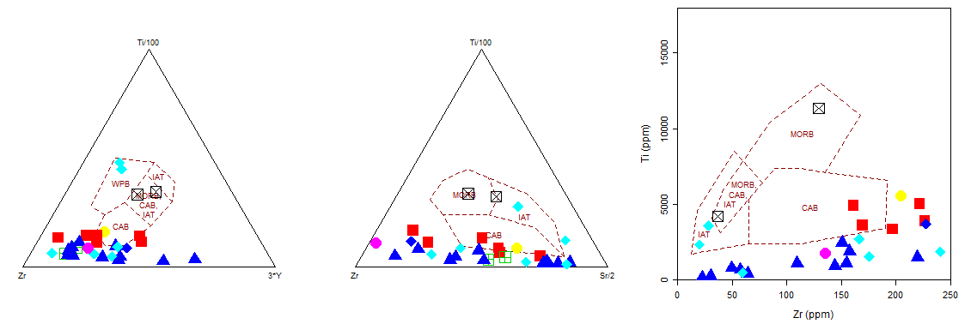

Fig. 23: Zr-Ti/100-3*Y, Zr-Ti/100-Sr/2 ternary and Zr versus Ti binary basalt tectonic discrimination
diagram (after Pearce and Cann, 1973).

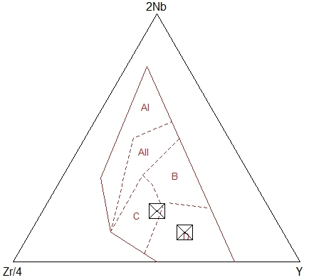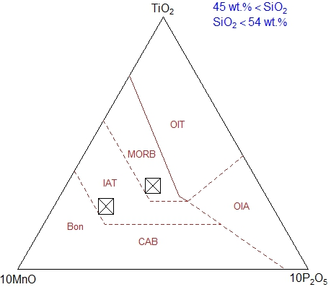

Fig. 24: 2Nb-Zr/4-Y (after Meschede, 1986) and TiO₂-10MnO-10P₂O₅ (after Mullen, 1983) ternary diagram basalt tectonic discrimination field for basalts. AI=within plate basalts, AII=within plate tholeiite basalts, B=MORB, C=back arc basalts, D=volcanic arc basalts; IAT=island arc tholeiite, MORB=mid ocean ridge basalts, OIT=ocean island tholeiite, OIA=ocean island arc, CAB=continental arc basalt.

Table 1: Age data on some granitoids and migmatite gneiss host in the Nigerian basement (Modified after Dada, 1996).
Lithology | Geological Age | T_{Nd} Ga | £_{Nd}(t) | T_{Sr} | δT=t-T_{Nd} | Reference
Kaduna granodiorite gneiss | 3.46Ga (U-Pb) | 3.57 | - | 3.49Ga | 10Ma | Bruguier et al. (1994)
 | 3.46Ga (U-Pb) |  |  |  |  | Ekwueme & Kroner (1993)
Kaduna early gneiss | 3.1Ga (U-Pb, Rb-Sr) | 3.54 | - | 3.18Ga | 440 | Dada (1989). Bruguier et al. (1994)
Malumfashi & NW Kad & Mallam Tanko migmatites | 3.1 & 2.4Ga (Rb-Sr) | - | - | - | - | Ogezi (1977)
Ibadan Aplite | 2.75Ga (Pb-Pb) | - | - | - | - | Oversby (1975)
Odo Ogun gneiss | 2.5Ga (U-Pb) | - | - | - | - | Pidgeon et al. (1976)
Ile-Ife grey gneiss | 2.3Ga/439Ma (U-Pb) | - | - | - | - | Rahaman (1988)
Ile-Ife granitic gneiss | 1.85Ga/439Ma (U-Pb) | - | - | - | - | Rahaman (1988)
Igbetti augen gneiss | 1.9Ga (Rb-Sr) | - | - | - | - | Rahaman et al. (1983)
Egbe-Kabba-Okene gneiss |  | 2.56 |  | 2.36 | - | Dada & Rahaman (In press)
Kaduna (cem) migmatite | 2.2Ga (Rb-Sr) | - | - | - | - | Hurley (1966)
Tilden Fulani migmatite | 2.5Ga/500Ma (U-Pb) | 1.80 | -1.3 | 680Ma | 1300Ma | Dada et al. (1993)
Badiko granite gneiss | 2.5Ga/500Ma (U-Pb) | 2.10 | -14.6 | 740Ma | 1600Ma | Dada et al., (1989)
Minna Granodiorite | 790 – 760 Ma (U-Pb) |  | - | - | - | Goodenough et al., 2014
Ibadan granite gneiss | 2.2Ga (Rb-Sr) | - | - | - | - | Grant (1970)
SW Ife-Ilesha granite gneiss | 1.8Ga (U-Pb) | - | - | - | - | Lancelot & Rahaman (1983)
Maru Phyllite | 1.06Ga (Rb-Sr) | - | - | - | - | Ogezi (1977)
Sokoto river migmatite | 1.06Ga (Rb-Sr) | - | - | - | - | Ogezi (1977)
NW Gusau migmatite | 1.15Ga (Rb-Sr) | - | - | - | - | Ogezi (1977)
Kusheriki banded gneiss | 1.2 & 1.3Ga (Rb-Sr) | - | - | - | - | Grant et al. (1972)
NW Kaduna migmatite | 1.15Ga (Rb-Sr) | - | - | - | - | Grant et al. (1972)
Ife-Ilesha granite gneiss | 1.12Ga (Rb-Sr) | - | - | - | - | Grant et al. (1972)
Sabon Gayam gneiss | 1.2 & 0.7 Ga (Rb-Sr) |  | - | - | - | Grant, 1978
Badiko syntectonic diorite | 623Ma (U-Pb) | 1.90 | -12.3 | 780Ma | 1297Ma | Dada et al. (1993)
Ikerre massive charnokite | 620Ma (U-Pb) | - | - | - | - | Tunbosun et al. (1984)
Akure gneissic charnokite | 634Ma (U-Pb) | - | - | - | - | Tunbosun et al. (1984)
Akure porphyritic granite | 621Ma (U-Pb) | - | - | - | - | Tunbosun et al. (1984)
Idanre gneissic charnokite | 580Ma (U-Pb) | - | - | - | - | Tunbosun et al. (1984)
Idanre massive charnokite | 593Ma (U-Pb) | - | - | - | - | Tunbosun et al. (1984)
Idanre porphyritic granite | 587Ma (U-Pb) | - | - | - | - | Tunbosun et al. (1984)
Toro biotite-Hbde granite | 607Ma (U-Pb) | 2.10 | -12.6 | 670Ma | 1493 | Dada et al. (1989)
Toro charnockitic diorite | 638Ma (U-Pb) | 2.50 | -15.6 | 1.07Ma | 1915 | Dada et al. (1989)
Bauchi quartz fayalite monzonite (bauchite) | 638Ma (U-Pb) | 1.70 | -3.9 | 1.80Ga | 1062 | Dada & Respaut (1989)
Toro migmatite | 581Ma (U-Pb) | 1.75 | -1.86 |  | 1280 | Ferre et al. (1996)
Toro anatectic granite | 616Ma | 1.88 | -14 |  | 1380 | Ferre et al. (1996)
Toro migmatite granite | 751Ma | 2.71 | -12.4 |  | 1960 | Ferre et al. (1996)
Birnin Gwari phyllite | 566Ma (Rb-Sr) | - | - | - | - | Ajibade (2008)
Minna Granodiorite | 505 + 12 (Rb-Sr) |  |  |  |  | Ajibade (2008)
Zungeru mylonites | 600-700Ma (Rb-Sr) | - | - | - | - | Ajibade et al. (1982)
Kazaure Older Granite | 592 + 14 (Rb-Sr) |  |  |  |  | Danbatta (2002)

Table 2 Major (wt %) abundance in the granitoids and associated volcanic rocks in the northern part of the Kushaka and the Birnin Gwari schist belts

Sample | KB1 | KB2 | KD3 | KTN4 | KGD5 | KGD6 | KGD7 | KGD8 | KGD9 | KSy10 | KSy11 | KKG12 | KKG13 | KKG14 | KKG15
 | KGC Volcanic |  | Basement Complex Granitoids (BCG) |  |  |  |  |  |  | Kushaka Granite
(%) | Basalt |  | Diorite | Tonalite | Granodiorite/Paleosome |  |  |  |  | Syenite |  | Granite
SiO₂ | 49.56 | 49.72 | 60.77 | 64.45 | 67.98 | 63 | 67.11 | 66.81 | 65.24 | 65.87 | 64.02 | 74.28 | 69.78 | 71.12 | 70.79
TiO₂ | 0.7 | 1.89 | 0.93 | 0.6 | 0.56 | 0.84 | 1.3 | 0.65 | 0.82 | 0.5 | 0.57 | 0.13 | 0.18 | 0.18 | 0.25
Al₂O₃ | 14.74 | 13.73 | 13.5 | 15.55 | 15.54 | 15.34 | 12.87 | 14.33 | 15.99 | 14.07 | 13.22 | 15.32 | 16.32 | 15.03 | 15.74
Fe₂O₃ | 10.14 | 13.52 | 7.04 | 4.78 | 4.03 | 5.67 | 7.69 | 7.15 | 5.13 | 4.07 | 4.54 | 0.83 | 1.57 | 1.27 | 2.17
MnO | 0.16 | 0.21 | 0.12 | 0.11 | 0.04 | 0.11 | 0.17 | 0.18 | 0.07 | 0.07 | 0.09 | 0.01 | 0.02 | 0.03 | 0.04
MgO | 8.96 | 6.8 | 4.2 | 2.07 | 1.36 | 2.53 | 1.71 | 1.11 | 2.31 | 2.06 | 2.68 | 0.26 | 0.21 | 0.45 | 0.38
CaO | 12.65 | 11.75 | 5.2 | 3.71 | 4.22 | 4.93 | 2.62 | 4.38 | 3.06 | 2.23 | 2.86 | 1.28 | 1.16 | 1.57 | 1.35
Na₂O | 1.4 | 1.41 | 1.67 | 4.12 | 3.83 | 3.03 | 2.42 | 2.73 | 3.87 | 4.32 | 4.08 | 4.76 | 5.98 | 4.86 | 5.42
K₂O | 0.19 | 0.34 | 4.18 | 3.09 | 1.64 | 2.97 | 2.66 | 2.23 | 1.6 | 5.98 | 6.37 | 3.71 | 4.2 | 4.16 | 3.98
P₂O₅ | 0.05 | 0.17 | 0.43 | 0.25 | 0.21 | 0.34 | 0.21 | 0.15 | 0.35 | 0.35 | 0.44 | 0.04 | 0.07 | 0.06 | 0.1
LOI | 0.34 | 0.61 | 0.66 | 0.39 | 0.69 | 0.92 | 0.48 | 0.26 | 1.09 | 0.18 | 0.37 | 0.47 | 0.78 | 0.2 | 0.46
Total | 100.15 | 98.89 | 98.7 | 99.12 | 100.1 | 99.68 | 99.24 | 99.98 | 99.53 | 99.7 | 99.24 | 101.09 | 100.27 | 98.93 | 100.68
K₂O/ Na₂O | 0.13 | 0.24 | 2.50 | 0.75 | 0.42 | 0.98 | 1.09 | 0.81 | 0.41 | 1.38 | 1.56 | 0.77 | 0.70 | 0.85 | 0.73

Sample | KKG16 | KBG17 | KBG18 | KBG19 | KBG20 | KBG21 | KGR22 | KGR23 | KQZL24 | KGN25 | KGN26 | KGN27 | KGN28 | KGN29 | KGN30
 | Kushaka Granite |  | Birnin Gwari Granite |  |  |  |  |  |  | Basement and Kushaka Gneiss Complex
(%) | Granite |  |  |  |  |  | Leucosome |  | Q/zolit | Granite Gneiss
SiO₂ | 70.41 | 70.15 | 76.73 | 73.76 | 74.06 | 75.5 | 75.44 | 73.61 | 82.42 | 70.49 | 74.42 | 70.74 | 77.53 | 67.81 | 74.89
TiO₂ | 0.31 | 0.41 | 0.07 | 0.04 | 0.02 | 0.15 | 0.11 | 0.62 | 0.29 | 0.45 | 0.26 | 0.6 | 0.39 | 0.31 | 0.08
Al₂O₃ | 14.98 | 15.12 | 14.16 | 15.3 | 14.95 | 12.86 | 12.99 | 12.9 | 14.57 | 14.21 | 13.2 | 13.68 | 12.65 | 15.34 | 15
Fe₂O₃ | 1.93 | 2.41 | 0.64 | 0.66 | 0.36 | 0.99 | 1.32 | 4.08 | 0.03 | 2.55 | 1.55 | 3.91 | 1.93 | 2.72 | 0.78
MnO | 0.03 | 0.04 | 0.01 | 0.03 | 0.06 | 0.08 | 0.03 | 0.08 | 0.17 | 0.09 | 0.05 | 0.04 | 0.03 | 0.03 | 0.01
MgO | 0.64 | 0.86 | 0.1 | 0.11 | 0.06 | 0.13 | 0.16 | 0.9 | 1.7 | 0.79 | 0.31 | 1.1 | 0.52 | 0.75 | 0.09
CaO | 1.9 | 1.94 | 0.87 | 0.41 | 0.45 | 0.45 | 0.82 | 2.48 | 0.04 | 2.31 | 1.24 | 1.15 | 1.5 | 2.67 | 0.95
Na₂O | 4.42 | 3.72 | 4.02 | 4.2 | 4.7 | 4.29 | 2.54 | 3.21 | 0.28 | 3.92 | 3.71 | 2.09 | 2.63 | 4.63 | 5.15
K₂O | 4.76 | 4.86 | 4.52 | 3.87 | 3.89 | 4.14 | 6.13 | 2.79 | 0.41 | 3.6 | 4.42 | 5.81 | 1.93 | 4.06 | 3.87
P₂O₅ | 0.11 | 0.12 | 0.03 | 0.42 | 0.51 | 0.02 | 0.06 | 0.13 | 0.02 | 0.11 | 0.04 | 0.14 | 0.08 | 0.17 | 0.03
LOI | 0.21 | 0.35 | 0.42 | 0.97 | 0.7 | 0.51 | 0.27 | 0.39 | 0.57 | 0.59 | 1.01 | 0.56 | 1.04 | 0.36 | 0.4
Total | 99.7 | 99.98 | 101.57 | 99.77 | 99.76 | 99.12 | 99.87 | 101.1 | 100.5 | 99.11 | 100.21 | 99.82 | 100.23 | 98.85 | 101.25
K₂O/ Na₂O | 1.07 | 1.30 | 1.12 | 0.92 | 0.82 | 0.96 | 2.41 | 0.86 | 1.46 | 0.91 | 1.19 | 2.77 | 0.73 | 0.87 | 0.75

Table 3A: Trace elements (ppm) abundance in the granitoids and associated volcanic rocks in the northern part of the Kushaka and the Birnin Gwari schist belts
Sample | KB1 | KB2 | KD3 | KTN4 | KGD5 | KGD6 | KGD7 | KGD8 | KGD9 | KKS10 | KKS11 | KKG12 | KKG13 | KKG14 | KKG15
 | KGC Volcanic |  | Basement Complex Granitoids (BCG) |  |  |  |  |  |  | Kushaka Granite
(%) | Basalt | Basalt | Diorite | Tonalite | G/Diorite | G/Diorite | G/Diorite | G/Diorite | G/Diorite | Syenite | Syenite | Granite | Granite | Granite | Granite
As | 3.1 | 2.9 | 0.8 | 2.4 | 4 | 0.2 | 2.4 | 3.8 | 2.8 | 1.4 | 4.7 | 0.8 | 2.1 | 0.1 | 2.2
Ba | 37 | 74.5 | 1723.3 | 1616.4 | 886.2 | 1247.3 | 764.7 | 572.3 | 217.5 | 2693.8 | 2644.8 | 894.6 | 1600.7 | 1228.9 | 1707
Ce | 13.2 | 27.7 | 110 | 89.3 | 104.7 | 73.4 | 145.9 | 54.4 | 63.1 | 121.1 | 77.3 | 10.8 | 32.9 | 34.6 | 79
Co | 82.1 | 79 | 51.4 | 66.4 | 72.3 | 41.9 | 54.6 | 51.3 | 40.9 | 44.2 | 51.2 | 64.2 | 52.2 | 48.9 | 42.4
Cr | 490.1 | 121 | 132.3 | 50.3 | 14.1 | 43.6 | 38.7 | 22.3 | 89.2 | 68.8 | 84.5 | 26.5 | 11.3 | 25.4 | 13.7
Cu | 26.6 | 91.9 | 19.2 | 15.8 | 11.8 | 17.6 | 27.3 | 17.3 | 27.7 | 9.2 | 24.2 | 4.6 | 7.2 | 7.9 | 7.1
Ga | 13.1 | 18.6 | 18.4 | 20.4 | 16.3 | 19.1 | 19.5 | 17.3 | 17.5 | 20.2 | 19.7 | 21.6 | 22.1 | 20.6 | 20.7
La | 1.4 | 13.3 | 67.1 | 43.4 | 69 | 49.4 | 105.9 | 16.1 | 31.9 | 88.2 | 52.8 | 5.2 | 16.1 | 21.3 | 46.9
Mo | 0.7 | 0.8 | 0.1 | 0.1 | <1 | <1 | 2.2 | 0.3 | 0.3 | 0.1 | 2 | 0 | <1 | <1 | <1
Nb | 1.6 | 8.4 | 17.4 | 8.7 | 4.2 | 15.1 | 26.3 | 11 | 10.4 | 23.8 | 25.5 | 2.5 | 14.9 | 9.1 | 20.3
Nd | 0.6 | 21.7 | 50.4 | 25.7 | 35.7 | 32 | 103.6 | 28.6 | 31.9 | 48.9 | 36.3 | 1.2 | 9.8 | 14.5 | 23.6
Ni | 135.8 | 51.9 | 59.3 | 15.9 | 4.2 | 6.7 | 14.3 | 5.6 | 29 | 27.9 | 35.2 | 1 | 0.5 | 3.7 | 2.7
Pb | 6.7 | 4.7 | 44.6 | 33.5 | 11.9 | 29.4 | 18.3 | 14.9 | 25.3 | 71.3 | 51.5 | 39.3 | 33 | 66.5 | 32.8
Rb | 2.8 | 4.4 | 198.4 | 89 | 61.6 | 146.8 | 151.4 | 90.6 | 63.7 | 230.8 | 277.8 | 124.7 | 103.8 | 164.4 | 116
Sc | 25.3 | 32.9 | 11.6 | 7.8 | <1 | 5.5 | 17.7 | 12.3 | 14.6 | 5.4 | 4.5 | 1.2 | 0.4 | 1 | 3.7
Sn | 0.4 | 1.4 | 8.4 | 7.8 | 4.7 | 8.2 | 8.1 | 3.8 | 3.8 | 8.4 | 9.6 | 6.9 | 7.6 | 6.6 | 8.3
Sr | 102.7 | 186.3 | 763.7 | 990.5 | 538.9 | 597.9 | 133.6 | 160.2 | 324.9 | 857.4 | 835 | 592.7 | 1012.8 | 917.8 | 1298.4
Ta | <1 | 0.3 | <1 | <1 | <1 | <1 | <1 | <1 | <1 | 1.7 | 1.6 | <1 | 0.9 | 0.5 | 0
Th | 0.5 | 1.9 | 20.6 | 10.4 | 11.9 | 14.1 | 15.6 | 7.5 | 6.6 | 31 | 29.2 | 2.7 | 6.3 | 8.7 | 12.7
U | 0.4 | 0.9 | 8.7 | 5.5 | 2.2 | 4.9 | 3.2 | 2.2 | 2.3 | 6.6 | 6.8 | 2.4 | 5.9 | 5.6 | 8.8
V | 266.4 | 384.8 | 160.8 | 86.1 | 78.3 | 118.8 | 113.2 | 60 | 114.2 | 50.6 | 61.7 | 11.7 | 11.4 | 16 | 17.9
W | 209.2 | 164.7 | 177.7 | 292.6 | 374.8 | 156.5 | 246.6 | 256.2 | 172.5 | 191.8 | 181.7 | 356.5 | 265.4 | 245.8 | 234.1
Y | 14.4 | 32.4 | 27.5 | 14.9 | 6 | 25.9 | 93.1 | 27.4 | 45.3 | 21.7 | 21 | 3.8 | 9.6 | 6.6 | 16.4
Zn | 64.4 | 103.7 | 87 | 76.9 | 51.7 | 87.2 | 88.3 | 75 | 65.8 | 69.5 | 73.7 | 53.4 | 57.8 | 40.6 | 67.8
Zr | 36.6 | 129.2 | 204.6 | 169.4 | 197 | 221.6 | 318.4 | 226.4 | 160.9 | 383 | 282.5 | 49.3 | 154.5 | 109.2 | 219.5
Rb/Sr | 0.02 | 0.02 | 0.25 | 0.08 | 0.11 | 0.24 | 1.13 | 0.56 | 0.19 | 0.26 | 0.33 | 0.21 | 0.10 | 0.17 | 0.08
Th/U | 1.25 | 2.11 | 2.36 | 1.89 | 5.40 | 2.87 | 4.8 | 3.40 | 2.86 | 4.69 | 4.29 | 1.12 | 1.06 | 1.55 | 1.44

Table 3B: Trace elements (ppm) abundance in the granitoids and associated volcanic rocks in the northern part of the Kushaka and the Birnin Gwari schist belts

Sample | KKG16 | KKG17 | KBG18 | KBG19 | KBG20 | KBG21 | KGR22 | KGR23 | KQZL24 | KGN25 | KGN26 | KGN27 | KGN28 | KGN29 | KGN30
 | Kushaka Granite |  | Birnin Gwari Granite |  |  |  |  |  |  | Basement and Kushaka Gneiss Complex
(%) | Granite |  |  |  |  |  | leucosome |  | Q/zolite | Granite Gneiss
As | 2.2 | 0.7 | 2.8 | 4.5 | 4.3 | 2.5 | 2.2 | 4.6 | 2.5 | 2.5 | 2.9 | 3.8 | <1 | 1.1 | 1.8
Ba | 1732 | 998 | 368.9 | 147.1 | 41.5 | 1183 | 104.5 | 519.8 | 122 | 1107.8 | 1445.5 | 33.3 | 453.9 | 2013.3 | 1408.4
Ce | 75 | 127.6 | 27.6 | 12 | 0 | 92.7 | 44.4 | 95.3 | 10.6 | 69.9 | 75.9 | 13.2 | 22.3 | 81.5 | 22.8
Co | 43.2 | 44.4 | 49.9 | 60.5 | 47.4 | 102 | 56.7 | 67.2 | 55.8 | 48.7 | 67.7 | 2.4 | 3.5 | 92.6 | 44.9
Cr | 26.2 | 28.5 | 8.4 | 6.9 | 5.8 | 3.3 | 7.8 | 14.4 | 6.8 | 7.4 | 3.7 | 10.6 | 12.4 | 15.1 | 12.8
Cu | 10.8 | 14.8 | 5.4 | 8.7 | 5.6 | 4.8 | 6.4 | 11 | 3.3 | 5.1 | 13.7 | 209.9 | 218.5 | 9.1 | 6
Ga | 19.4 | 21.6 | 20.7 | 20.6 | 16.9 | 12.7 | 13.7 | 17.4 | 2 | 14.3 | 11.4 | 3.3 | 3.8 | 24.5 | 15.5
La | 65.8 | 77.5 | 13.7 | 1.9 | 0.5 | 157.2 | 25.1 | 54.4 | <1 | 46.5 | 44.4 | 0.9 | 26.2 | 56.7 | 12
Mo | <1 | 0 | <1 | 0.3 | 0 | 0.5 | 0.1 | 0.3 | <1 | 0.1 | 0.3 | <1 | <1 | <1 | <1
Nb | 8.1 | 16.6 | 10.6 | 30.5 | 17.7 | 9.2 | 7.3 | 18.3 | 6.6 | 7.8 | 10.3 | <1 | <1 | 12 | 6
Nd | 26.9 | 40.8 | 11.6 | 6 | 0.8 | 88.7 | 19.4 | 43.7 | 6.5 | 31.1 | 23.8 | 10.5 | 5.5 | 41.6 | 16.3
Ni | 6.2 | 8.3 | 0.9 | 1.5 | 0.9 | 1.4 | 2 | 5 | <1 | 0.9 | 1.2 | 1.8 | 4 | 2.2 | 1.5
Pb | 33.8 | 33.4 | 55.9 | 13.2 | 15.7 | 24.1 | 33.9 | 17.6 | 0.6 | 41 | 41.1 | 35.3 | 25.6 | 41 | 70.3
Rb | 130.3 | 215.5 | 180.1 | 387.5 | 363 | 156.1 | 430.1 | 132.8 | 6.5 | 102.6 | 140.9 | 13.6 | 12 | 85 | 97.7
Sc | <1 | 5.1 | 2.8 | 1.7 | <1 | 3.7 | 4.7 | 6.6 | 1.8 | 7.4 | 1 | <1 | <1 | 2 | 0.8
Sn | 6.5 | 7.8 | 5.3 | 14.6 | 11.7 | 7.2 | 10 | 7.9 | 6.9 | 5.9 | 8.2 | 38.6 | 30.6 | 8.4 | 6.4
Sr | 1032.3 | 285.3 | 133.1 | 38.5 | 26.3 | 46.1 | 33.4 | 102.8 | 8.2 | 230.7 | 143.4 | 131.2 | 290.8 | 1027.9 | 631.7
Ta | 0 | 1.5 | 1 | 8.6 | 9.3 | <1 | <1 | 0.1 | <1 | <1 | <1 | <1 | <1 | 0.5 | <1
Th | 11.7 | 17.1 | 8.6 | 1 | 0.4 | 20.6 | 19.9 | 16.6 | 1.2 | 14.8 | 21.7 | <1 | <1 | 13.2 | 3
U | 5.9 | 3.4 | 5.9 | 9.5 | 15.7 | 6.5 | 14.2 | 2.5 | 0.1 | 3.7 | 5 | 0.9 | 2.7 | 6.1 | 3.2
V | 24.5 | 38.8 | 6.4 | 1.1 | <1 | 3.8 | 6.7 | 37.5 | 6.2 | 20.7 | 10.1 | 2.6 | 4 | 31.4 | 8.8
W | 204.7 | 252.9 | 293.8 | 337.3 | 349 | 570.4 | 394.8 | 361 | 341.8 | 254.8 | 367.4 | <1 | 2.3 | 195 | 275.5
Y | 10.3 | 27.4 | 9.4 | 6.1 | 4.5 | 60.5 | 41.9 | 51.2 | 13.9 | 31.6 | 21.5 | 3.6 | 2.9 | 7.9 | 10.5
Zn | 46.8 | 45.9 | 16.1 | 38.6 | 21.8 | 21.4 | 18.8 | 36.9 | 0.5 | 54 | 29.6 | 43.3 | 685.6 | 133.4 | 23.7
Zr | 157.3 | 150.6 | 64 | 30 | 22.4 | 144.1 | 57.3 | 227.5 | 135.3 | 166.4 | 175.4 | 28.2 | 20 | 240.6 | 59.6
Rb/Sr | 0.12 | 0.75 | 1.35 | 10.06 | 13.80 | 3.38 | 12.87 | 1.29 | 0.79 | 0.44 | 0.98 | 0.10 | 0.04 | 0.08 | 0.15
Th/U | 1.98 | 5.02 | 1.45 | 0.10 | 0.02 | 3.16 | 1.40 | 6.64 | 12.0 | 4.0 | 4.34 | 1.0 | 0.33 | 2.16 | 0.93
Basalt: KB1=Marinai, KB2=Kabugu. Diorite: KD3=Kwona Mutua. Tonalite: KTN4=Sabo-Layi, Granodiorite: KGD5=Marinai KGD6=Gwaska paleosome, KGD7=Ungwan Madaki, KGD8=Sabon Kushaka, KGD9=BirninGwari / Mando. Syenite: KSy10=Koriga, KSy11=Koriga. Granite (Kushaka): KKG12=Maganda (Por), KKG13=Maganda, KKG14=Udawa, KKG15=Kugu, KKG16=Manini. Granite (Birnin Gwari): KBG17=Goron Dutse (Por), KBG18=Goron Dutse, KBG19=Mando, KBG20=Mando/Loko, KBG21=Nasarawa Kwona, KGR22=Gwaska (Por leucosome), KGR23=Ungwan Madaki Leucosome. Quartzolite: KQZL24=Quarzolite Granite Gneiss: KGN25= Kampani Doka, KGN26= Kampani Doka, KGN27=Kungwi Granite, KGN28=Kugu, KGN29= Gwagwaulu, KGN3= Gwagwaulu.

Table 4: REE data (ppm) on the granitoids in the northern part of the Kushaka and the Birnin Gwari schist belts

Sample | KB1 | KD3 | KTN4 | KGD7 | KSy10 | KKG17 | KBG19 | KBG19 | KGR23 | KGN28
La | 0.5 | 45.8 | 26.3 | 80.8 | 58.3 | 3.9 | 61.6 | 2.9 | 39.8 | 3.0
Ce | 1.16 | 91.05 | 56.72 | 123.11 | 99.37 | 7.58 | 111.15 | 5.87 | 82.16 | 6.79
Pr | 0.2 | 11.06 | 5.26 | 21.01 | 11.87 | 1.07 | 12.17 | 0.79 | 10.51 | 0.98
Nd | 1.0 | 39.7 | 16.8 | 81.4 | 40.4 | 4.0 | 38.4 | 2.8 | 38.7 | 4.1
Sm | 0.32 | 6.22 | 2.04 | 18.62 | 6.04 | 0.91 | 5.83 | 0.78 | 8.11 | 1.03
Eu | 0.13 | 1.12 | 0.42 | 2.86 | 1.36 | 0.09 | 0.64 | 0.16 | 0.96 | 0.24
Gd | 0.41 | 4.06 | 1.53 | 20.20 | 4.58 | 0.71 | 4.49 | 0.80 | 7.80 | 1.20
Tb | 0.07 | 0.39 | 0.15 | 3.02 | 0.50 | 0.08 | 0.54 | 0.14 | 1.16 | 0.20
Dy | 0.49 | 1.56 | 0.70 | 16.90 | 2.40 | 0.33 | 2.79 | 0.82 | 6.56 | 1.23
Ho | 0.1 | 0.24 | 0.12 | 2.83 | 0.42 | 0.05 | 0.49 | 0.13 | 1.13 | 0.20
Er | 0.27 | 0.57 | 0.33 | 6.37 | 1.11 | 0.10 | 1.25 | 0.33 | 2.64 | 0.44
Tm | 0.04 | 0.07 | 0.05 | 0.76 | 0.15 | 0.01 | 0.17 | 0.05 | 0.32 | 0.05
Yb | 0.24 | 0.40 | 0.27 | 3.97 | 0.88 | 0.06 | 0.92 | 0.29 | 1.66 | 1.93
Lu | 0.03 | 0.06 | 0.04 | 0.55 | 0.13 | <0.01 | 0.12 | 0.04 | 0.23 | 0.03
∑REE | 4.96 | 202..3 | 110.73 | 382.40 | 227.51 | 18.90 | 240.56 | 15.90 | 201.74 | 21.42
(La/Yb)_{N} | 1.40 | 77.20 | 65.67 | 13.72 | 44.67 | 43.82 | 45.14 | 6.74 | 16.16 | 1.05
(Ce/Yb)_{N} | 1.25 | 58.88 | 54.34 | 8.02 | 29.21 | 32.68 | 31.25 | 5.24 | 12.80 | 0.91
(La/Sm)_{N} | 0.98 | 4.63 | 8.11 | 2.73 | 6.07 | 2.70 | 6.65 | 2.34 | 3.09 | 1.83
(Ce/Sm)_{N} | 0.87 | 3.53 | 6.71 | 1.60 | 3.97 | 2.01 | 4.60 | 1.82 | 2.44 | 1.59
(Eu /Yb)_{N} | 1.54 | 7.96 | 4.42 | 2.05 | 439 | 4.27 | 1.98 | 1.57 | 1.64 | 0.35
Eu/Eu* | 1.10 | 0.68 | 0.73 | 0.45 | 0.79 | 0.34 | 0.38 | 0.62 | 0.37 | 0.66

Table 5: Comparison of geochemical characteristics of the granitic rocks in the Kushaka and the Birnin Gwari schist belts with those in other parts of Nigeria and the World

Geochemical Characteristics | NW Nigeria (1) | NE Nigeria (2) | North Central Nigeria |  | SE Nigeria (4) |  | SW Nigeria (5) | Cameroon & Adamawa Massif (6) | Sudan (7) | Poland(8) | NE Turkey (9) | This Study  Kushaka & Birnin Gwari
Geochemical Characteristics | NW Nigeria (1) | NE Nigeria (2) | (3a) | (3b) | (4a) | (4b)
SiO2 wt % | 63.5-70.4 | 62.72-75.09 | 71.34-73.96 | 66.61-86.89 | 63.47-70.91 | 65.4-69.89 | 64.17-77.19 | 64.75-76.27 | 57.66-72.06 | 60-76 | 53 - 85 | 64.02–74.28
Na₂O – K₂O vs SiO₂ | Calc alkaline | Transalkaline to non-alkaline | NA | NA | Calc-alkaline | Calc-alkaline | Calc-alkaline | Calc-alkaline | Calc-alkaline | Alkaline to sub-alkaline | Calc-alkaline | Calc-alkaline
K₂O vs. SiO₂ | NA | High K Calc-alkaline | NA | NA | FeO enriched | High K Calc-alkaline, Transalkaline, Non-alkaline | High K Calc-alkaline | High K Calc-alkaline | High K Calc-alkaline | High K Calc-alkaline to shoshonite | Medium to High K Calc-alkaline | High K calc-alkaline
Fe - number | Magnesian | Ferrirerous to High Ferriferous | Magnesian | Magnesian | Magnesian | Ferroan | Ferroan | Ferroan & Magnesian | Ferroan & Magnesian | Femic | NA | Ferroan & Magnesian
MALI | Alkalic- calcic | NA | Alkalic - Calcic | Calcic – Alkalic | Alkalic – Calcic to Calcic Alkali | Alkalic – Calcic to Alkali | Alkalic – Calcic to Calcic Alkali | Calcic - Alkalic | Calcic - Alkalic | Alkalic - Calcic | NA | Alkalic to Calcic
ASI | Metaluminous & peralkaline for syenite | Met  aluminous | Per-aluminous | NA | Per  aluminous | Met  aluminous | Met  Aluminous | Met aluminous | Met aluminous | NA | Met aluminous | Meta & Per aluminous
Eu anomaly | NA | Moderate Eu anomaly | Pronounce Eu anomaly | NA | NA | Pronounce Eu anomaly |  | Pronounce Eu anomaly | Moderate Eu anomaly | NA | -- | Pronounce Eu anomaly

Explanation: No 1: Olanrewaju and Rahaman (1982); Egbuniwe et al., (1985); 2: Rahaman et al., (1998); 3a: Onyegocha (1986); 3b: Obiora and Ukaegbu (2007); 4a:Rahaman et al., (1988); 4b: Obiora, (2012); 5: Okonkwo and Winchester, 2004; 6: Haruna, (2014); 7: Lissan & Bakheit, (2011); 8: Baginski et al, (2007); Karacic et al., (2008). 3a and b were computed by Obiora and Ukaegbu, (2009).

Table 6: Comparison of analytical results of rocks similar to Basalt of the Kushaka Complex

Sample wt% | 1 | 2 | 3 | 4 | 5 | 6 | 7 | 8 | 9 | 10 | 11
SiO₂ | 49.64 | 49.03 | 47.11 | 51.11 | 50.11 | 46.88 | 49.00 | 51.20 | 51.40 | 49.30 | 51.10
TiO₂ | 1.29 | 0.63 | 2.05 | 2.42 | 0.55 | 2.60 | 1.09 | 0.96 | 0.69 | 1.49 | 1.60
Al₂O₃ | 14.23 | 22.84 | 16.57 | 13.52 | 14.75 | 20.75 | 14.80 | 15.20 | 14.85 | 17.00 | 16.20
Fe₂O₃ | 11.83 | 11.48 | 13.31 | 14.51 | - | 11.46 | - | - | - | - | -
MnO | 0.18 | 0.04 | 0.26 | 0.22 | 0.21 | 0.05 | 0.19 | 0.22 | 0.53 | 0.10 | 0.17
MgO | 7.88 | 6.63 | 6.59 | 5.04 | 8.56 | - | 6.36 | 6.40 | 6.36 | 7.20 | 6.20
CaO | 12.20 | 7.83 | 1.08 | 8.75 | 10.34 | 7.80 | 9.75 | 10.70 | 12.16 | 11.70 | 9.90
Na₂O | 1.40 | 1.55 | 1.65 | 2.79 | 0.63 | 3.25 | 2.07 | 2.80 | 2.19 | 2.70 | 2.51
K₂O | 0.26 | 0.02 | 0.28 | 1.13 | 0.20 | 0.78 | 0.25 | 0.20 | 0.51 | 0.16 | 0.70
P₂O₅ | 0.11 | 0.01 | 0.52 | 0.39 | 0.07 | - | 0.19 | 0.14 | 0.14 | 0.16 | 0.22
Ppm
Sr | 144.50 | 3 | 267 | 371 | 45 | - | 124 | 102 | - | 130 | 400
Zr | 82.90 | 32 | 85 | 220 | 15 | - | 110 | 57 | 130 | 45 | -
Y | 23.40 | 18 | 22 | 49 | 17 | - | 25 | 22 | 36 | 43 | 32
Ni | 93.85 | 125 | 146 | 59 | 85 | - | 150 | 166 | 123 | 97 | 85
Co | 80.55 | 185 | 46 | - | 28 | 56 | 48 | 60 | 66 | 32 | 39
Cu | 59.25 | 24 | 124 | 398 | 185 | 99 | 100 | 111 | 68 | 77 | 127
Zn | 84.05 | 64 | 170 | 109 | - | 60 | 100 | 115 | - | - | 100

1: average Kushaka Basalt (present work); 2: average Zuru amphibolite (Danbatta and Garba, 2007); 3: average Ilesha, amphibolite, SW Nigeria (Olade and Elueze, 1979); 4: average Jebba amphibolite, SW Nigeria (Okonkwo and Winchester, 1996); 5: average Burum amphibolite, Central Nigeria (Elueze and Okunlola, 2003); 6: average Obudu amphibolite NE Nigeria (Ejimofor et al., 1996); 7: average Archaan metabasalt, Canadian Shield (Glikson, 1971); 8: average Archaen metabasalt, W. Australia (Hallberg, 1972); 9: average Dhowar metavolcanis, India (Naqvi and Hussain, 1973); 10: average Oceanic tholeiite (Engel et al., 1965); 11: average tholeiitic basalt (Manson, 1967; Prinz, 1967).

