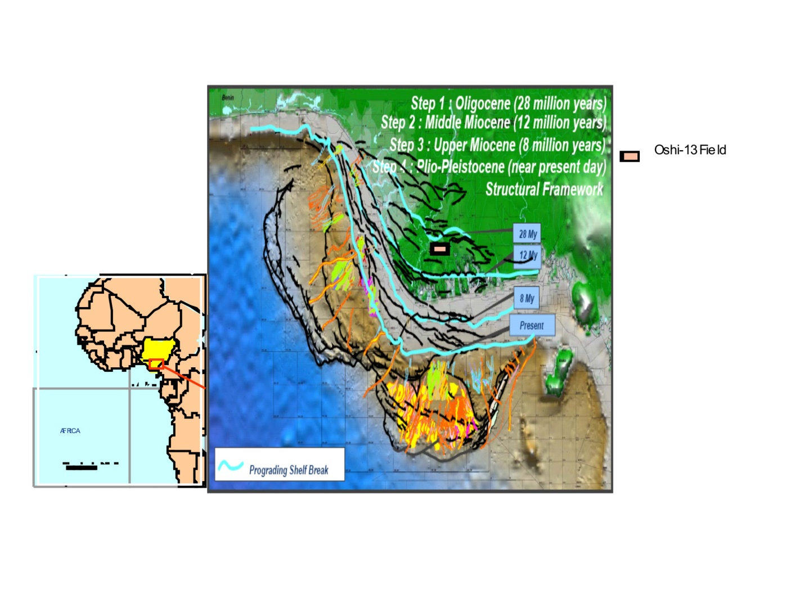
Fig.1: Map showing the location of the Oshi-13 Field in Niger Delta Basin

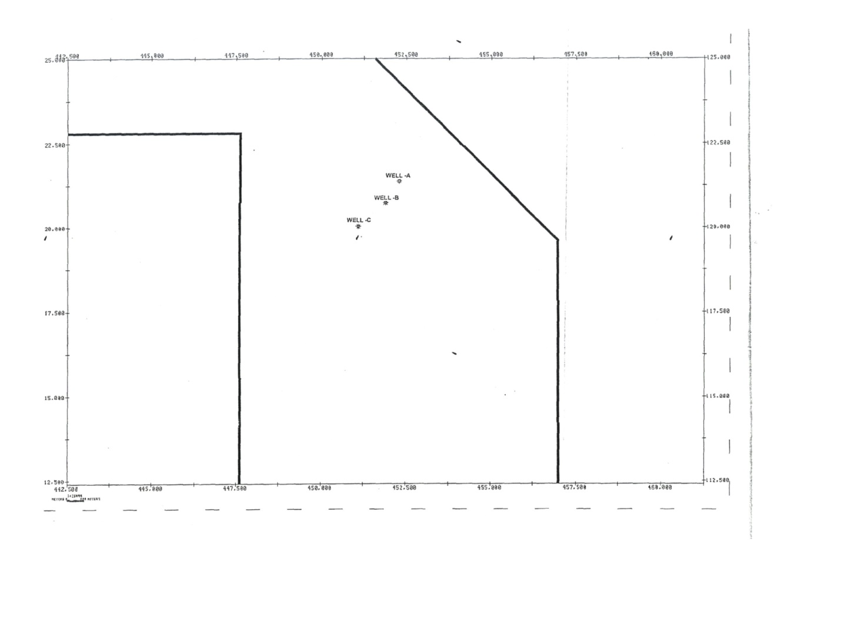
Fig.2: Oshi-13 FieldBase Map showing positions of the Three wells

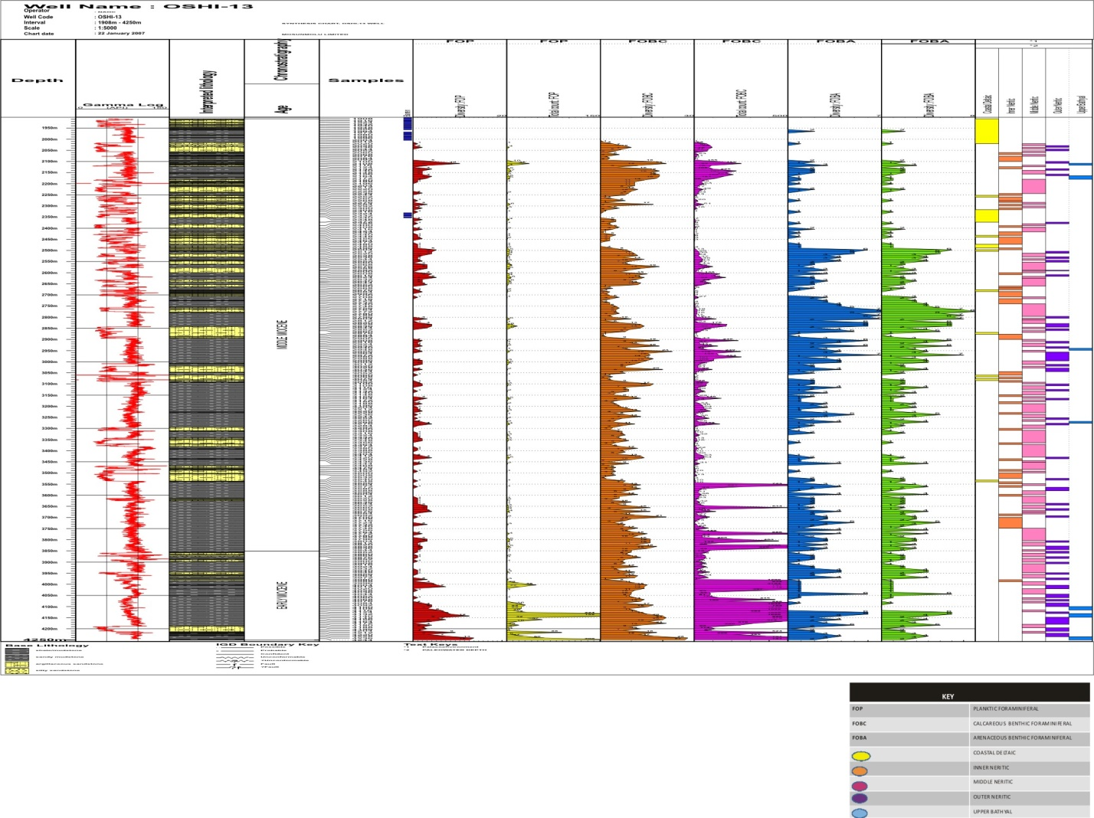

Fig.3: Foraminiferal Distribution Chart of Osh-13 B wells

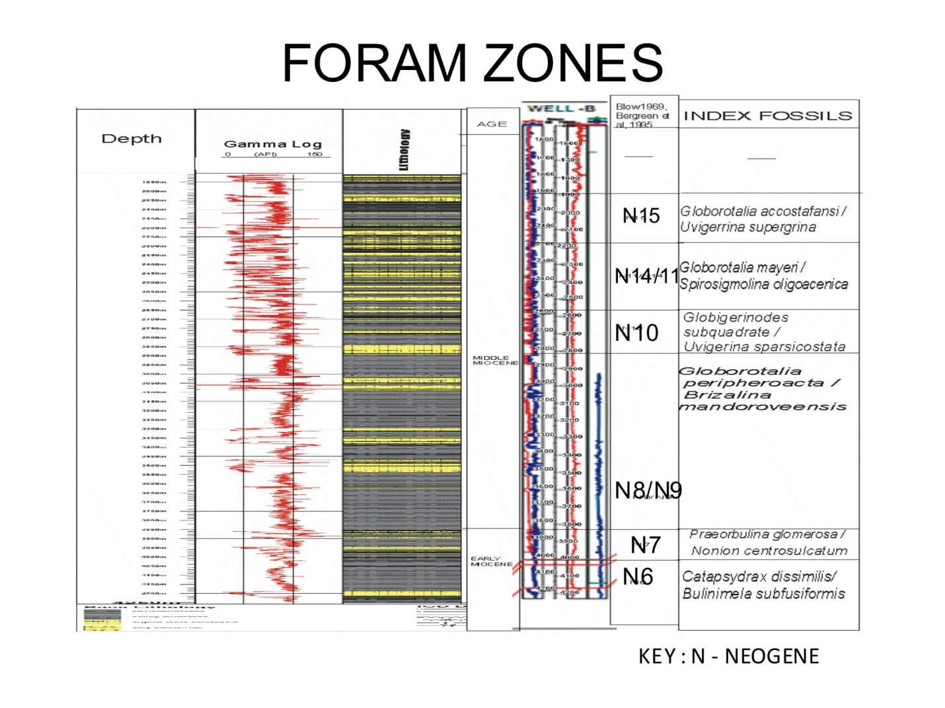

Fig.4: Foraminiferal Biozonation of Osh-13 B wells

