Graphical Abstract
Title of article: Improvement of the hydroxyapatite mechanical properties by spark plasma sintering
Abderrahmen Mechay ^{a, b, *} , , Noureddine Jouini ^{b}, Fréderic Schoenstein ^{b}, Florent Tétard ^{b}, Hafed Elfekiª

ª Laboratoire des Sciences des Matériaux et d’Environnements, Faculté des Sciences de Sfax, 3018 Sfax, Tunisia
^{b} Laboratoire des Sciences des Procédés et des Matériaux, CNRS-UPR 9001, Université Paris 13, PRES Sorbonne Paris Cité, 93430 Villetaneuse, France

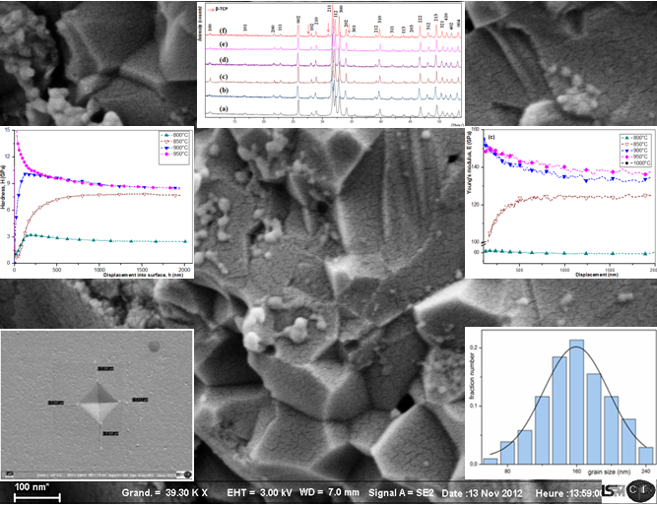
By means of the spark plasma sintering, HA powders were sintered and the microstructure, Vickers microhardness, Young's modulus and density in relation to the sintering time and temperature are carefully described.

