Kinetics and Mechanism of Oxidation of GSH by cis-(diaqua)-bis-(Ethylenediamine) Cobalt(III) ion.

B. Mohanty^{a*}, J. Beheraª, S. Acharya^{b}, P. Mohantyª and A.K. Patnaik^{c}

a. Department of Chemistry, Utkal University, Bhubaneswar,751004, Odisha, India
b. IMMT, Bhubaneswar, Odisha, India
c. Ravenshaw University, Cuttack, 753003, Odisha, India
*Corresponding author E-mail : omm.gayatri@gmail.com
Abstract
The kinetics of GSH oxidation to GSSG by cis-(diaqua)-bis-(ethylenediamine)cobalt(III) perchlorate was studied spectophotometrically under pseudo-first order condition using 10³[Co(III)] = 5 mol dm⁻³, 2.5 ≤ 10²[GSH] ≤ 10.00 mol dm⁻³, 3.5 ≤ pH ≤ 5.0, 318K ≤ T ≤ 333K at a fixed ionic strength I = 0.3 mol dm⁻³ (NaClO₄). The disappearance of [Co(III)] at 500 nm with time showed first-order kinetic trend. The first order dependence on [GSH] and pH was observed. Temperature dependence of the second order rate constant k'₂ = k_{obs}/[GSH] were analysed for the Co(III)-OH₂³⁺ (k₁) and Co(III)-OH²⁺ (k₂) reactivities. An outer-sphere complex formation between the Co(III) and GSH followed by one-electron transfer from GSH to Co(III) resulting the formation of Co(II) and GS. – radical. GS. radical undergoes fast dimerisation to GSSG. Activation parameters were calculated. These values favor the electron transfer reaction.

Key words –Co (III) complex, GSH, GSSG, Spectrophotometer, Redox reaction.

- Introduction
Glutathione (GSH) is a tripeptide containing three amino acids L-cysteine, L-glutamic acid and L-glycine with unusual peptide linkage between amine group of cysteine and carboxylic group of glutamate. The thiol group (SH) of cysteine serves as proton donor and is responsible for the biological activity of glutathione. It plays a fundamental role in numerous metabolic and biochemical reactions such as DNA synthesis and repair, protein synthesis, amino acid transport and enzyme activation.
Because of the importance of GSH, we are interested to study the kinetics of oxidation of GSH by biological active cobalt complex. Cobalt is an essential trace element for all organisms as the active center of co-enzyme called cobalamines. This includes vitamin B₁₂ which is essential for mammals. A deficiency of cobalt leads to pernicious anemia. Studies on the chemistry of electron transfer reaction of cobalt(III) complexes have received a sustained high level of attention from the scientific community for decades due to their relevance in various redox processes in biological system and act as promising agent for antitumor^{1, 2}, anthelmintic³, antiparasitic^{4, 5} antibiotics⁶, and antimicrobial activities⁷. Numerous studies have been performed, addressing the dependence of electron transfer

on different environments including metalloproteins⁸, vitamin B₁₂⁹, liquids^{10, 11}, micelles ^{12, 13}, vesicles¹⁴, and DNA⁷
We report here redox reactions of GSH with Co(III) complex as oxidant and GSH as reductant. The product was isolated, identified and mechanism was proposed.
- Experimental
  - Material and methods
Cis - (diaqua) – bis - (ethylenediamine) cobalt (III) perchlorate was prepared following the reported method^{15, 16}. It was recrystallised and dried. The solid complex was characterized by elemental analysis and spectroscopic methods. All other chemicals used were of analar grade. Doubly distilled water was used to prepare all the solutions. The acid strength of the medium was maintained by addition of HClO₄. The UV-Vis spectra of the complex showed the characteristic peaks at 380 nm(ε = 65dm⁻³ mol⁻¹ cm⁻¹) and 500 nm (ε = 80dm⁻³ mol⁻¹ cm⁻¹).
  - Kinetic Study
Kinetics of oxidation of GSH by Co (III) complex in perchloric acid medium was studied from 318 to 333K, I = 0.3 mol dm⁻³ (NaClO₄). The kinetic measurements were carried out with a systronic 2202 UV-Vis spectrophotometer equipped with a thermostatic water bath for temperature control (accuracy = 0.1ºC). The progress of the reaction was monitored by following the decrease in absorbance at 500 nm “Fig. 1”. The detail experimental procedure of kinetic study was reported in our published paper¹⁷. The kinetics were studied under pseudo-first order conditions, where the substrate[GSH] varied from 2.5 x 10⁻² mol dm⁻³ to 10.0 x 10⁻² mol dm⁻³ and pH was varied from 3.5 to 5.0 and the [Co(III)L] complex is 5 x 10⁻² mol dm⁻³. The rate constants (k_{obs}) were calculated from the slope of ln (A_{t}-A∞) versus t (s) plots from the relationship using computer program.
ln (A_{t}-A∞) = ln (A₀-A∞) – k_{obs}.t
Where A₀, A_{t}, A∞ denote optical density of the reaction mixture at zero time, time t and at infinite time respectively. A∞ was measured after completion of the reaction. The correlation coefficients of plots used to determine k_{obs} were found to be 0.99 in most of the cases.
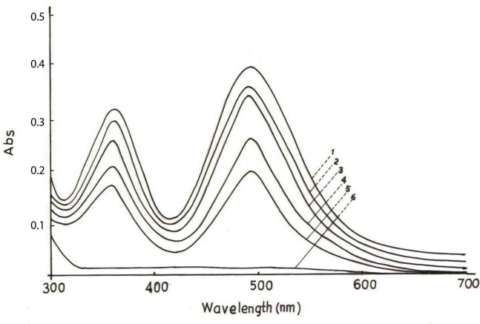
Fig-1: UV-Vis spectral scan of GSH with Co(III) at 303K, pH = 4.0, Co(III) = 0.005 mol dm⁻³, I = 0.3 mol dm⁻³(NaClO₄), (1) Immediate after mixing, curves(2,3) Δt = 5mins, curves (4,5) Δt = 10mins, (6) after 24hs
3. Stoichiometry and Characterization of the Product
The reaction mixture containing [substrate] and [Co (III)L] in ratio 1:10, I = 0.3 mol dm⁻³ (NaClO₄) were allowed to react till completion of the reaction. From the above stoichiometry study it was revealed that the reaction exhibited as 1:1 stoichiometry for GSH oxidation.

2 Co³⁺ + 2 e = 2 Co²⁺
2 GSH = GSSG + 2 H⁺ + 2 e
2 Co (III) + 2 GSH + 2 OH⁻ = 2 Co (II) + GSSG + 2 H₂O
To prepare the reaction product [Co (III)L] = 0.05 mol dm⁻³ was mixed with hot solution of [HClO₄] = 0.005 mol dm⁻³, then pH of the solution was adjusted to 4.5 (Sol-I). In a separate beaker [GSH] = 0.05 mol dm⁻³ was mixed with NaClO₄ = 0.3 mol dm⁻³. Its pH was adjusted to 4.5 (Sol-II). Both the solutions (I and II) were mixed and evaporated in a thermostat at 60ºC for 3h till a pasty solution was formed. Then it was slowly dried in a desiccator. The yield of the product was nearly 70%. The FTIR spectra of the dried product were recorded “Fig. 3” in a Perkin Elmer (UK) FTIR spectrophotometer using KBr pellet technique and it was compared with FTIR spectra of the substrate GSH (Fig. 2). Co (II) in the product was identified by Kitson method¹⁸.

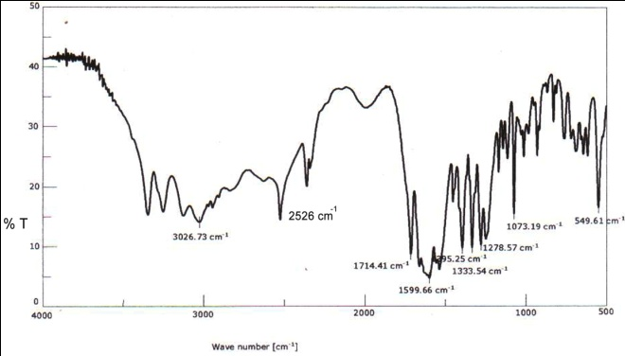
Fig-2: FTIR spectra of pure GSH
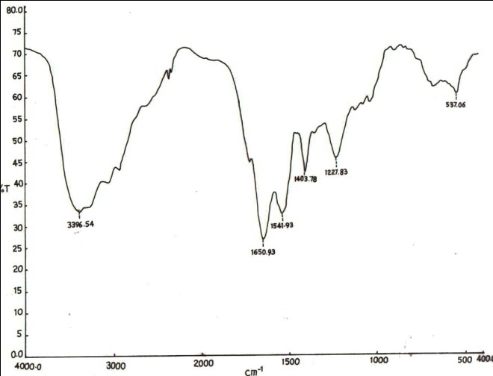
Fig-3: FTIR spectra of oxidation product GSSG

Fig.3 showed a broad peak at 3396.54 cm⁻¹ in the product may be assigned to υ_{N-H} (NH₃⁺) as compared to 3252 cm⁻¹ and 3026 cm⁻¹ in GSH. The shifting to higher frequency was probably due to an association of water molecules with the product. The NH₃⁺ bending bands and a strong absorption peak of carboxylate ion are mixed up and a broad band is observed at 1650.93 cm⁻¹ in the product compared to 1600 cm⁻¹, 1538 cm⁻¹ and 1395 cm⁻¹ peak in GSH. The strong peaks at 1541.93 cm⁻¹, 1403.78 cm⁻¹, 1227.83 cm⁻¹ and 537.06 cm⁻¹ in the product corresponds to 1599.66 cm⁻¹ , 1383.54 cm⁻¹ , 1278.57 cm⁻¹ and 549.61 cm⁻¹ in GSH is due to the free NH₂ twisting and rocking¹⁹. The weak band at 2526 cm⁻¹ in GSH due to S-H stretching is absent in the product suggesting the dimerisation of GSH to GSSG having S-S linkage. The product was isolated as GSSG. [_2S)-2-amino-5-[[(2R)-3-[(2R)-2-[[(4S)-4-amino-5-hydroxy-5-oxopentanoyl]amino]-3-[carboxymethylamino)-3-oxopropyl]disulfanyl-1-(carboxymethylamino)-1-oxopropan-2-yl]-5-oxopentanoic acid]. The structure of substrate (GSH) and product (GSSG) was shown as
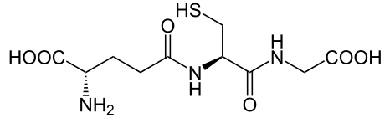
Structure of substrate GSH

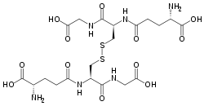
Structure of product(GSSG)
- Results
All kinetic runs were performed under pseudo-first order conditions.
4.1 Effect of [GSH] on reaction rate
With the varying concentration of [GSH] = 2.5 x 10⁻²to 10.0 x 10⁻²mol dm⁻³,10⁴ k_{obs}(s⁻¹) (323K) increased from 6.8 to 10.42 mol dm⁻³ when pH = 4.0, I = 0.3mol dm⁻³ and [Co(III)L] = 5.0 x 10⁻³ mol dm⁻³ (Table-1). The plot of k_{obs} versus [GSH] ‘Fig-4” was linear at different temperatures indicating 1st order dependence of rate on [GSH]. Furthermore, the 2nd order rate constant k₂'(mol⁻¹dm³s⁻¹) = k_{obs}/[GSH]_{T} almost remains constant. As the order of the reaction is one with respect to [GSH]_{T} , the order of the reaction is one with respect to [ Co(III)L]. The rate law is therefore given by
Rate = k_{obs}[Co^{III}-OH]

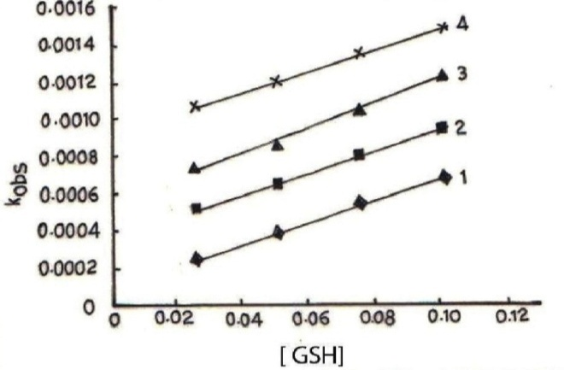
Fig-4: Plot of k_{obs} vs [GSH] at I = 0.3 mol dm⁻³, temp=318 K(1), 323K(2), 328K(3) and 333K(4)
4.2 Effect of pH on reaction rate
The effect of pH on reaction rate was studied varying pH = 3.5 to 5.0, [Co(III)L] = 5 x 10⁻³ mol dm⁻³, [GSH] = 2.5 x 10⁻² mol dm⁻³ and I = 0.3 mol dm⁻³. The rate10⁴ k_{obs} (318K) increased from 2.48 to 6.8 mol dm⁻³ as pH was increased from 3.5 to 5.0. This behavior was repeated for the entire [GSH]_{T} range 0.025 to 0.1 mol dm⁻³. Plots of k_{obs}/[GSH] versus [H⁺] “Fig 5” was a straight line indicating first order dependence of the rate on [H⁺]. The rate constants k₁ and k₂ were obtained from plots of k_{obs}/[GSH] versus [H⁺].
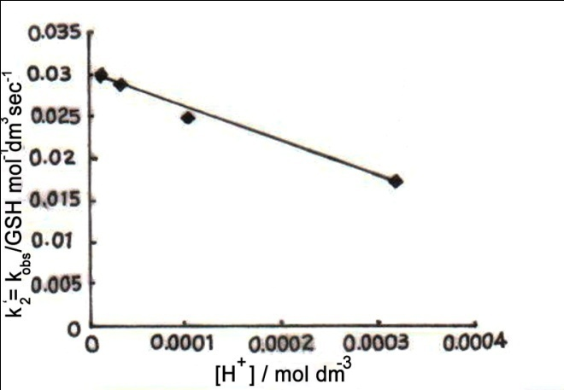
Fig-5: Variation of k'₂ = k_{obs} / [GSH] vs [H⁺] at 328K, [GHS] = 0.05 mol dm⁻³,I = 0.3 mol dm⁻³
4.3 Effect of temperature on reaction rate
The rate of the reaction was studied varying the temperature 318K to 333K keeping [Co(III)L] = 5 x 10⁻³ mol dm⁻³, [GSH]_{T} = 2.5 x 10⁻³ mol dm⁻³, I = 0.3 mol dm⁻³, pH = 3.5. Pseudo-first order rate constant k_{obs} (s⁻¹) was found to increased from 2.48 x 10⁻⁴ to 10.71 x 10⁻⁴mol dm⁻³as temperature increased from 318K “Table-1”.
Table-1 Pseudo-first order reaction rate constants of oxidation of GSH at different temperatures
[GSH] (mol dm⁻³) | pH | 10⁴[H⁺] (mol dm⁻³) | 10⁴ k_{obs} (s⁻¹)
 |  |  | 318K | 323K | 328K | 333K
0.025 | 3.5 | 3.160 | 2.48 | 5.20 | 7.55 | 10.71
0.025 | 4.0 | 1.000 | 3.65 | 6.80 | 12.22 | 12.23
0.025 | 4.5 | 0.316 | 6.53 | 8.67 | 11.08 | 13.95
0.025 | 5.0 | 0.100 | 8.35 | 10.65 | 13.11 | 15.86
0.05 | 3.5 | 3.160 | 3.97 | 6.58 | 8.74 | 12.04
0.05 | 4.0 | 1.000 | 5.23 | 7.87 | 11.51 | 14.15
0.05 | 4.5 | 0.316 | 8.10 | 10.30 | 13.45 | 15.81
0.05 | 5.0 | 0.100 | 9.90 | 12.58 | 15.24 | 17.48
0.075 | 3.5 | 3.160 | 5.58 | 8.06 | 10.54 | 13.55
0.075 | 4.0 | 1.000 | 7.03 | 9.57 | 13.29 | 16.04
0.075 | 4.5 | 0.316 | 9.43 | 12.17 | 14.66 | 17.61
0.075 | 5.0 | 0.100 | 11.23 | 14.37 | 16.89 | 19.56
0.10 | 3.5 | 3.160 | 6.80 | 9.32 | 12.33 | 14.82
0.10 | 4.0 | 1.000 | 8.32 | 10.42 | 15.05 | 17.93
0.10 | 4.5 | 0.316 | 11.15 | 13.58 | 16.00 | 19.44
0.10 | 5.0 | 0.100 | 12.60 | 15.90 | 18.21 | 21.10
[Co^{III}L] = 5 x 10⁻³ mol dm⁻³, I = 0.3 mol dm⁻³
5. Discussion
The oxidation reaction was taken place through two paths with the rate constants k₁ and k₂. Here k₂ path was almost remains constant. So the activation parameters were determined from the electron transfer rate constants k_{1.} The values of ΔH₁# and ΔS₁# were found to be 66.15 ± 9.5 KJ mol⁻¹ and 77.77 ± 29.2 JK⁻¹ mol⁻¹ respectively. The moderate values of activation parameters favor the electron transfer reaction. The negative values of activation parameters suggested the formation of the ordered transition state.
Since pK₁, pK₂, pK₃ and pK₄ of GSH are 2.05, 3.47, 8.63 and 9.52(Scheme 1), at higher concentration of the acid 0.03 mol dm⁻³, the undissociated form of GSH will participate in the electron transfer reaction. The reaction sequence delineated below (Scheme 2) was consistent with the experimental data.
Mechanism
SCHEME – 1
Deprotonation equilibria of GSH
The above observation suggested the following mechanism as shown in scheme-2. From the above reaction the rate law was derived as
SCHEME-2
Proposed mechanism of electron transfer reaction
K_{h}
Co^{III}- OH₂ Co^{III}- OH + H⁺
+ +
GSH GSH
k₁ k₂
GS⋅ + Co(II) GS⋅ + Co(II)
2 GS⋅ = GSSG (fast)
From the proposed mechanism, the rate law was derived as
[Co^{III}-OH][H⁺] (1)
K_{h} =
[Co^{III}-OH₂]
Rate = k₁[GSH][Co^{III}-OH₂]_{e} + k₂[GSH][Co^{III}-OH]_{e}

=k₁[GSH][Co^{III}-OH₂]_{e} + k₂K_{h}[Co^{III}-OH₂]_{e}[GSH] / [H⁺]
=[GSH][Co^{III}-OH₂]_{e}{k₁[H⁺]+k₂K_{h}} (2)
[H⁺]
[Co^{III}-OH₂]_{T} = [Co^{III}-OH₂] _{e} + [Co^{III}-OH] _{e}
= [Co^{III}-OH₂] _{e} + {[Co^{III}-OH₂]K_{h} / [H⁺]}
=[Co^{III}-OH₂]_{e}{[H⁺]+K_{h}} (3)
[H⁺]
[Co^{III}-OH₂]_{e}={[Co^{III}-OH₂]_{T}[H⁺]}/{[H⁺]+K_{h}} (4)
Rate = [GSH]_{T}[Co^{III}-OH]_{T}{k₁[H⁺] + k₂K_{h}}/{[H⁺] + K_{h}} (5)
Rate=k_{obs}[Co^{III}-OH]_{T} (6)
Comparing (5) & (6)
k_{obs}=[GSH]_{T}{k₁[H⁺]+k₂K_{h}}/{[H⁺]+K_{h}} (7)
k_{obs =} k₂' ₌ {k₁[H⁺] + k₂ K_{h}}
[GSH]_{T} k₂'{[H⁺] +k_{h}}
k₂'{[H⁺]+k_{h}}={k₁[H⁺]+k₂K_{h}} (8)
where k₂' = k_{obs} / [GSH]_{T}
There exists two species of Co (III) as Co^{III} – OH₂ and Co^{III} – OH in acid solution which were in equilibrium with each other. Both the species react with GSH through two paths with rates are k₁ and k₂ respectively producing radicals GS. and Co(II). The GS. radicals dimerised rapidly forming GSSG.
From equation (8) the left hand side expression was plotted against [H⁺]. It showed a straight line with a positive slope. From the slope and intercept k₁ and k₂ were calculated. These values at four different temperatures 318 – 333K were calculated and tabulated in “Table 2”. It shows that k₂ rate is much faster than k₁.
The values of k₁ (rate of oxidation of GSH by Co^{III}-OH₂ species) varies with temperature whereas k₂ (rate of oxidation of GSH by Co^{III}-OH species) remains almost constant and the activation parameters for the path k₁ were calculated and tabulated “Table-2”. The activation parameters were determined from the electron transfer rate constants k_{1.}

Table-2 : Electron transfer rate constants at different temperatures and activation parameter
Temp. (K) pK_{h} k₁ k₂
(mol⁻¹dm³sec⁻¹) (mol⁻¹dm³sec⁻¹)
318 5.65 0.0073 0.127
323 5.53 0.0128 0.112
328 5.41 0.0176 0.105

333 5.30 0.0242 0.084
333 5.30 0.0242 0.084

ΔH# = (66.15 ± 9.5) kJ mol⁻¹
ΔS# = (-77.77 ± 29.2) JK⁻¹ mol⁻¹ .
Conclusion
The oxidation reaction of GSH by Co(III) complex proceeds through two steps (k₁ and k₂) producing free radical as GS. and Co(II) respectively. The free radical GS. dimerises to GSSG. Reduction at Co(III) center has been achieved due to generation of a radical at the bound ligand by the one equivalent oxidant. k₂ path is much faster than k₁ path. The activation parameters corresponding to k₁ were evaluated, such as activation enthalpy (ΔH# = 66.15 ± 9.5 KJ mol⁻¹ ) and activation entropy ( ΔS # = -77.77 ± 29.2 JK⁻¹ mol⁻¹). Moderate values of activation parameters favor the electron transfer process. Negative value of activation entropy corresponds to ordered transition state.
Since there was no evidence of bridging of ligand between the oxidant and reductant, inner sphere mechanism was ruled out. The electron transfer mechanism between GSH and Co (III) complex was expected to be outer sphere mechanism.
Kinetics of oxidation of tripeptide (GSH) was compared with the kinetics of oxidation of one of its amino acid L – cysteine²⁰ by Co(III) complex under similar conditions. It was concluded that the rate of electron transfer reaction of the tripeptide GSH is 40 times slower than aminoacid.
Acknowledgement
The authors are thankful to H.O.D Chemistry, Utkal University, Bhubaneswar, India for providing research facilities.
References
[1] S. Osinsky, I. Levitin, L. Bubnovskaya, A. Sigan, I. Ganusevich, A. Kovelskaya, N. Valkovaskaya, L. Campanella, P. Wardman, Exp Oncol, (2004) 26, 140-144.
[2] S. Osinsky, I. Levitin, A. Sigan, L. Bubnovskaya, I. Ganusevich, L. Campanella, P. Wardman, Russ Chem Bull, (2003) 52, 2636-2645 .
[3] C. A. Behm, I. Creaser, B. Daszkiewicz, R. J. Geue, A. M. Sargeson, G.W. Walker, J. Chem Soc, Chem Commun., (1993) 24, 1844-1846.
[4] M. E. Karaman, R. M. Pashley, N. K. Bolonkin, Langmuir, (1995) 11, 2872-2880.
[5] C. A. Behm, P. F. L. Boreham, I. I. Creaser, B. Daszkiewicz, D. J. Maddalena, A.M. Sargeson, M. Snowdown, Aust J Chem, , (1995) 48,1009.
[6] G. Ghirlanda, P. Scrimin, P. Tecilla, A. Toffoletti, Langmuir, (1998) 14, 1643-1646.
[7] S. Srinivasan, J. Annaraj, P. R. Athappan, J Inorg Biochem,(2005) 99, 876-882.
[8] K. Bernauer, S. Ghizdavu, L. Verardo, Coord Chem Rev, (1999) 357,190-192.
[9] M.; Wolak, G. Stochel, R. Van Eldik, J Am Chem Soc, (2003) 125, 1334-1351.
[10] V. O. Saik, A. A. Goun, J. Nanda, K. Shirota, H. L. Tavernier, M. D. Fayer, J. Phys Chem A, (2004) 108, 6696-6703.
[11] L. Burel, M. Mostafavi, S. Murata, M. Tachiya, J Phys Chem A, (1999) 103, 5882-5888.
[12] K. Weidemaier, H. L. Tavernier, M. D. Fayer, J Phys Chem B, (1997) 101, 9352-9361.
[13] H. L. Tavernier, A. V. Barzykin, M. Tachiya, M. D. Fayer, J Phys Chem B, (1998) 102, 6078-6088.
[14] A.I. Vogel, Inorganic synthesis, (1951) Vol-II, 222.
[15] M.J. KrisnaMurty, Inorg. Nuclear Chem., (1972) 34, 3915.
[16] F. Basalo and R.G. Pearson, Mechanism of Inorganic Reaction, Wiley, 1964
[17]. B. Mohanty, J.Behera, P. Mohanty, S. Acharya, A.K. Patnaik and S.P. Das, J. Indian Chem. Soc., (2011) 88(10), 1561-1566.
[18] R.E. Kitson, Anal. Chem. (1950) 22, 664-667.
[19] K. Nakamoto,Infrared and Raman Spectra of Inorg. and Coord. Compexes, 5th Edn, John Willey and Sons Inc. Publication.
[20] K. Asemave, S.G. Yiase, S.O. Adejo, International Journal of Science and Technology, (2012)2(5), 242-247.

